____________________________________________________ Launch Chart

Quarterback: _______________________________________________________________________________________
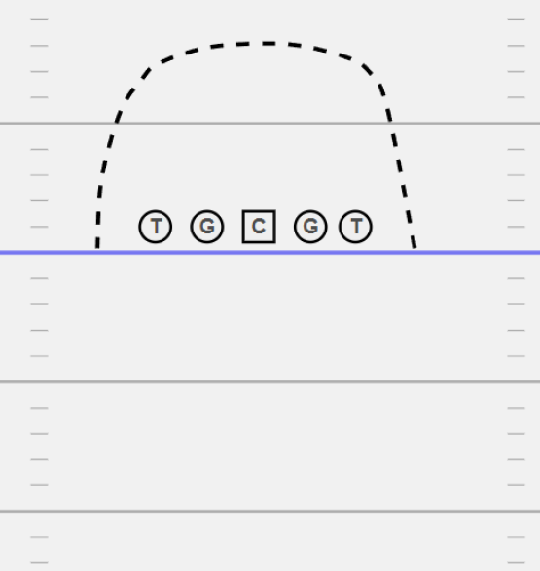
Height: _________________
Weight: _________________
Age: ____________________
Time to Throw: ____________________
Release Point: __________________________________

Notes: _________________________________________
_______________________________________________
_______________________________________________
_______________________________________________
_______________________________________________
_______________________________________________
_______________________________________________

Left Flat | Left hook | Low Hole | Right Hook | Right Hole
Left Outside | Left Seam | Deep Middle | Right Seam | Right Outside

