150+ Football Drills
For Coaches

Chris Haddad
INTRODUCTION

Drills are the foundation of any sport. In football, it’s important to make your drills as close to a game situation as possible. This will help your athletes thrive during the game and not freeze in the moment.

150+ Football Drills For Coaches was created to help you coach any position. Every drill will serve a purpose that is closely related to a game situation.

These drills are meant for all levels of football (youth, high school, college, and even professional teams). The key is to make sure your player understands why they’re doing a drill and how it relates to a game situation.

Each drill should take the coach no more than 30 seconds to set up. Every drill has a start, a purpose, and a finish.

We highly recommend adding your twist to these drills - whether it be players catching a ball, picking up a fumble, or even tackling a ball carrier.

One of the main reasons I created this book was to help coaches worldwide improve practice habits and turn boring practices into exciting game situations.

Remember, players want to be coached. Keeping the players engaged throughout practice with fast-paced drills and situational play will make them want to practice, rather than forcing them to get through it.

If there’s anything I can do to help you - please feel free to reach out to me! The best place to reach me is on Twitter - @chrisvIQtory. I’m happy to answer any questions that you may have.
GET YOUR FREE
VIDEO LIBRARY

Simply scan the QR code below with your phone to get your video library. All of these drills directly correlate to every drill in the video library.

TABLE OF CONTENTS

Quarterbacks…………………………………………………………………… 8

Running Backs………………………………………………………………… 25

Wide Receivers………………………………………………………………… 42

Offensive Line…………………………………………………………………… 61

Defensive Line………………………………………………………………… 83

Linebackers……………………………………………………………………… 96

Defensive Backs……………………………………………………………… 113

Tackling…………………………………………………………………………… 130

Special Teams………………………………………………………………… 158

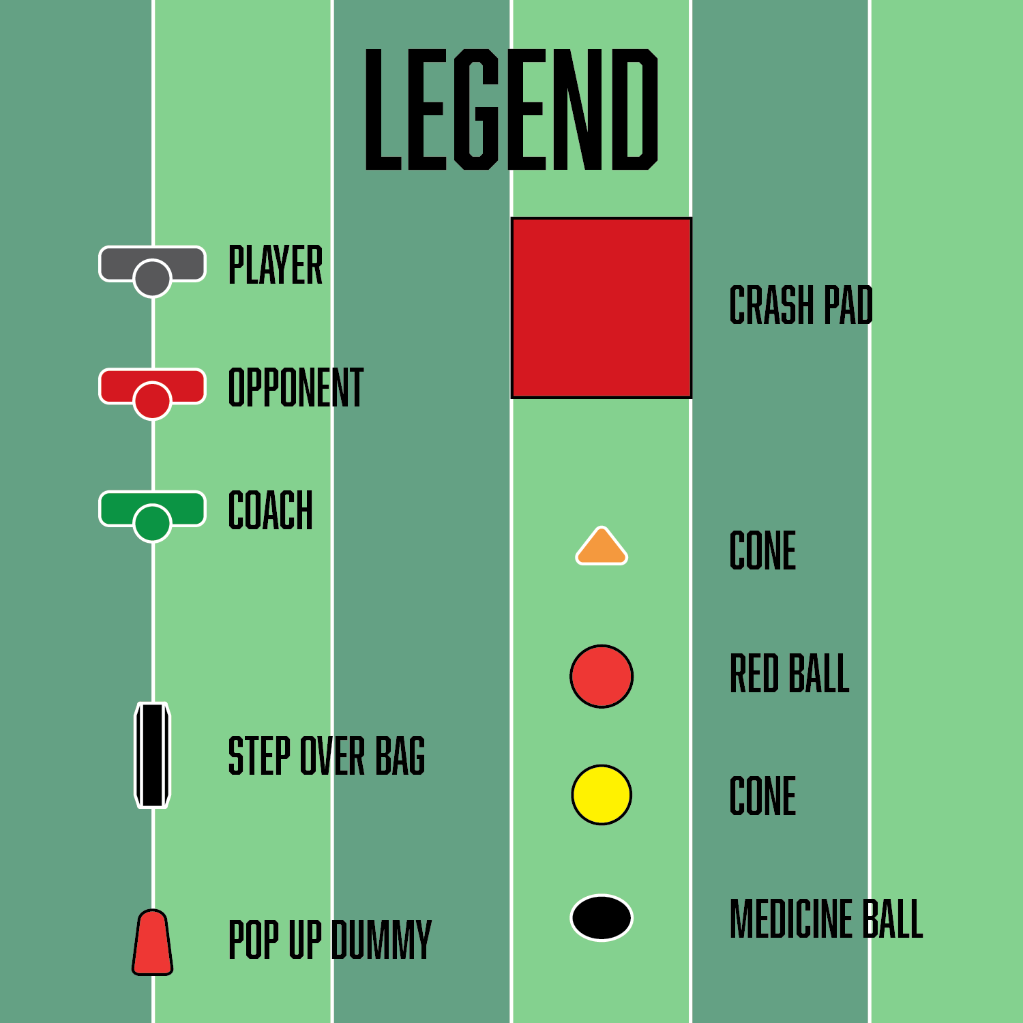
QUARTERBACKS

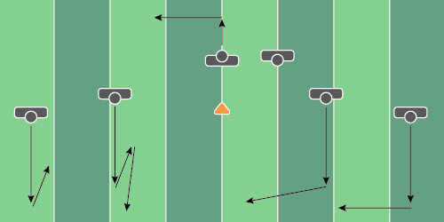
Figure 1.1

Scramble Drill

Equipment Needed: Players

Purpose: Receivers adjusting routes when the pocket collapses.

Required Players: 4-5

Required Coaches: 0

Description: (1) The quarterback should take his normal drop in the pocket (2) Once the quarterback feels as if the pocket collapses, move left or right toward one side of the field (3) Receivers that are deep should move back to the QB. Shallow receivers should move vertically. Backside receivers should move across the field back toward the QB.

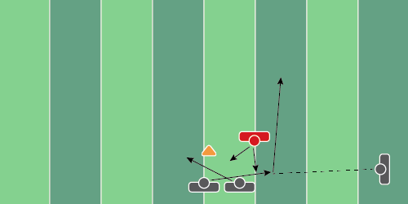
Figure 1.2

Read Option Drill

Equipment Needed: Players/Coaches

Purpose: Working all 3 phases in the triple-option game.

Required Players: 2-3

Required Coaches: 1-2

Description: (1) The quarterback will receive the snap and read the defensive end for the first read. (2) Once the QB has read the defensive end, the coach will pass him a football, which he will pitch to his option running back.(3) The quarterback should finish the drill by running 10-15 yards downfield.
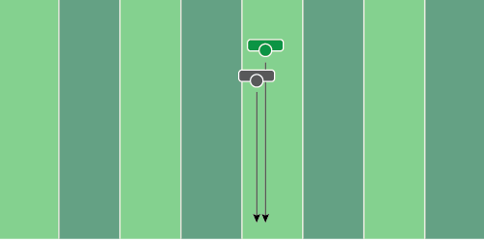
Figure 1.3

QB Drop Drill

Equipment Needed: Players

Purpose: Warmup drill for drop steps.

Required Players: 1

Required Coaches: 1

Description: (1) The quarterback should start the drill by taking his drop. (2) Continue to crossover and reach with the back leg to simulate first step drops. (3) The coach should hold up numbers with his fingers to keep the quarterback’s eyes downfield.
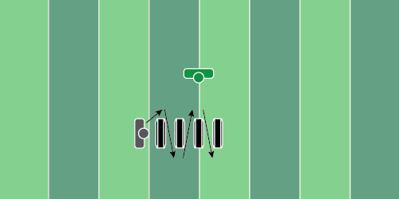
Figure 1.4

Base Weave Drill

Equipment Needed: Bags Or Cones

Purpose: Working on dropping back as well as climbing the pocket.

Required Players: 1

Required Coaches: 0

Description: (1) QB should focus on keeping a wide base while they maneuver through the bags or cones. (2) Once the player moves forward past the bag, they should move backward, simulating pocket movement (3) Add a coach to the drill by standing in front of the bags, giving numbers (holding up fingers) to the quarterback to make sure their eyes stay downfield.
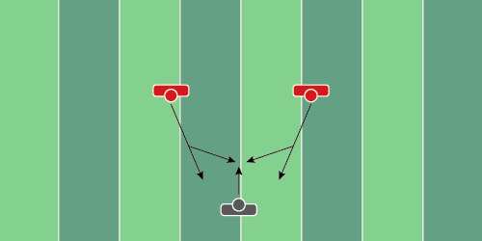
Figure 1.5

Pocket Presence Drill

Equipment Needed: Players/Coaches

Purpose: Teaching the QB to move the pocket when it collapses.

Required Players: 1

Required Coaches: 2 (or 2 players)

Description: (1) The quarterback should take a drop after receiving the football from a center or the coach. (2) Once the quarterback hits the top of their drop, the two coaches (or players) should run at the quarterback, forcing him to move the pocket. (3) One player should cross in front, and one behind the QB. Randomize who goes in front and behind to force the QB to react.
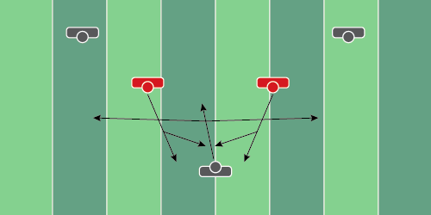
Figure 1.6

Pocket Presence Drill (2)

Equipment Needed: Players/Coaches

Purpose: Helping a QB move the pocket when it collapses.

Required Players: 1

Required Coaches: 2 (or 2 players)

Description: (1) The quarterback should take a drop after receiving the football from a center or the coach. (2) Once the quarterback hits the top of the drop, the two coaches (or players) should run at the quarterback, forcing him to move the pocket. (3) Once the QB has stepped up into the pocket, scramble to the right or left and throw the football.
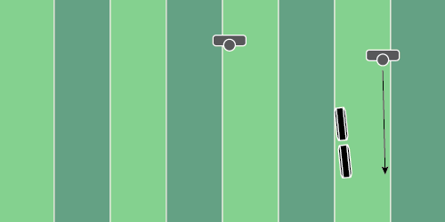
Figure 1.7

Deep Ball Spot Drill

Equipment Needed: Step Over Bags Or Shields

Purpose: Helping the Qb to deliver the football in an area of the field; Deep ball accuracy.

Required Players: 2

Required Coaches: 0

Description: (1) The quarterback should take a drop after receiving the football from a center or the coach. (2) Once the quarterback hits the top of the drop, deliver the football to the receiver running a “go” route. The point of the drill is to deliver the football in a tight window.
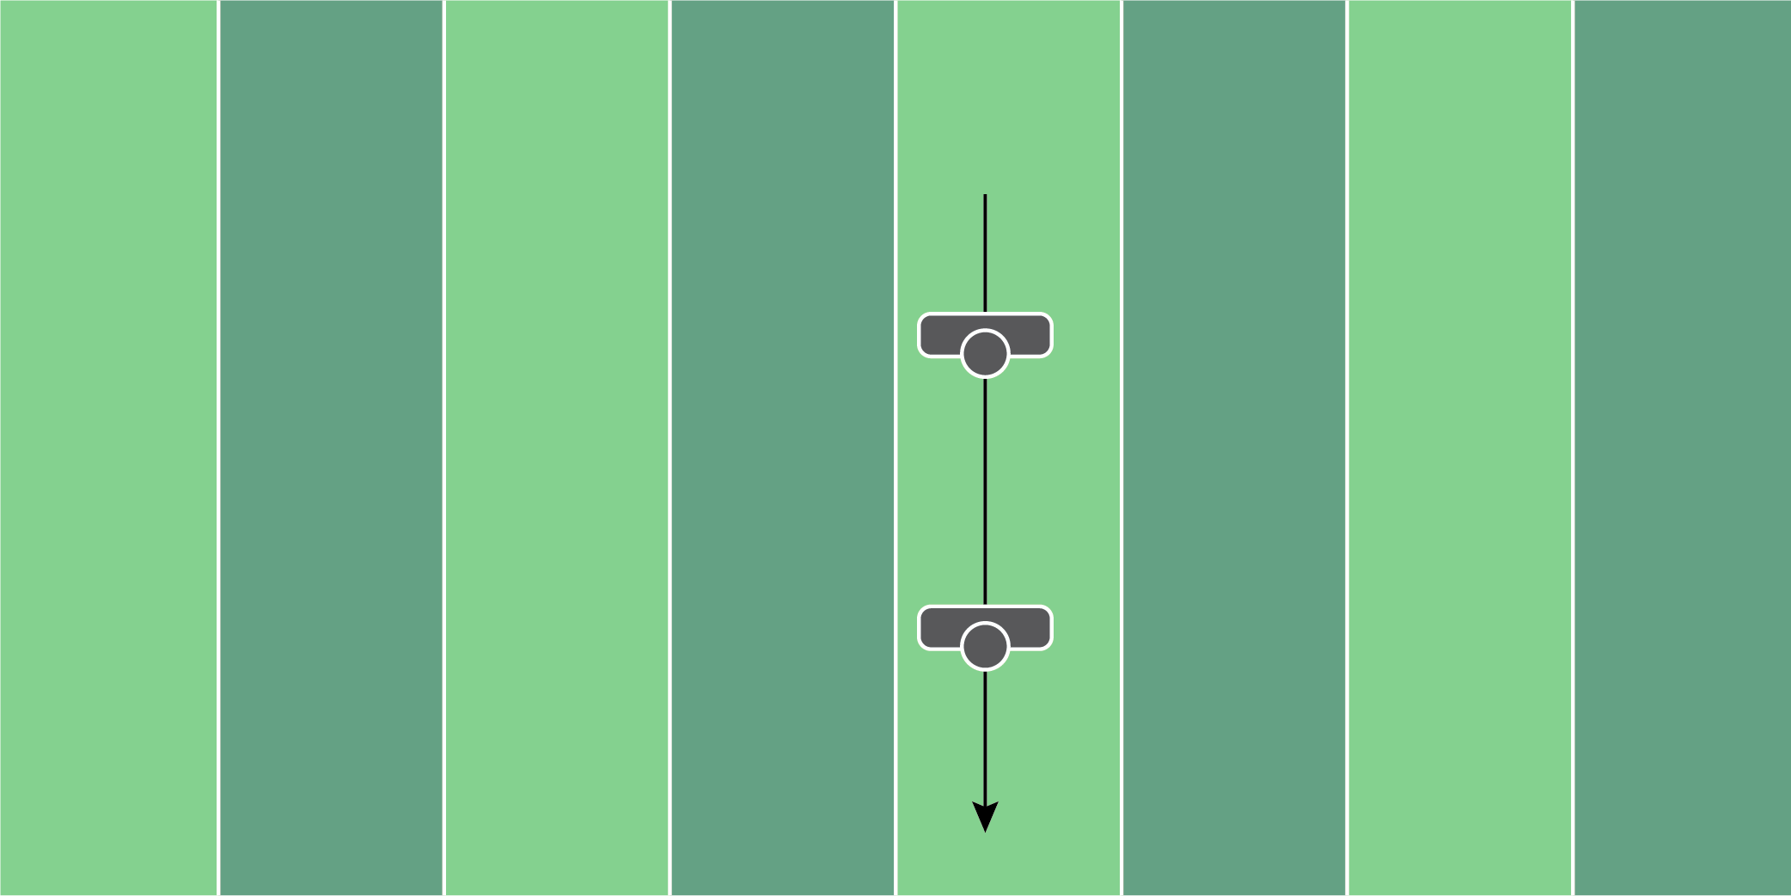
Figure 1.8

Separation Steps Drill

Equipment Needed: Players

Purpose: Working on the separation steps in a 3/5/7 step drops.

Required Players: 1

Required Coaches: 0

Description: (1) Start on a yard line or anywhere there is a straight line. (2) From here, reach with the back foot continuously until you reach the opposite sideline. This drill will help you work on separation and open up the hips - great for a warm-up drill.
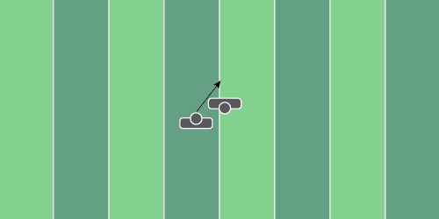
Figure 1.9

Option Drill

Equipment Needed: Players

Purpose: Develop a relationship between fullback and quarterback for the dive/zone read in triple option.

Required Players: 2

Required Coaches: 0

Description: (1) The quarterback should be set with the ball extended completely out toward the running back. Next, the QB should have his head in the hole or on the player in which he’s reading. (2) On the cadence, the fullback should move forward, allowing the quarterback to get a feel for when to release the football to the fullback, or pull it and keep it.
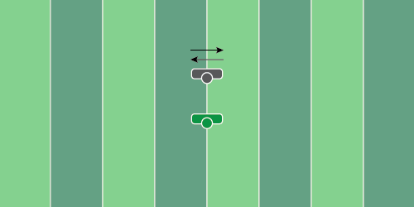
Figure 1.10

Eyes Downfield Drill

Equipment Needed: Bean bags or tennis balls

Purpose: Helping a QB keep their eyes downfield and “feel” pressure.

Required Players: 1

Required Coaches: 2

Description: (1) The quarterback will start in a wide stance as if he’s preparing to throw the football. (2) The QB will move side to side, while the coach lightly tosses bean bags or tennis balls at them. (3) The quarterback will move side to side, dodging the tennis balls or bean bags, while keeping his eyes downfield. (4) A player or coach should hold up numbers (fingers) while the player is dodging the bags to keep his eyes downfield.
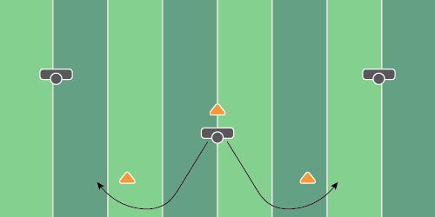
Figure 1.11

On The Run Cone Drill

Equipment Needed: Cones

Purpose: Helping QB’s throw on the run.

Required Players: 1

Required Coaches: 2 (or 2 players)

Description: (1) The quarterback should take a drop after receiving the football from a center or the coach. (2) The quarterback should start to move in the direction of the cone behind them. From here, attack the line of scrimmage, get the front shoulder facing toward the target and deliver the football to the coach/player.
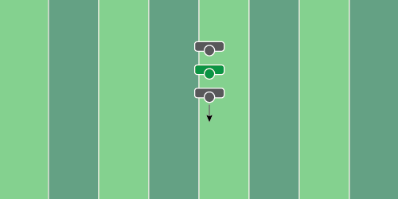
Figure 1.12

Screen Drill

Equipment Needed: Players/Coaches

Purpose: Learning how to throw a screen over a defensive lineman.

Required Players: 1

Required Coaches: 2 (or 2 players)

Description: (1) The quarterback should take a drop after receiving the football from a center or the coach. Take the necessary steps to get depth away from the line of scrimmage. (2) From here, the coach or player acting as the defensive lineman should try to jump in the air and tip the ball that the quarterback throws. (4) The quarterback needs to deliver the ball to their receiver who should be next to or near the line of scrimmage.
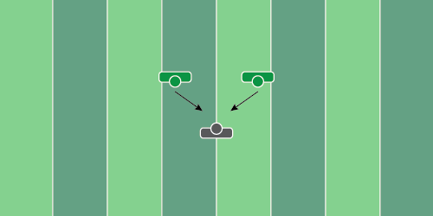
Figure 1.13

QB Gauntlet Drill

Equipment Needed: Players/Coaches

Purpose: Climb the pocket while securing the ball with 2 hands.

Required Players: 1

Required Coaches: 2 (or 2 players)

Description: (1) The quarterback should take a drop as if they’re going to pass (2) Once the QB hits the top of the drop, slide up into the pocket. (3) Once the QB slides up in the pocket, the 2 players or coaches should try to strip the football from the QB.

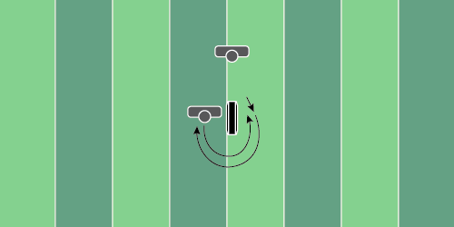
Figure 1.14

Pocket Control Drill

Equipment Needed: Players/Coaches

Purpose: Teaching the QB to deliver the football while moving the pocket.

Required Players: 1

Required Coaches: 2 (or 2 players)

Description: (1) Starting on the left side of the step-over bag, the QB should shuffle around the bag, then work his way back to the start. The coach may determine how many times the quarterback should go back and forth. (2) When the coach says “throw” the quarterback must deliver the football to the player/coach that’s about 10 yards away.
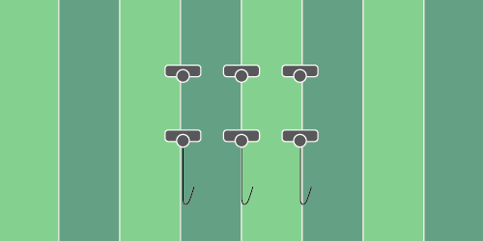
Figure 1.15

Plant & Throw Drill

Equipment Needed: Players/Coaches

Purpose: Training the quarterback's eyes to locate and throw.

Required Players: 1

Required Coaches: 1

Description: (1) The quarterback should start by walking away from their wide receiver. (2) When the coach says “throw”, the quarterback will plant their back foot, snap their eyes to the target, and throw the football to the intended target.
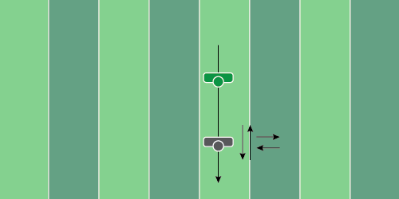
Figure 1.16

Drop & Reset Drill

Equipment Needed: Players/Coaches

Purpose: Teaching the QB to move the pocket after the initial drop.

Required Players: 1

Required Coaches: 1

Description: (1) The quarterback should take a 3/5/7 drop. (2) The coach should point in a direction in which the quarterback should move. The quarterback should move his feet in that direction and reset his feet.

RUNNING
BACKS
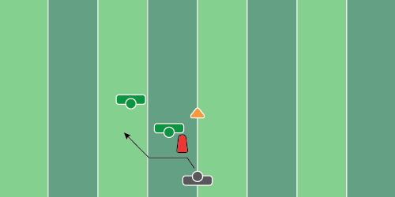
Figure 2.1

Zone Read & Cut Drill

Equipment Needed: Hand shields & shiver balls/exercise balls

Purpose: Teaching the running back to stay patient & reacting off defensive movements.

Required Players: 1

Required Coaches: 2

Description: (1) The running back should take the hand-off or start with the football (2) Move toward the first coach and make a jump cut. (3) The player should then move toward the shiver ball and react the opposite way of the coach rolling the ball (or the hand shield if there’s no ball)
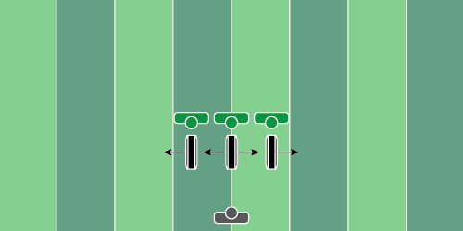
Figure 2.2

Read & React Drill

Equipment Needed: Hand shields or step over bags

Purpose: Teaching the running back to stay patient & reacting to defensive movements.

Required Players: 1

Required Coaches: 3

Description: (1) The running back should take the hand-off or start with the football (2) Move toward the line of scrimmage and react off of the coach’s movements (3) The coaches should use a numbering system to decide which way to go. For example, “1” means every coach goes to the right. “2” means the outside coaches go to their outside and the middle coach goes left or right. “3” means every coach goes left. This is the easiest communication system among coaches.
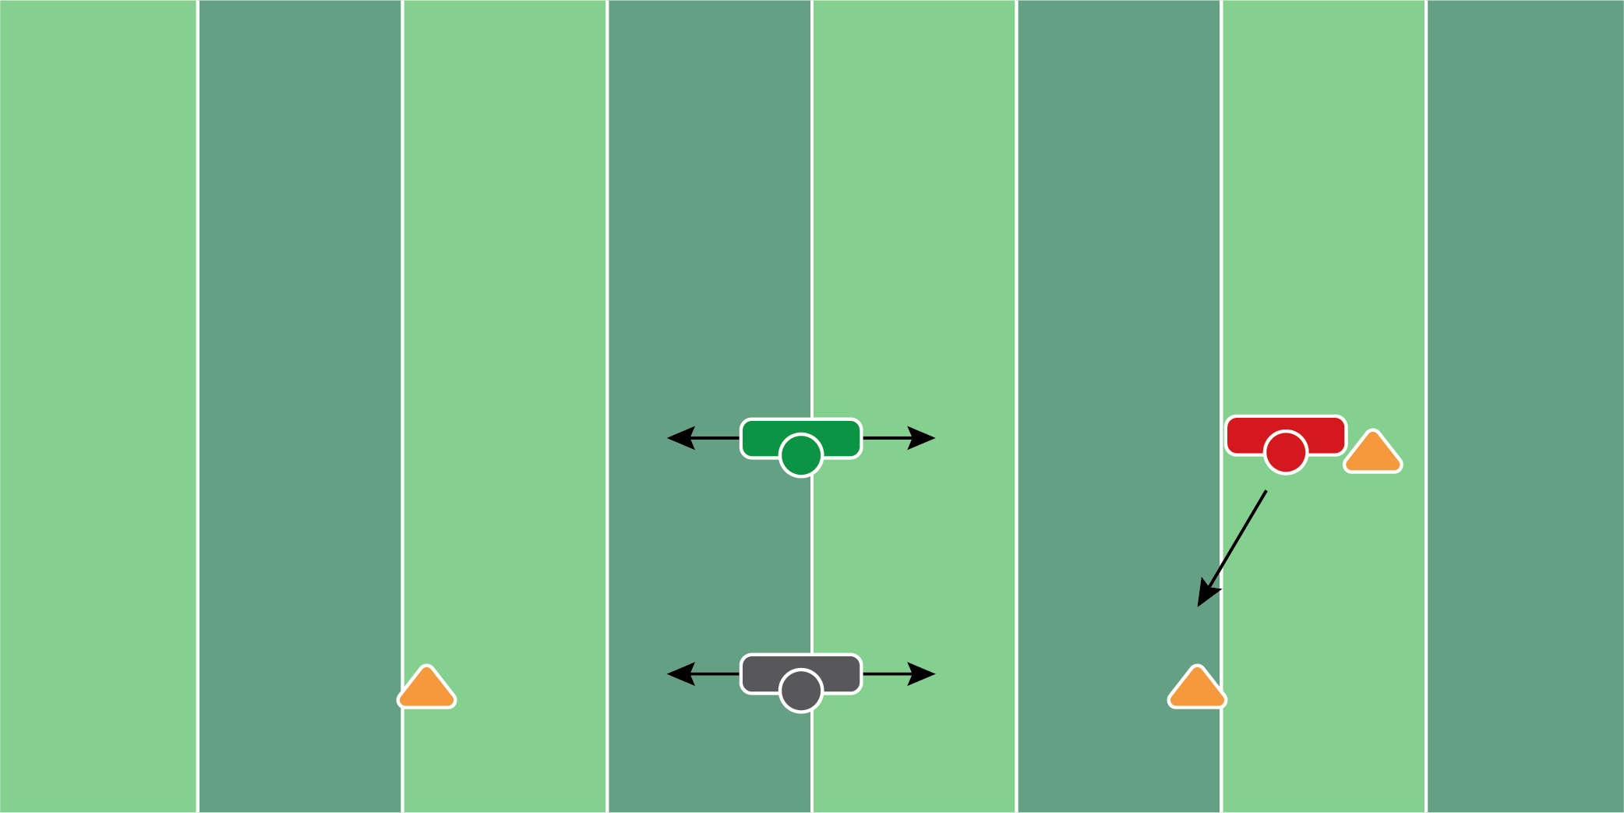
Figure 2.3

Lateral Blocking Drill

Equipment Needed: Cones & Medicine Ball

Purpose: Teaching the running back to keep their elbows in and deliver a strong blow to the defender.

Required Players: 1

Required Coaches: 1

Description: (1) The running back should start shuffling from side to side. The coach will throw the medicine ball at the player who must throw it back to the coach. (2) Once the player has gone back and forth 4 to 5 times, the coach will say break, which then he will make contact with a live player running to the cone.
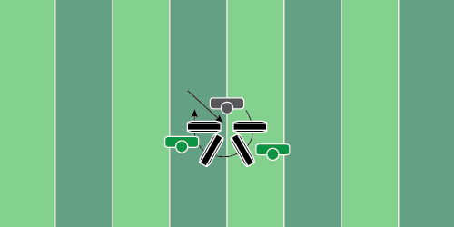
Figure 2.4

Stumble Drill

Equipment Needed: Step Over Bags

Purpose: Teaching ball security when stumbling and falling down.

Required Players: 1

Required Coaches: 1

Description: (1) The running backs should start with their hand on the ground at the top of the step-over bags. (2) Next, move in a clockwise circle around the bags, keeping the hand in the same spot. (3) Coaches should punch at the ball or try to dislodge the ball from the players as they’re moving in a circle.
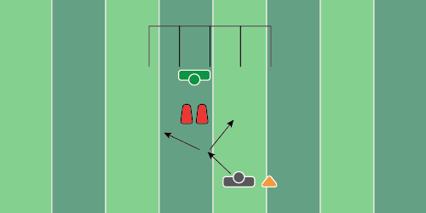
Figure 2.5

Zone Read & React Drill

Equipment Needed: Step over bags/barrels & chutes

Purpose: Teaching the running back to read the outside defender and finish with low pad level.

Required Players: 1

Required Coaches: 1

Description: (1) The running back should start with the football or take a hand-off from the quarterback. (2) As the running back is moving toward the coach, the coach will move left or right. (3) The running back will react off of the movement and finish under the chutes.
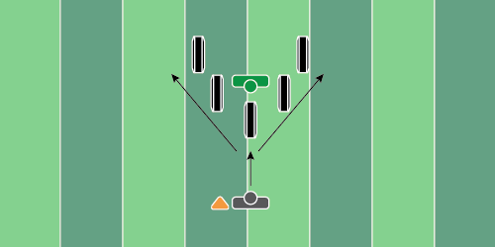
Figure 2.6

High Knee React Drill

Equipment Needed: Step Over Bags

Purpose: Teaching the player to react and finish with high knees through the line of scrimmage.

Required Players: 1

Required Coaches: 1

Description: (1) The running back should start next to the cone. When the coach says “go”, the running back should run toward the first step bag. (2) The coach should make a move to the right or left. Once he makes a move, the running back should go opposite, stepping over each bag and finishing with a 10-yard burst.
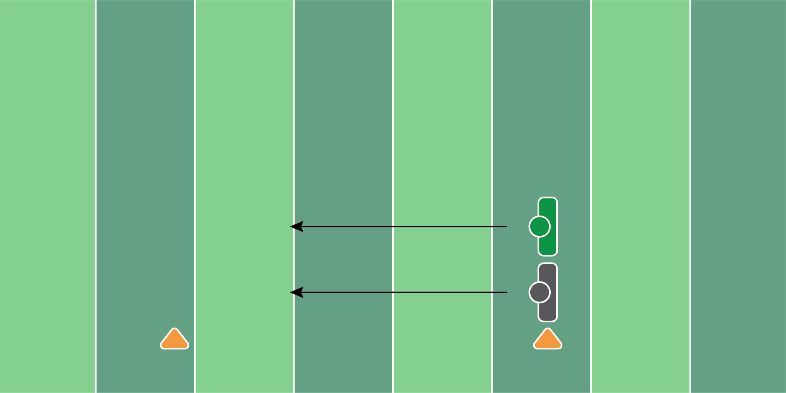
Figure 2.7

Stumble Strip Drill

Equipment Needed: Players/Coaches

Purpose: Teaching ball security when secondary contact is made on a running back.

Required Players: 1

Required Coaches: 1

Description: (1) The running back should start with their hand on the ground as if they’re stumbling. (2) As the running back moves forward, touching the ground every 2-3 yards, the player/coach should try to punch out and strip the football.
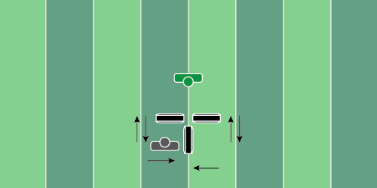
Figure 2.8

T Reaction Drill

Equipment Needed: Step over bags

Purpose: Reaction drill with ball security and driving the knees up over the bags.

Required Players: 1

Required Coaches: 1

Description: (1) The running back should start in the bottom left corner of the “T”. When the coach says “go”, the running back should run his legs in place and react to the coach’s commands. (2) Each of the commands given by the coach should be forward, backward, or side to side. (3) Finish the drill with a 5-yard burst forward in front of the bags.
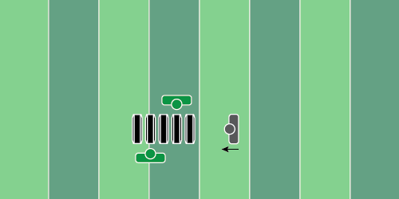
Figure 2.9

Ball Security While Falling Drill

Equipment Needed: Step over bags

Purpose: Teaching the player ball security as they’re falling to the ground.

Required Players: 1

Required Coaches: 1

Description: (1) The running back will start at the beginning of the step-over bags. Start by falling toward the ground and rolling over safely. (2) while the athlete is rolling on the ground, the coach should try to punch the ball out of the running back’s hands.
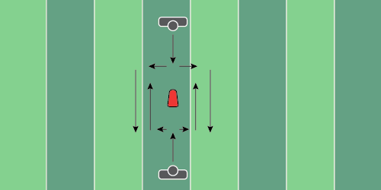
Figure 2.10

Jump Cut Reaction Drill

Equipment Needed: Pop Up Dummy

Purpose: Jumpcut and react off of the opponent’s movement.

Required Players: 2

Required Coaches: 0

Description: (1) The running backs will start the drill by running toward the popup dummy. (2) Once they reach the popup dummy, they will then jump cut in different directions, reacting to each other’s movement. (3) Coaches can determine if they want to have every player go to the right, go to the left, or react off of the other person’s movement. We recommend you make sure to clearly define what’s happening, so there are no injuries.

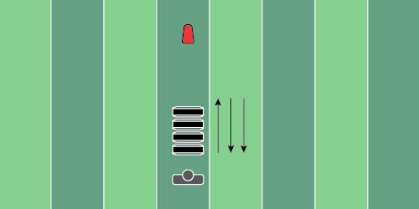
Figure 2.11

Step Bag Change Direction Drill

Equipment Needed: Step over bags

Purpose: Practice driving the knees up while running.

Required Players: 1

Required Coaches: 1

Description: (1) The running back should start at the bottom of the step-over bags. From here, the coach will blow the whistle to start the drill and work toward the end of the step-over bags. (2) The coach will blow the whistle, having the player change directions to the other end of the step bags (3) The player should go back and forth several times before the coach whistles the player to run out of the step bags. Finish under a chute or make a cut, away from a bag.
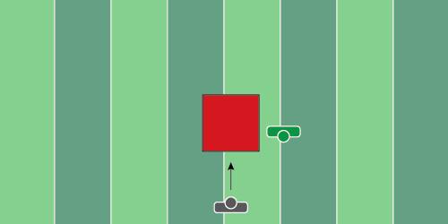
Figure 2.12

Goal Line Diving Drill

Equipment Needed: Landing pads or step over bags

Purpose: Protecting the football on contact while diving for a touchdown.

Required Players: 1

Required Coaches: 1

Description: (1) The running back should start 5 yards before the landing pad. When the coach blows the whistle, the player will run as fast as he can and dive through the air. (2) The coach should attempt to hit the player with a bag or punch the ball out. The running back should focus on absorbing the contact while maintaining ball security throughout the entire process.

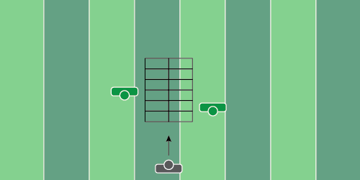
Figure 2.13

Rope Ladder Drill

Equipment Needed: Rope Ladder

Purpose: High knees while fighting off defenders and maintaining ball security.

Required Players: 1

Required Coaches: 1

Description: (1) The running back should start at the beginning of the rope ladder. When the coach says “go” the running back will go through the rope ladder, one foot in each square. (2) While the running back is moving through the ladder, the coach should attempt to dislodge the football from the running back.

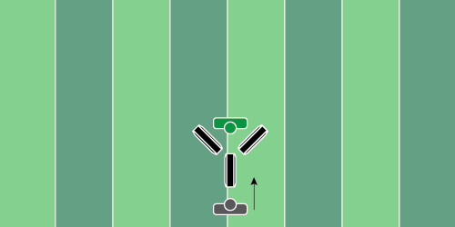
Figure 2.14

Running Back Blocking Drill

Equipment Needed: Step over bags, hand shields

Purpose: Practice making contact with a wide base and driving through the defender.

Required Players: 1

Required Coaches: 1

Description: (1) The running back should start at the normal formation depth. When the coach says “go”, the running back will move toward the line of scrimmage. (2) The running back will make contact under the chute with a coach who will be holding a hand shield, driving him backward.

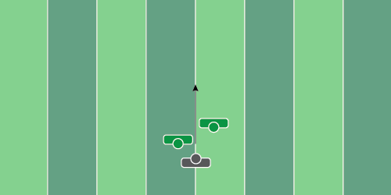
Figure 2.15

Ball Security Circuit Drill

Equipment Needed: Players/Coaches

Purpose: Working ball security in all phases of contact.

Required Players: 1

Required Coaches: 2

Description: (1) The running back should start on the ground. When the coach says “go”, the running back will get up from the ground and move through the gauntlet of coaches trying to strip the ball. (2) Coaches should try to punch the ball out as soon as the player starts to get up from the ground, as well as when they start to accelerate forward.

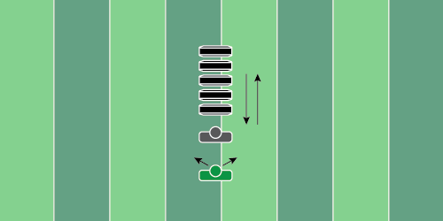
Figure 2.16

High Knee Transition Drill

Equipment Needed: Step over bags

Purpose: Transitioning with high knees and reacting off defensive movements.

Required Players: 1

Required Coaches: 1

Description: (1) The running back should start the drill by working to one end of the bags, then work back to the start. (2) Once the player has gone down and back, the coach should point the running back in a direction to break to.
WIDE RECEIVERS
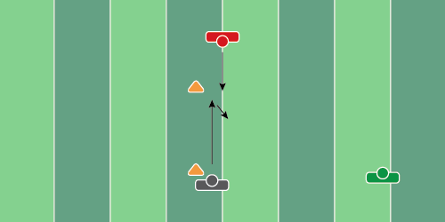
Figure 3.1

Hitch Compete Drill

Equipment Needed: Players/Coaches

Purpose: Competing and fighting for the football on a quick hitch.

Required Players: 2

Required Coaches: 1

Description: (1) The wide receiver will run a 5-yard hitch. (2) The coach will throw the football to the wide receiver (3) As the ball is thrown, the defensive player should move toward the WR, trying to intercept it or knock it out of his hands.

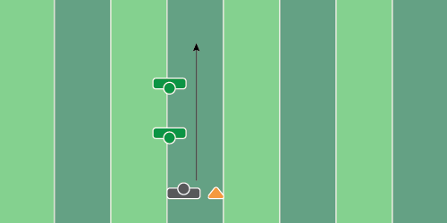
Figure 3.2

Dip & Chop Drill

Equipment Needed: Hand shield & arm shield

Purpose: Working on the different phases of running a vertical route.

Required Players: 1

Required Coaches: 2

Description: (1) The wide receiver should start by running straight toward the 2 coaches that are about 5 yards apart from each other. (2) The wide receiver should dip on the first coach who is holding a hand shield. (3) The WR should then move straight toward the second coach and chop their hand and stack back on top.

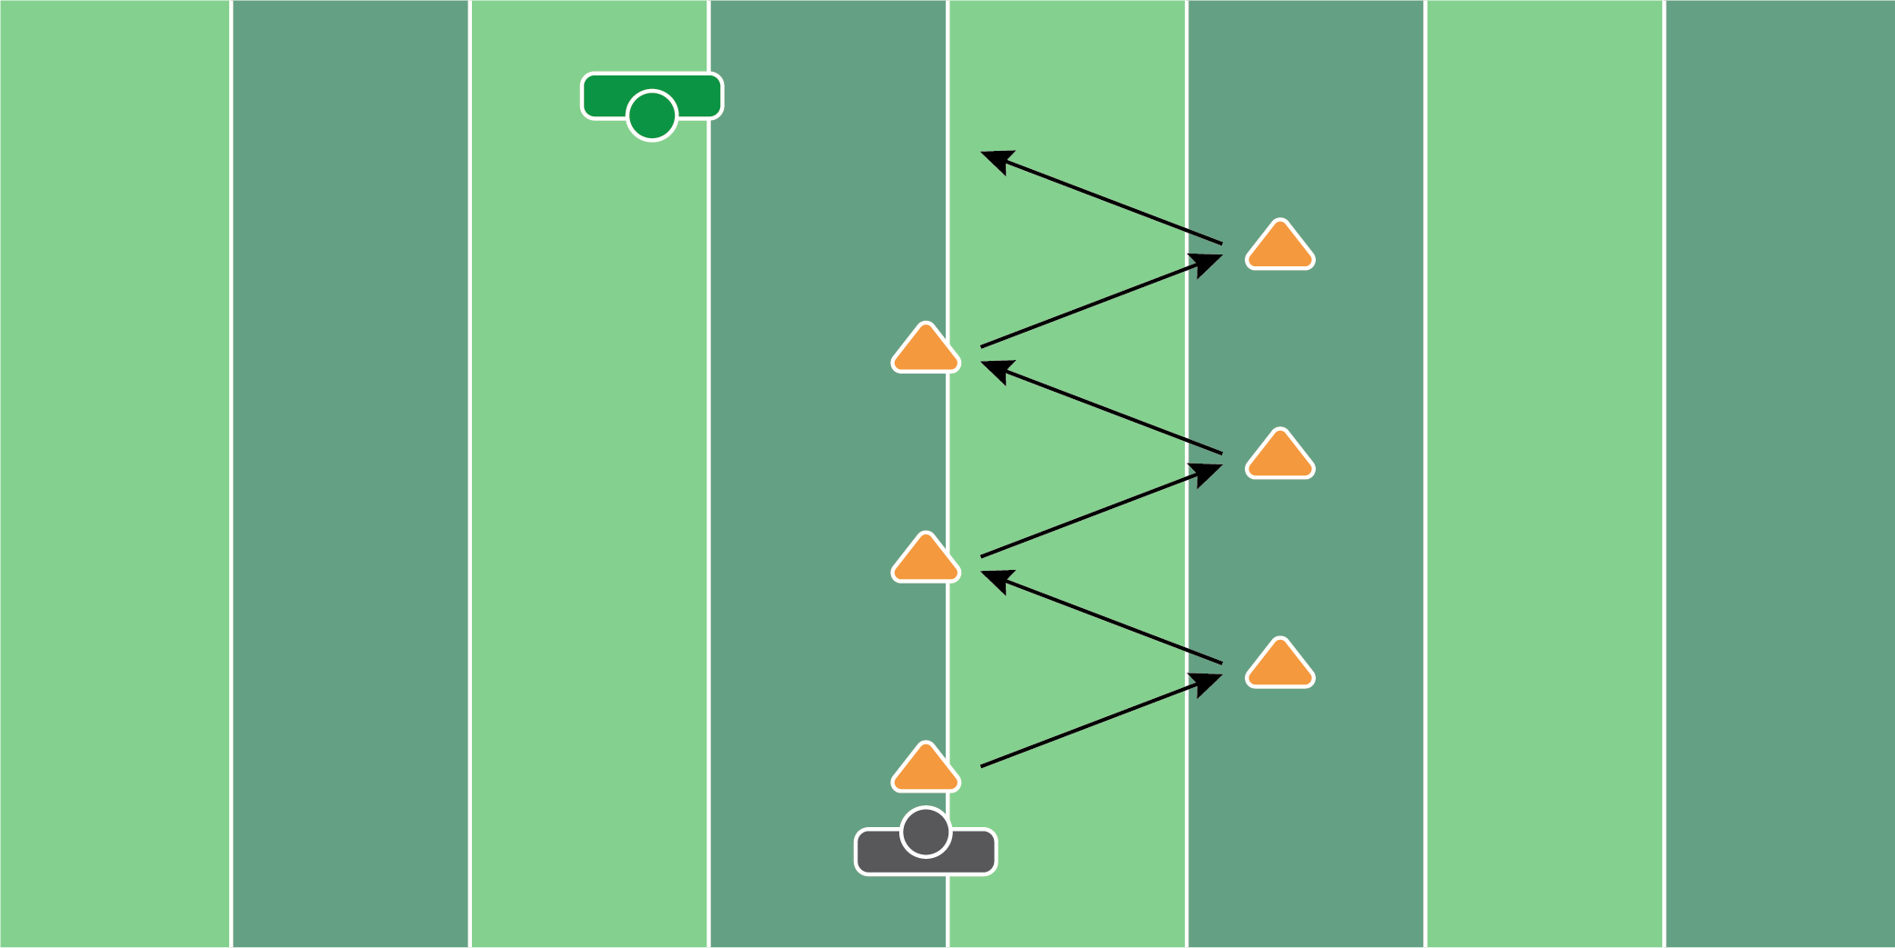
Figure 3.3

5 Cone Transition Drill

Equipment Needed: 5 cones

Purpose: Learning to transition out of breaks.

Required Players: 1

Required Coaches: 1 (or 1 player)

Description: (1) The wide receiver will run to each cone and transition to the next cone (2) At each cone, the player should run out of their break as fast as possible. (3) Finish the drill by catching a football from a coach or player.
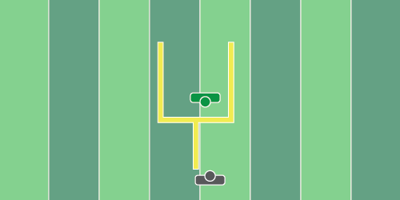
Figure 3.4

Marked Ball Drill

Equipment Needed: Players/Coaches

Purpose: Focus on bringing the eyes to the football.

Required Players: 1

Required Coaches: 1

Description: (1) The wide receiver will lineup a yard outside of the field goal post. This is to act as a defender trailing the receiver. (2) The coach should throw the football high, chest level, and low so the receiver tracks the ball at different levels. (3) For added difficulty, write numbers on the football so the player has to find them.

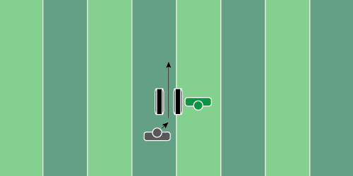
Figure 3.5

Squeeze Drill

Equipment Needed: Pop up dummies or step over bags (standing up)

Purpose: Teaching the receiver to get as skinny as possible when playing against man coverage.

Required Players: 1

Required Coaches: 2

Description: (1) The wide receiver will release in between the two bags and turn their shoulders slightly to get skinny. The purpose of this drill is to clear the defensive back’s hands and work to stack on top of them (2) Once the WR gets through the popup dummies, chop the hand of the final coach and sprint for 10 yards.

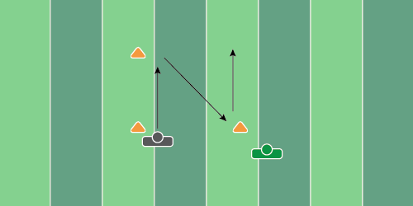
Figure 3.6

Hitch & Go Drill

Equipment Needed: Cones

Purpose: Catching the football from a comeback & tracking the deep ball.

Required Players: 1

Required Coaches: 1

Description: (1) The wide receiver will run a 5-yard hitch and work back to the coach. (2) Once the ball is caught, the player will give the ball back to the coach, who will throw a vertical/fade route to that same player. This speed can be done at full speed or ½ speed.

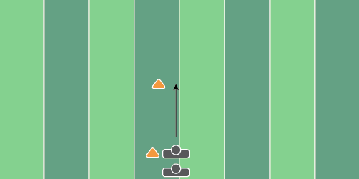
Figure 3.7

Stance & Start With Bands

Equipment Needed: Bands

Purpose: Resistance training with bands to work on explosiveness.

Required Players: 2

Required Coaches: 0

Description: (1) The wide receiver will line up in their stance, with a band around their waist. Once the coach says “go”, the player will explode off the line of scrimmage and run for 10 yards, while the second player provides resistance on the band.

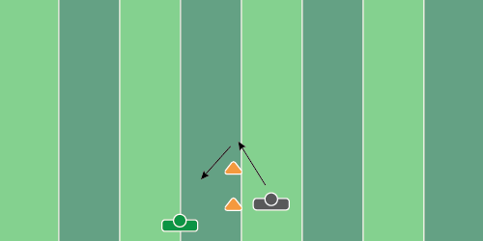
Figure 3.8

Turn & Locate Drill

Equipment Needed: Players/Coaches

Purpose: Locating the football after coming out of the break.

Required Players: 1

Required Coaches: 1

Description: (1) The wide receiver will start facing away from the coach. When the coach says “go” the receiver will run 2-3 steps before planting and turning back toward the coach. (2) The coach will throw the football as the player puts his foot in the ground on the last step. The key is to make the WR turn his head as fast as possible.

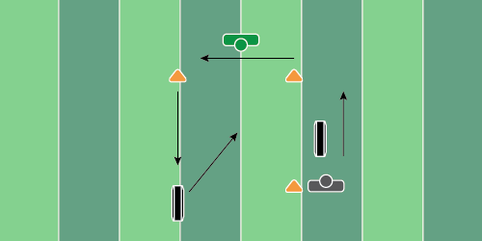
Figure 3.9

4 Corner Drill

Equipment Needed: Popup dummies & cones

Purpose: Works on release, cuts, and separation at the top of the break.

Required Players: 1

Required Coaches: 1

Description: (1) The wide receiver will start by making a move on the popup dummy and getting an inside/outside release. (2) At the next two cones, break left (3) At the final popup dummy, press into it and use your elbow to create separation, before working back to the center of the box to catch the football from the coach.

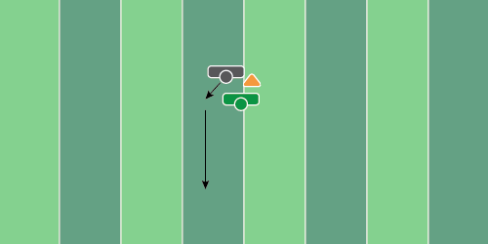
Figure 3.10

Vertical Positioning Drill

Equipment Needed: Players/Coaches

Purpose: Competing and fighting for positioning at the top of a route.

Required Players: 1

Required Coaches: 2

Description: (1) The wide receiver will run a vertical route with an outside release. (2) While the receiver is running down the field, the coach will use his near hand to disrupt the wide receiver. The receiver must replace the coach’s hand and try to stack on top of the coach. (3) Once the player is 20-25 yards down the field, throw the football to simulate a “go” route.

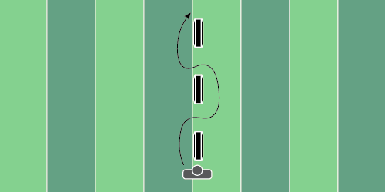
Figure 3.11

Chop/Rip Drill

Equipment Needed: Pop up dummies or step over bags

Purpose: Teaching the player to chop and rip past a defender.

Required Players: 1

Required Coaches: 0 (3 if using step over bags)

Description: (1) The wide receiver will start at the bottom of the bags or dummies. (2) Start the drill by moving forward, and chopping the bag with one hand, and ripping in the opposite direction. Do this 3 times and finish with a 10-yard sprint.

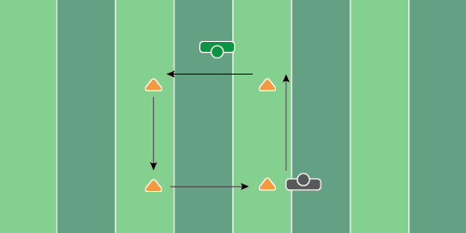
Figure 3.12

Box Drill

Equipment Needed: 4 Cones

Purpose: Accelerate and decelerate out of each break at the 4 cones.

Required Players: 1

Required Coaches: 1

Description: (1) The wide receiver will start by running straight to the first cone. Upon each cone, the WR should put their foot in the ground and cut to the next cone. Repeat this process for the first 3 cuts. (2) On the final break, the coach should deliver the football to the player crossing.

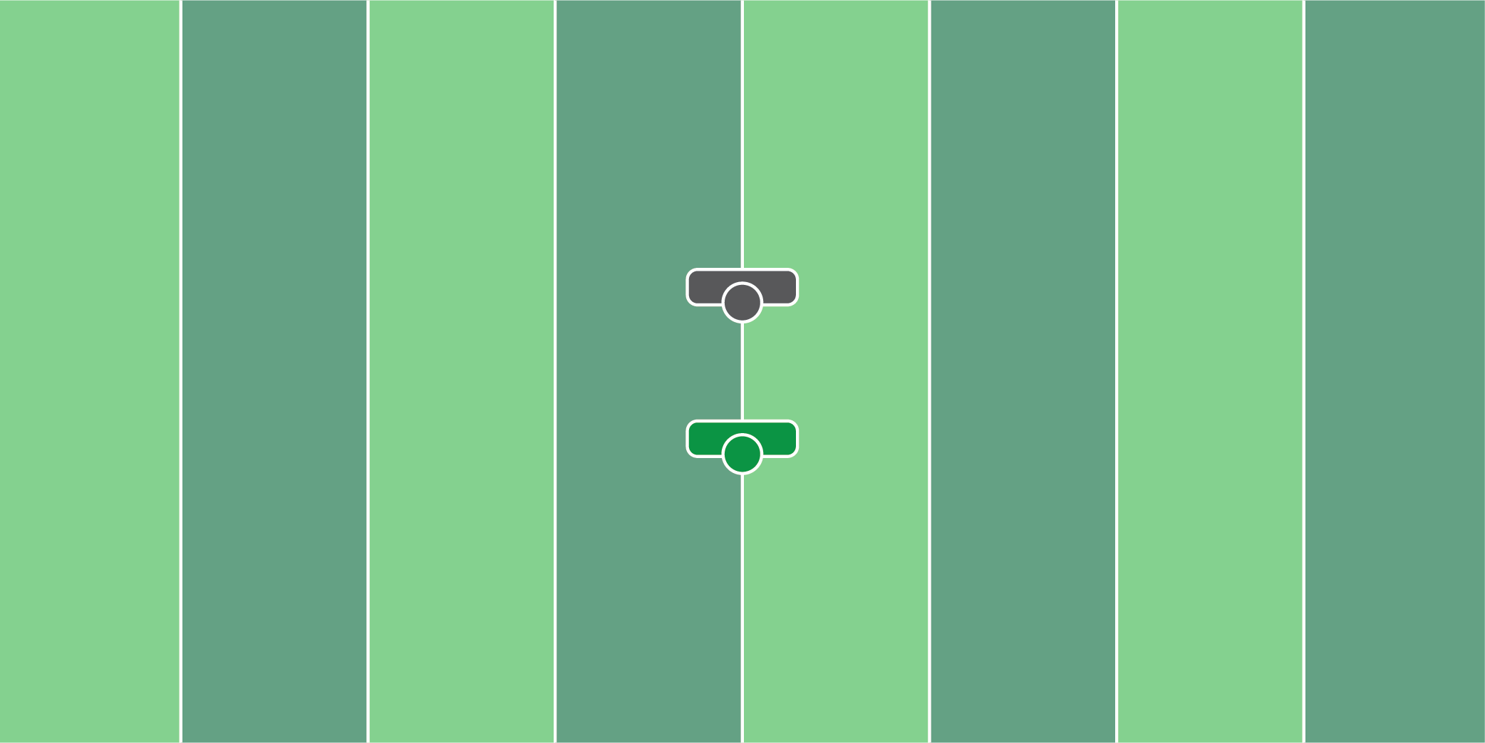
Figure 3.13

High Point Drill

Equipment Needed: Players/Coaches

Purpose: Practice jumping as high as possible and catching the football at its highest point.

Required Players: 1

Required Coaches: 1

Description: (1) The wide receiver will stand in place and react to the coach throwing the football. (2) The coach will throw the football straight up in the air, out of reach of the receiver so they have to jump and catch it.

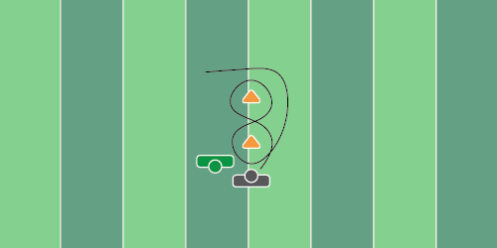
Figure 3.14

Figure 8 Drill

Equipment Needed: 2 Cones

Purpose: Practice running in and out of breaks.

Required Players: 1

Required Coaches: 1

Description: (1) The wide receiver will start by running in the shape of the number 8 around the cones. (2) Once the receiver gets completely around the cone they started at, proceed to the next cone and break right/left where the coach will throw the football.

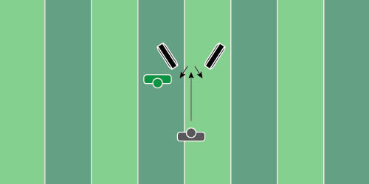
Figure 3.15

Comeback Numbered Drill

Equipment Needed: 2 Step over bags

Purpose: Break out of the route and snap the head around as quickly as possible.

Required Players: 1

Required Coaches: 1 (2 if you want to add a catch)

Description: (1) The wide receiver will start by running straight between the two step-over bags and work back toward the coach. (2) Once the receiver starts to work back toward the coach, the coach will hold up fingers, which the receiver has to recite back to the coach. (3) The second coach will throw the ball to the receiver as he gets his head around.

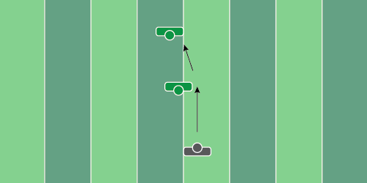
Figure 3.16

Contested Catch Drill

Equipment Needed: Hand shields

Purpose: Learning how to high point the football while absorbing contact.

Required Players: 1

Required Coaches: 3 (or 2 coaches & 1 player)

Description: (1) The wide receiver will run straight and chop the outside hand of the first coach, working back to the stack. (2) Once the WR clears the first coach, he will then look back for the ball and jump up to catch it. (3) When the ball is in the air, the coach closest to the ball will hit the player with the hand shield, making contact with the receiver.

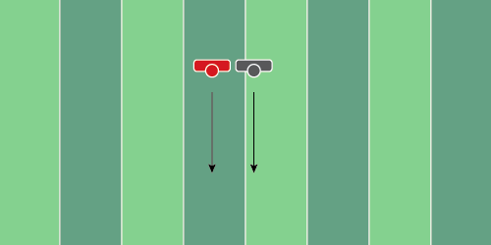
Figure 3.17

Hand Replace Drill

Equipment Needed: Players/Coaches

Purpose: Learning to replace the hand of the defensive back when pressing vertically.

Required Players: 2

Required Coaches: 0

Description: (1) The wide receiver will start by running vertically. The second player will run side by side the WR, placing his hand on the shoulder or hip of the WR. (2) Once the WR feels the hand of the defender on his shoulder or hip, the WR should replace the hand to make sure he is in front. (3) Repeat this for 20 yards.

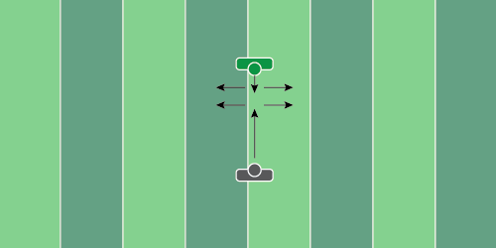
Figure 3.18

Stalk Block Mirror Drill

Equipment Needed: Players/Coaches

Purpose: Mirror the movements of the defender to position yourself properly to block them.

Required Players: 2

Required Coaches: 0

Description: (1) The wide receiver should start 5-10 yards away from the defensive player. When the coach says “go” run toward the defensive player. (2) Once the offensive player reaches the defensive player, the defensive player will begin to shuffle left and right. (3) The offensive player will then move wherever the defensive player goes. (4) This is a footwork drill, so the offensive player doesn’t need to put hands on the defensive player.

OFFENSIVE
LINE
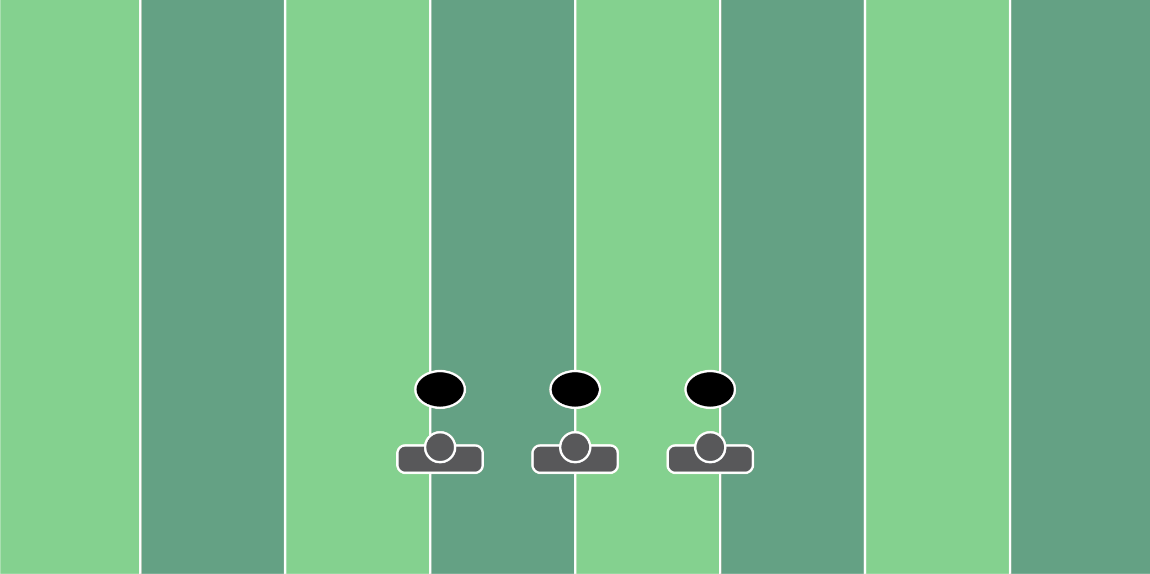
Figure 4.1

Med Ball Set Drill

Equipment Needed: Medicine Balls

Purpose: Training hand speed and quickness when setting.

Required Players: 1

Required Coaches: 0

Description: (1) The offensive lineman will start in their stance with two hands on the medicine ball. (2) When the coach says “go”, he will pop up in his set and have the medicine ball at chest height. (3) Repeat this process multiple times to work on hand speed and quick sets.

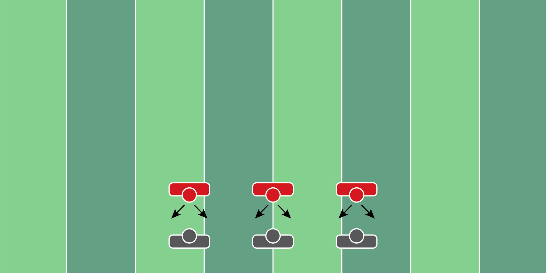
Figure 4.2

Passing Twist Drill

Equipment Needed: Players/Coaches

Purpose: Training hands and eyes to pass a twist or a stunt and reset the feet.

Required Players: 2

Required Coaches: 0

Description: (1) The offensive lineman will start in their stance, with their hands set on the defensive player. (2) When the coach says “go”, the offensive lineman will pass the defensive player to one side, and reset as if they’re going to block another player on a twist.
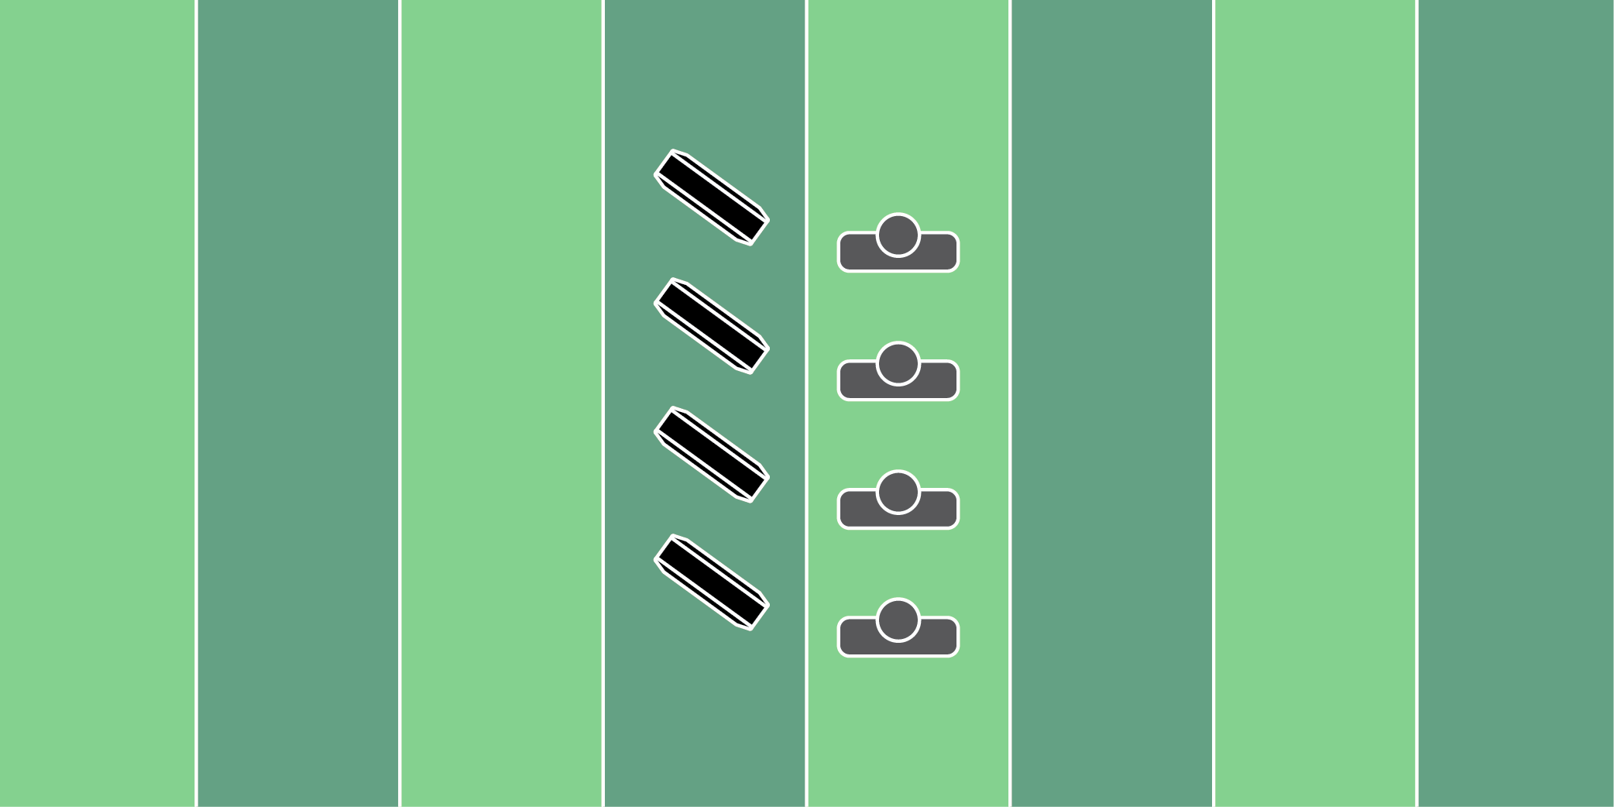
Figure 4.3

PVC T Set Drill

Equipment Needed: PVC pipe & step over bags

Purpose: Learning proper width and depth on a set.

Required Players: 1

Required Coaches: 0

Description: (1) The offensive lineman will start to one side of the “T” shaped PVC pipe, in their stance. When the coach says “go”, the offensive lineman should take one step over the PVC pipe at the proper depth and width that the coach would like. (2) After 3-5 reps, then remove the PVC pipes and have the players straddle the step-over bags and work to the end.

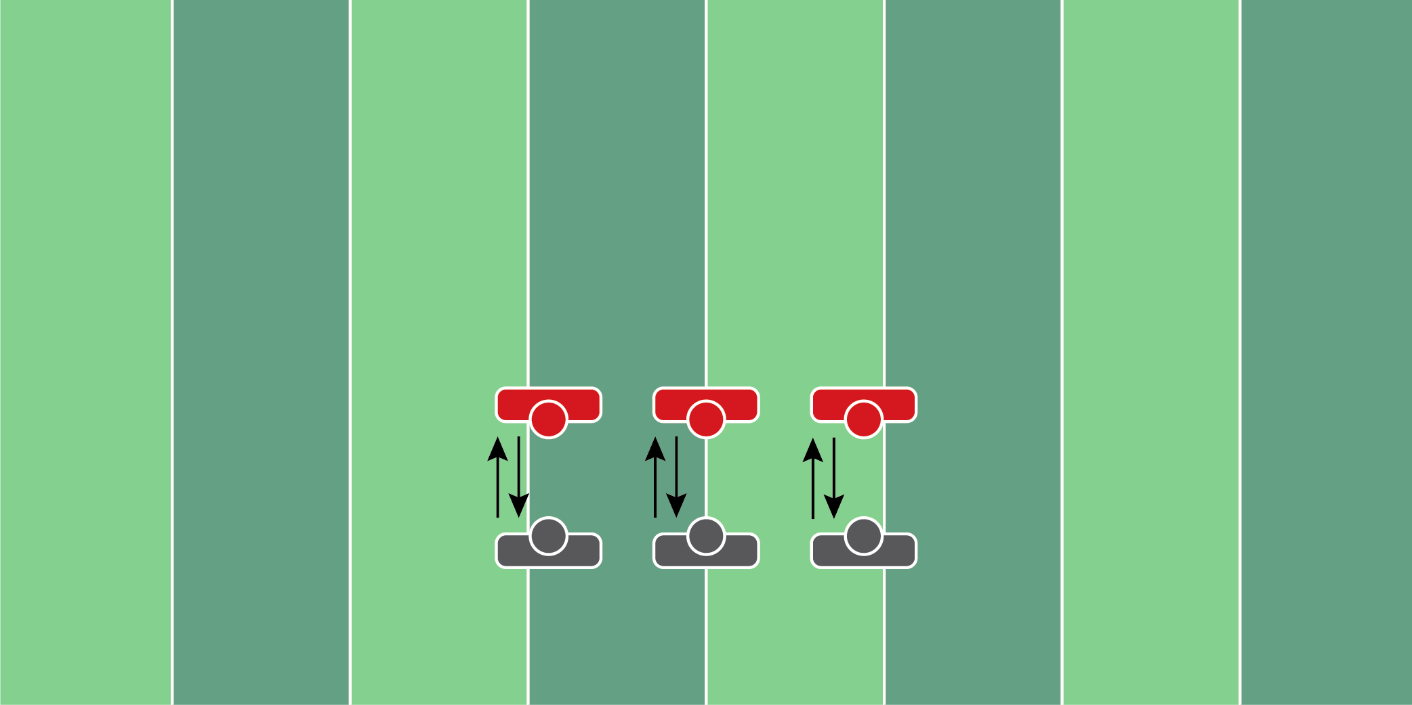
Figure 4.4

Bull Rush Reset Drill

Equipment Needed: Players/Coaches

Purpose: Training to reset the hands and feet on a bull rush.

Required Players: 2

Required Coaches: 0

Description: (1) The offensive lineman and defensive player should start engaged. When the coach says “go”, the defensive player should push as hard as possible on the offensive player. (2) Once the offensive player feels pressure, he should take 1-2 hop steps backward to regather their feet and push forward. (3) Once the offensive player pushes back, the defensive player then should try to pull on the offensive player to try to throw them off balance. The key to the drill is to stay balanced in all of the push and pull phases.

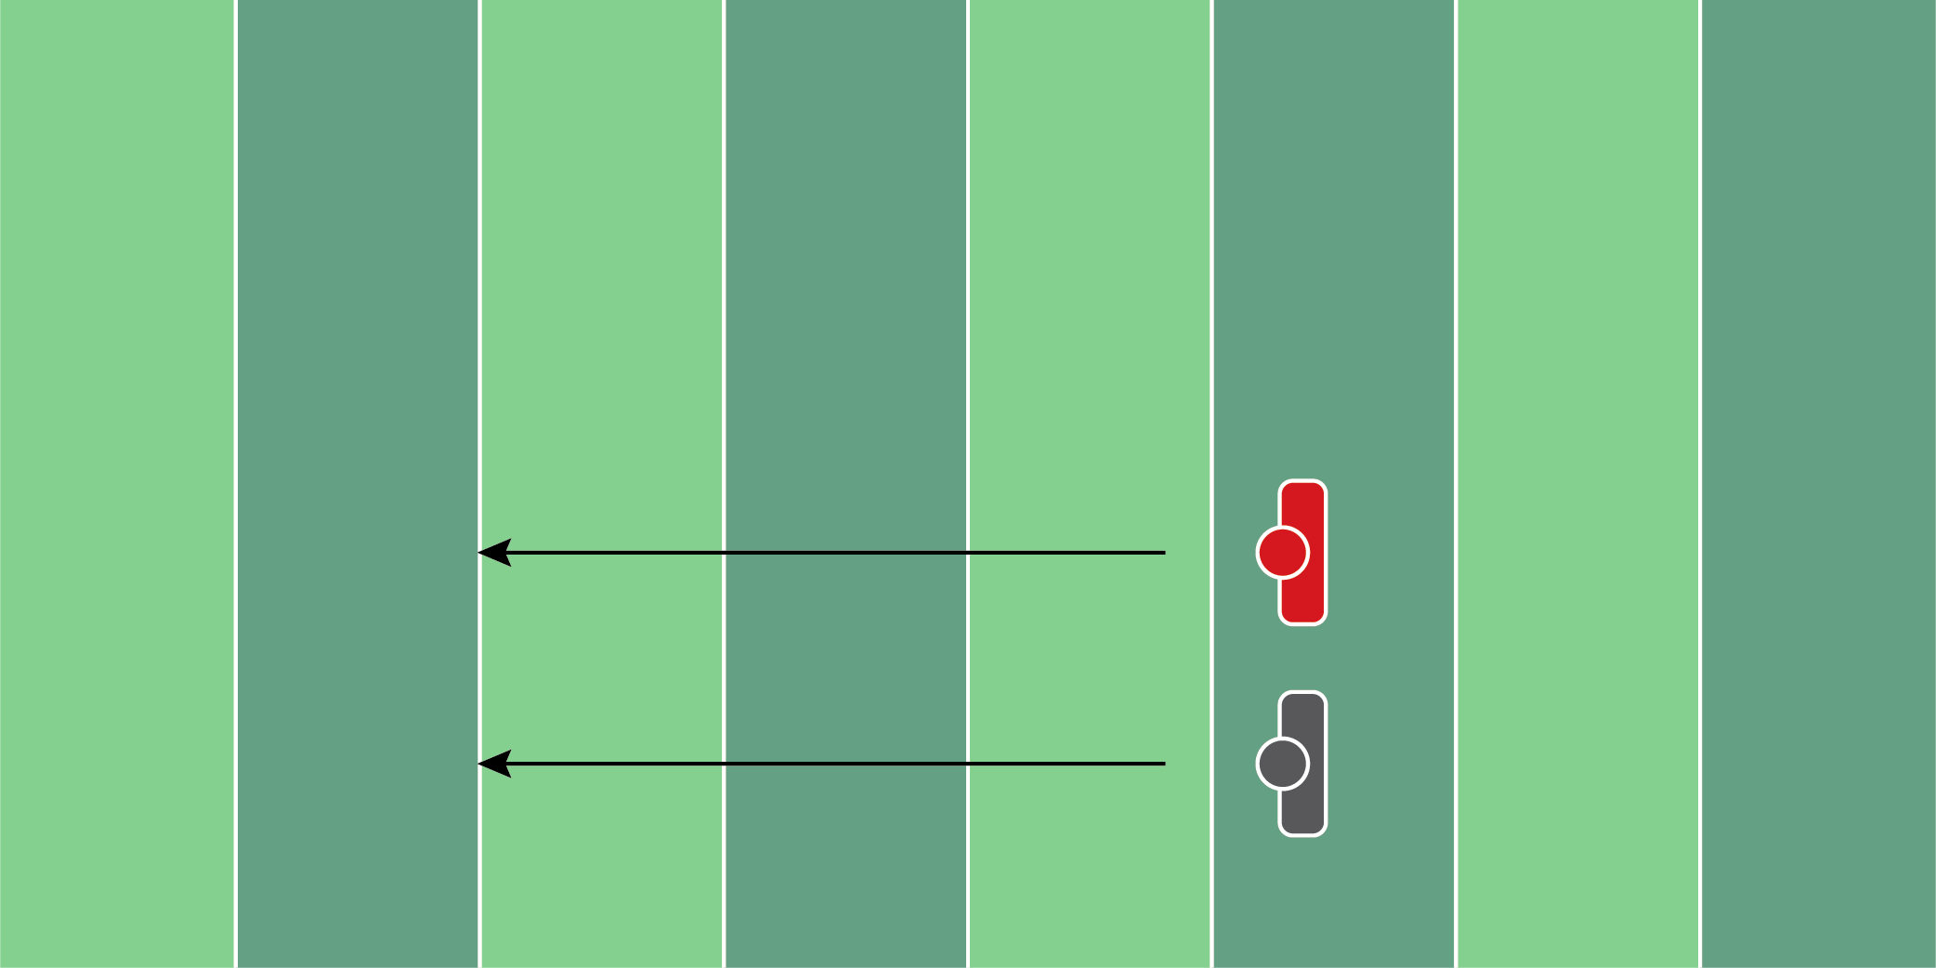
Figure 4.5

Line Drill

Equipment Needed: Players/Coaches

Purpose: Training hand placement on edge rushers.

Required Players: 2

Required Coaches: 0

Description: (1) The offensive lineman will start in a two-point stance. The defensive player will move at ¼ speed down the yard line. (2) Once the defensive player starts moving, the offensive lineman will move laterally with the defensive player, hitting their shoulder/breastplate every 3-4 seconds. (3) Continue this movement all the way to the sideline.

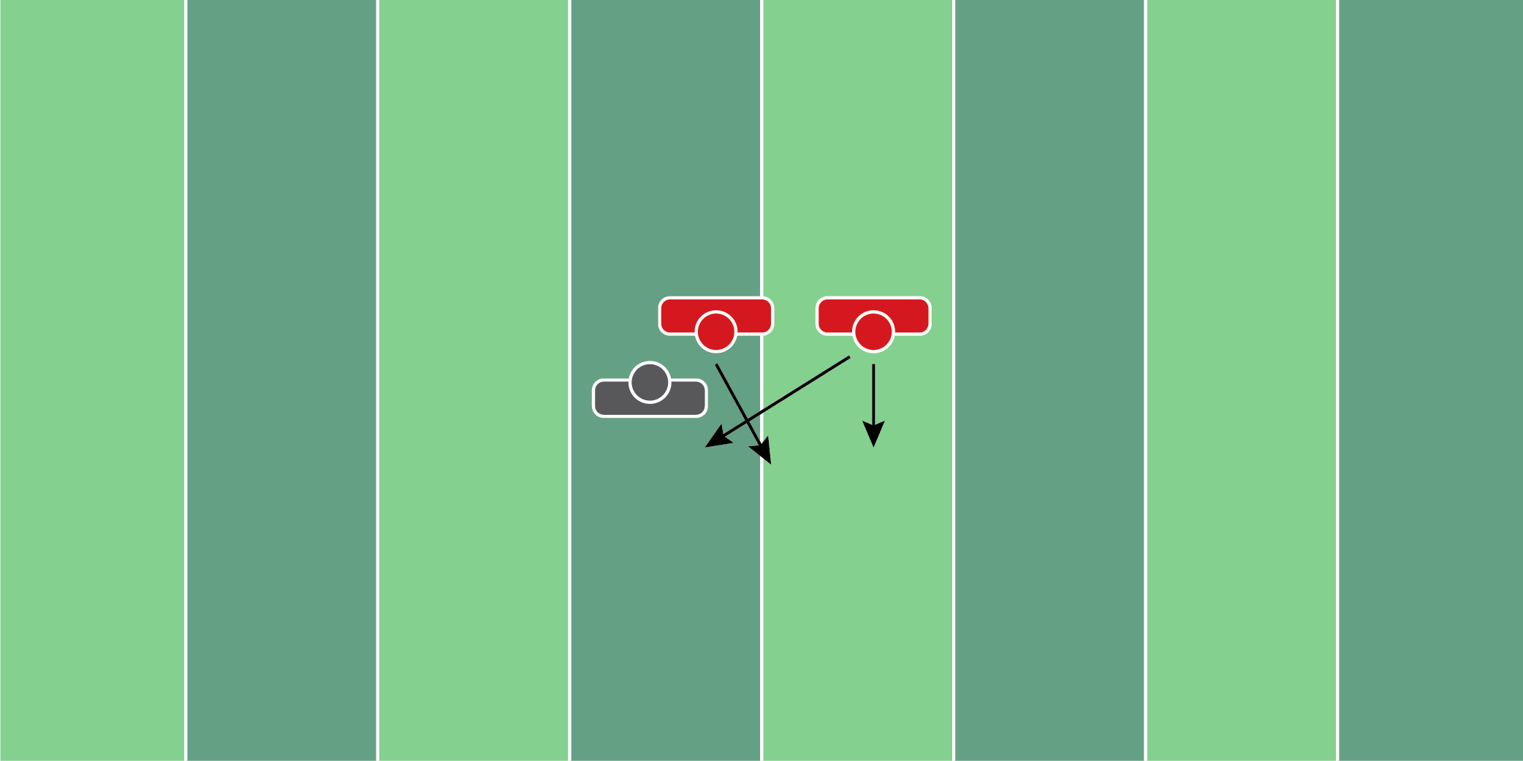
Figure 4.6

Twist Set Drill

Equipment Needed: Players/Coaches

Purpose: Training the hands and eyes to prepare for a twist.

Required Players: 3

Required Coaches: 0

Description: (1) The offensive lineman will start in their stance. When the coach says “go”, the 2 defensive players will move forward. (2) The coach should have the defensive players mix up rushing upfield and twisting. (3) If the defensive players stay straight, the offensive lineman should continue to kick to him. If the defensive player twists back in, he should pass him off and take the twisting player.

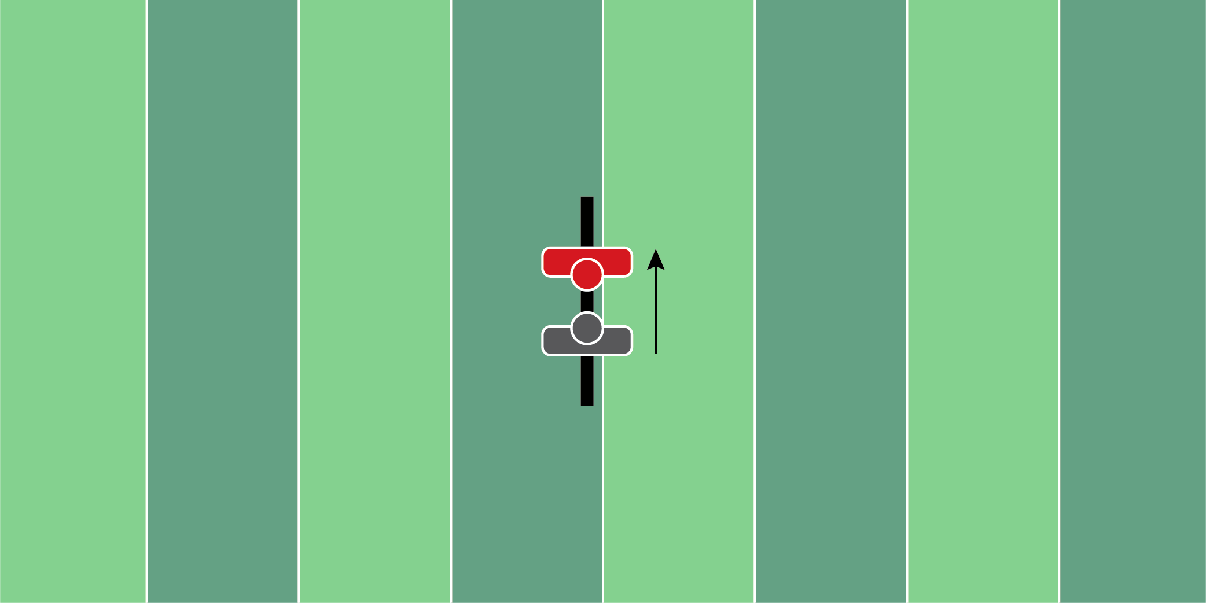
Figure 4.7

Post Contact Finish Drill

Equipment Needed: Players/Coaches

Purpose: Working on driving feet after initial contact has been made.

Required Players: 2

Required Coaches: 0

Description: (1) The offensive lineman and defensive player should start engaged. (2) When the coach says “go”, the offensive player should drive the defensive player backward, keeping a wide base throughout the entire process.

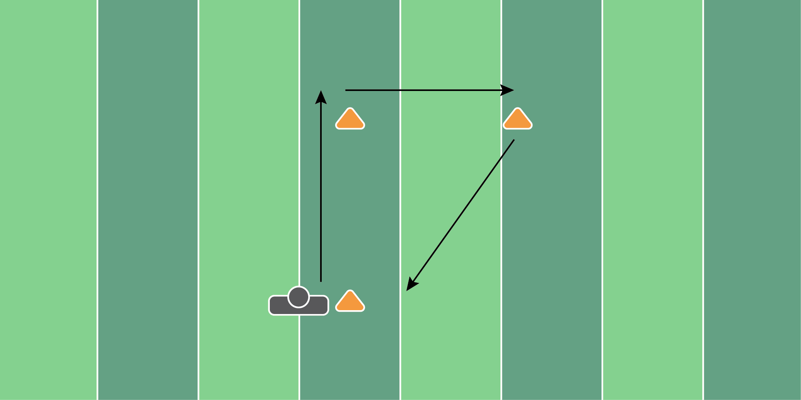
Figure 4.8

Triangle Drill

Equipment Needed: Players/Coaches

Purpose: Training footwork in a fast-paced drill.

Required Players: 1

Required Coaches: 0

Description: (1) The offensive lineman should start by working forward with a wide base. (2) Once the lineman hits the top of the cone, slide laterally to the next cone. (3) The last part of the drill should be a kick step to the final cone. (4) It's important to have 2 of these drills set up, that way the lineman is working in both directions.

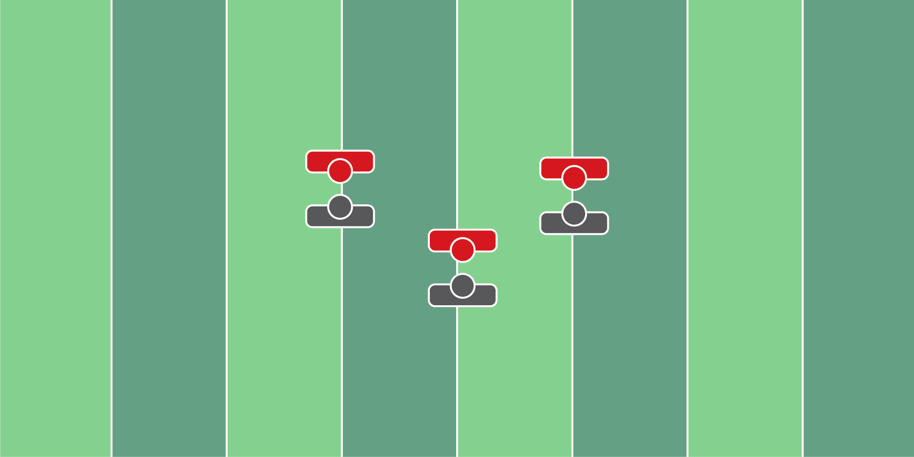
Figure 4.9

Quick Game Control Drill

Equipment Needed: Players/Coaches

Purpose: Teaching offensive lineman to keep the arms of a defensive lineman down during quick game passes.

Required Players: 2

Required Coaches: 0

Description: (1) The offensive lineman and defensive player should start engaged. (2) The defensive lineman should jump in the air as high as possible, simulating that he’s trying to knock down a pass from the quarterback. (3) As the defensive lineman jumps up, the offensive lineman should grab the chest plate of the defensive lineman and try to keep them grounded.

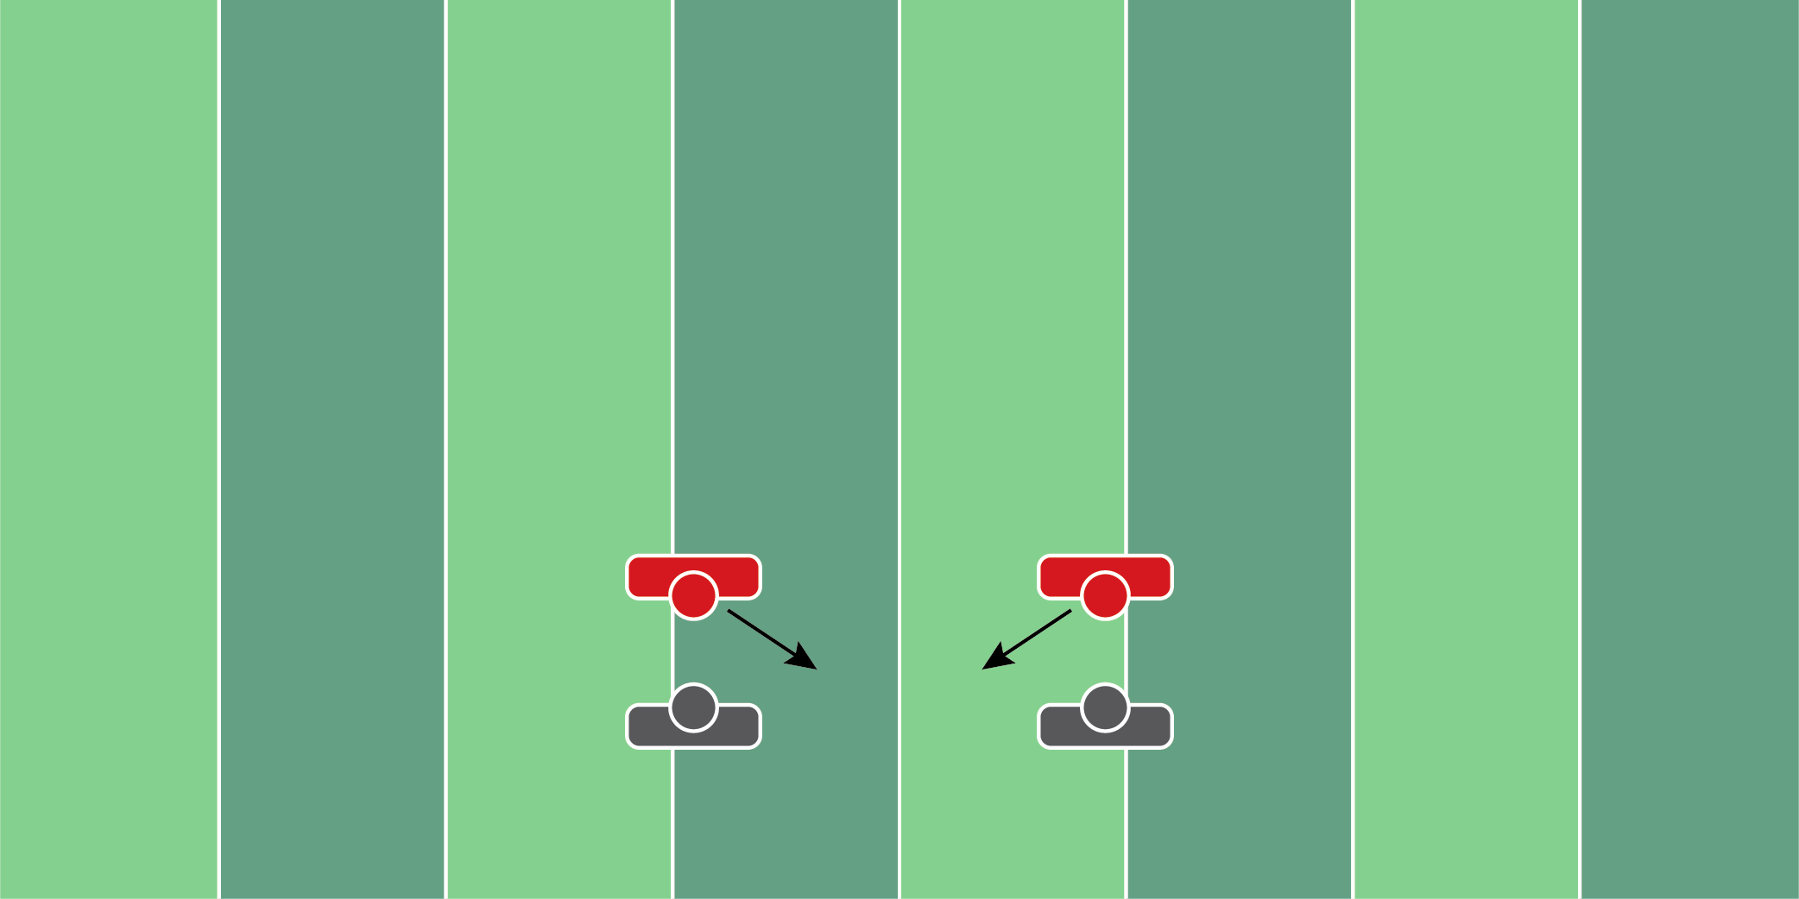
Figure 4.10

Cross Face Drill

Equipment Needed: Players/Coaches

Purpose: Prevent the cross-face from the defensive lineman.

Required Players: 2

Required Coaches: 0

Description: (1) The offensive lineman and defensive player should start engaged. (2) When ready, the defensive lineman should try to rip and cross in front of the offensive lineman. (3) When the defensive lineman starts to cross-face, the offensive lineman should move his feet and maintain contact.

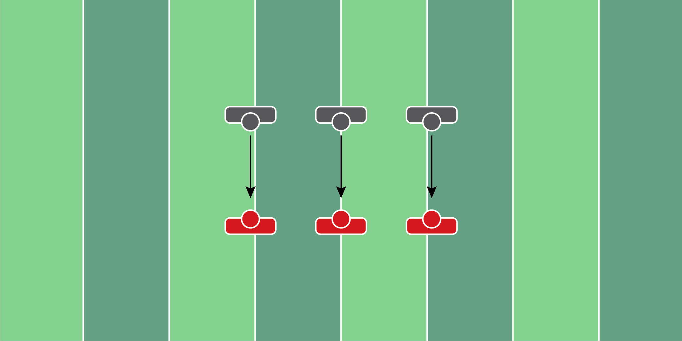
Figure 4.11

Close & Collide Drill

Equipment Needed: Players/Coaches

Purpose: Training to gather and strike from distance.

Required Players: 2

Required Coaches: 0

Description: (1) The offensive lineman and defensive player should start 5 yards apart. (2) When ready, the offensive lineman should shuffle their feet toward the defensive player with a wide base. (3) When contact is made, it’s important to keep the feet moving and bring the hands through contact.

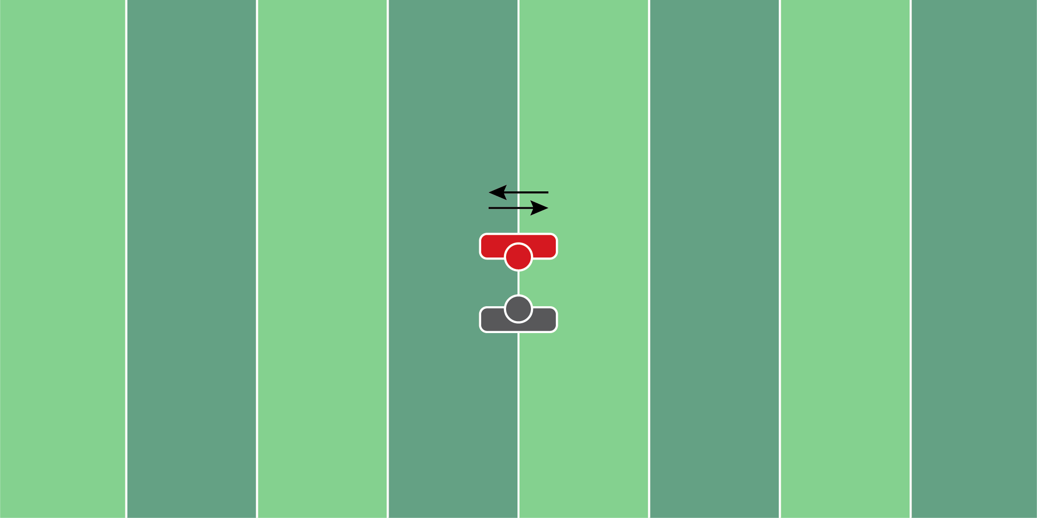
Figure 4.12

Mirror Drill

Equipment Needed: Players/Coaches

Purpose: Mirror drill to match the defensive lineman’s movement.

Required Players: 2

Required Coaches: 0

Description: (1) The offensive lineman and defensive player should start a yard apart from each other. (2) The defensive lineman should shuffle back and forth. (3) The offensive lineman should put his hands behind his back and mirror the movement of the defensive player back and forth.

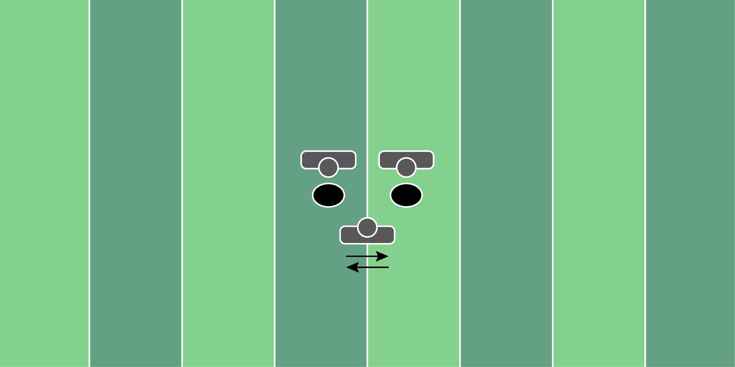
Figure 4.13

Punch Twist Drill

Equipment Needed: Medicine Balls

Purpose: Resetting the hands and feet when punching.

Required Players: 1

Required Coaches: 2 (or 2 players)

Description: (1) The offensive lineman should start a yard away from the first coach. (2) Start by kicking back to the right and punch the medicine ball that is thrown from the coach. (3) Once the ball is punched, the offensive lineman should move laterally to the left and punch the second medicine ball.

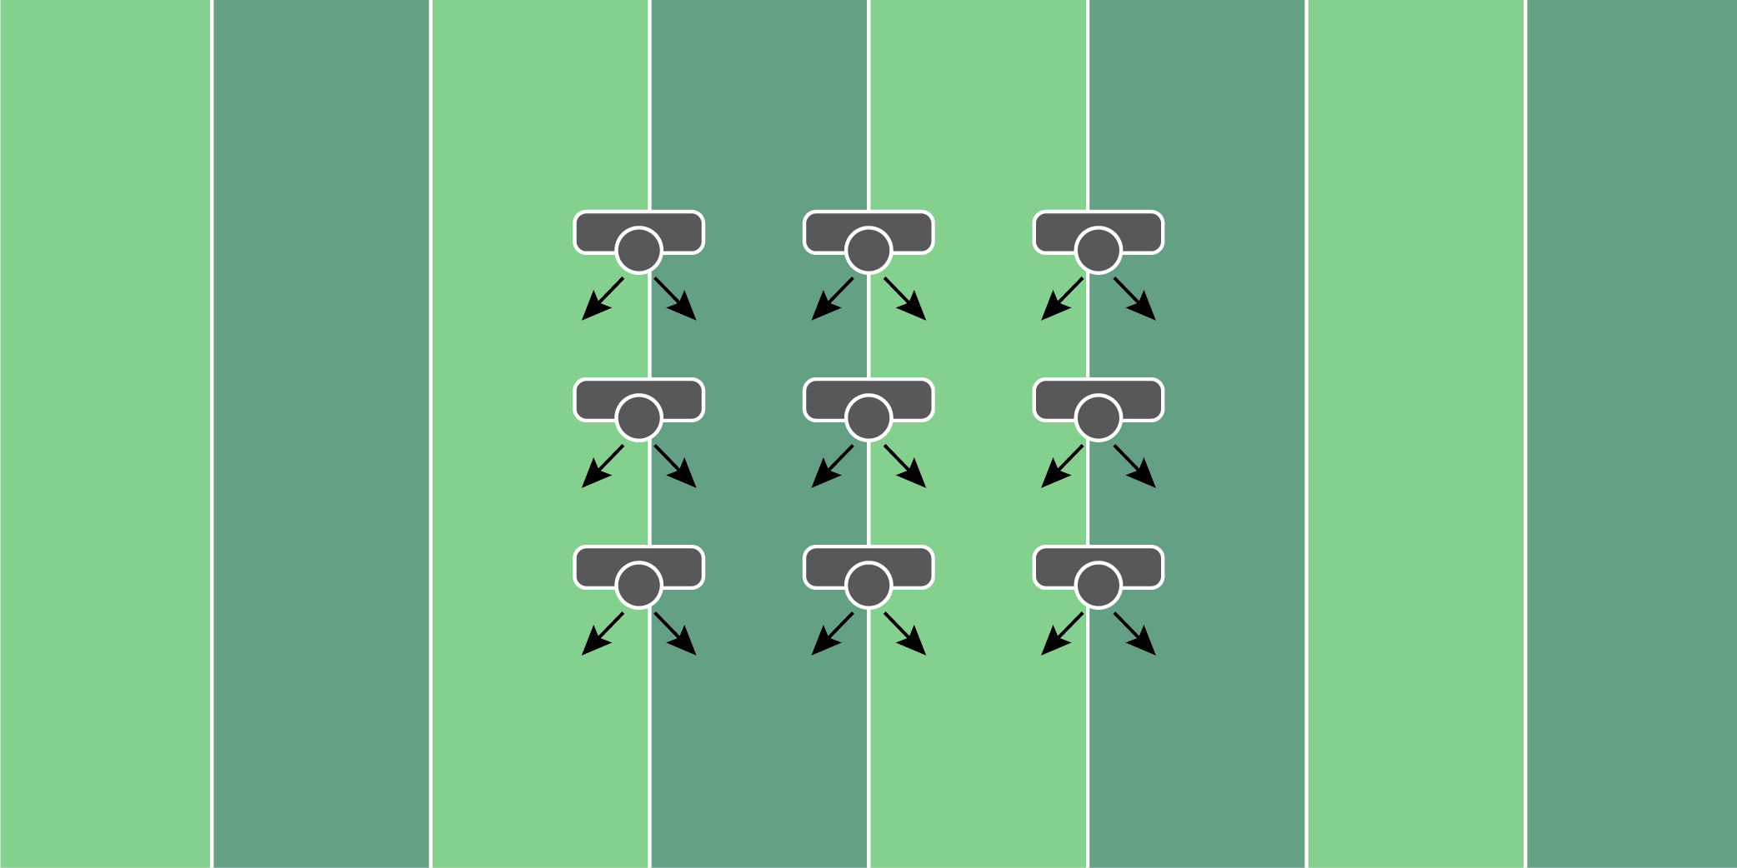
Figure 4.14

First Step Drill

Equipment Needed: Players/Coaches

Purpose: Training the first steps and hand positioning.

Required Players: 1

Required Coaches: 0

Description: (1) The offensive lineman should start in their stance. (2) Once the coach says “go” the offensive lineman should practice taking 3 different types of steps - 1. Down Step 2. Pull Step 3. Kick step. Coaches can vary steps based on the system they run.

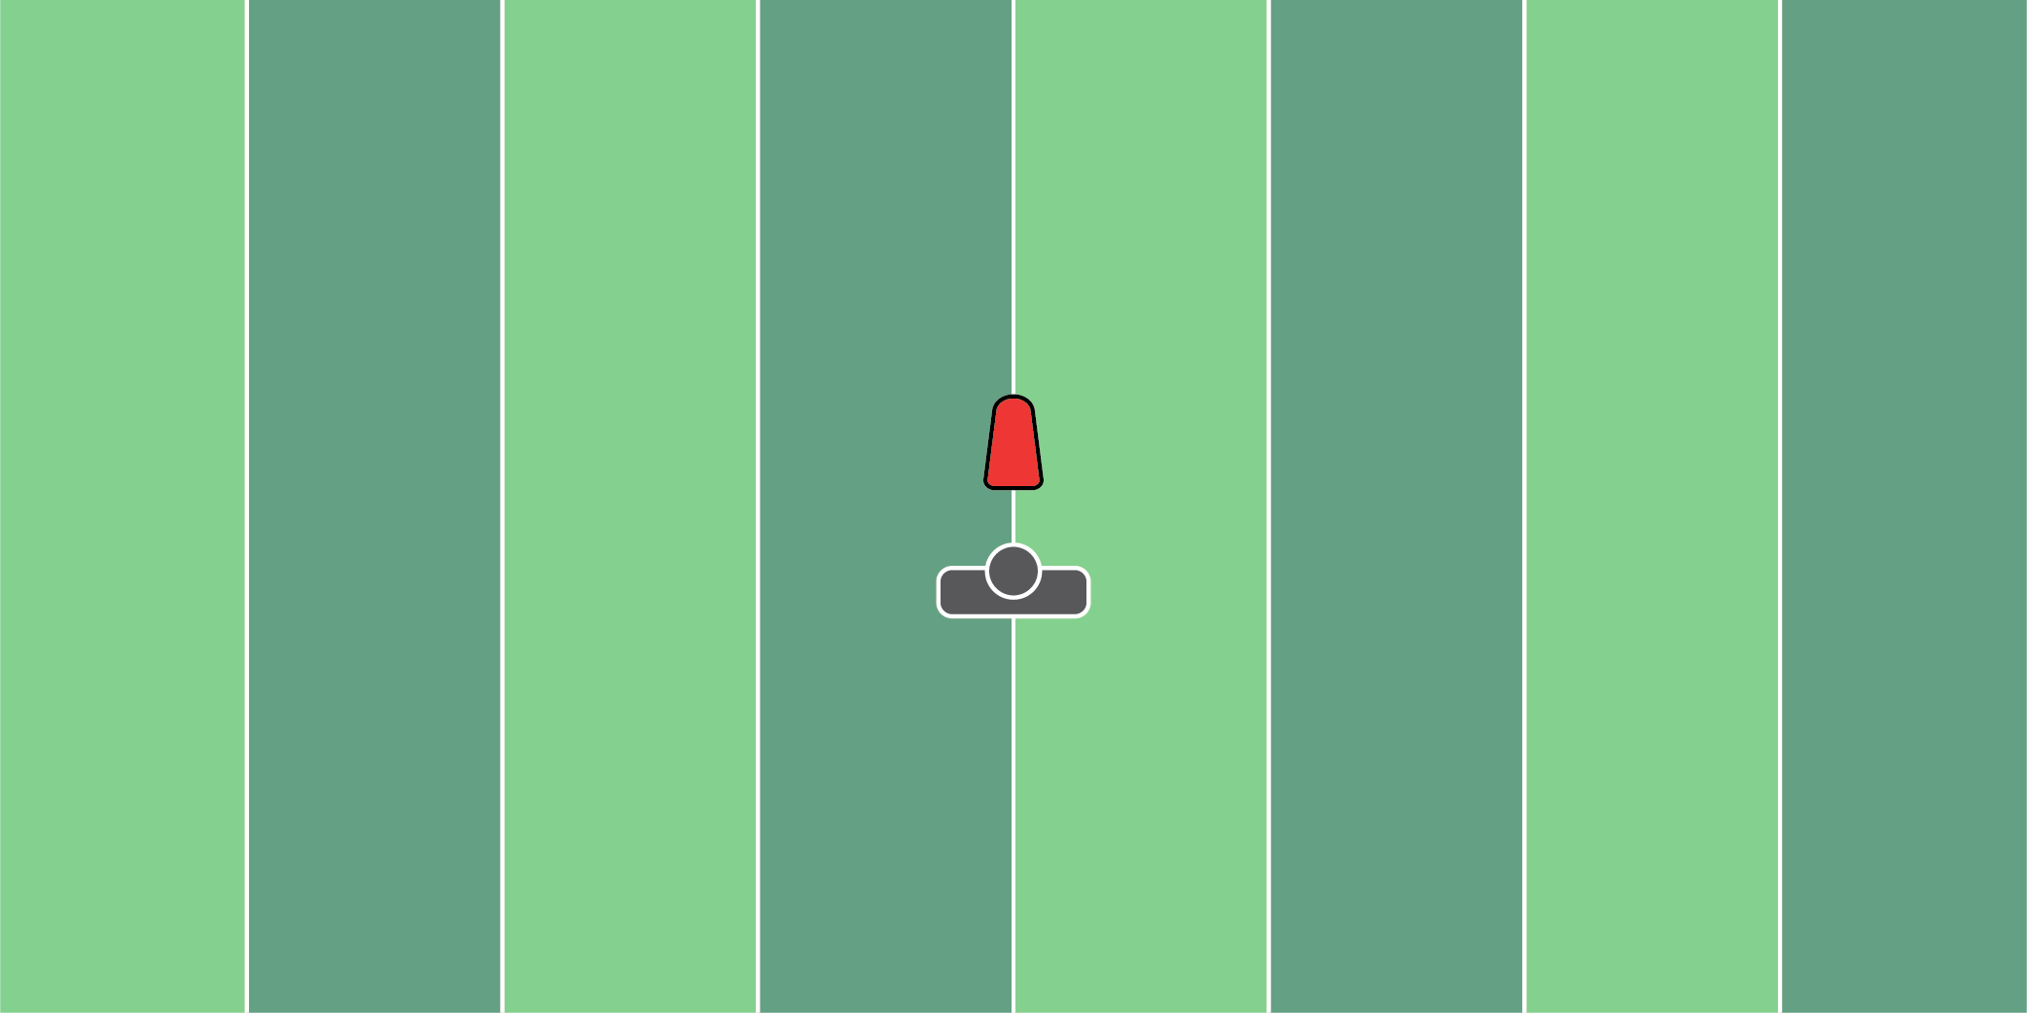
Figure 4.15

Pop Up Dummy Punch Drill

Equipment Needed: Popup dummy

Purpose: Training hand speed and power.

Required Players: 1

Required Coaches: 1

Description: (1) The offensive lineman should start in a good athletic stance, 1 yard away from the popup dummy. (2) The offensive lineman should punch the dummy with controlled force. (3) Once the dummy is punched, the coach should pass the bag back to the offensive lineman as fast as possible. Continue this pass back and forth for 30-40 reps.

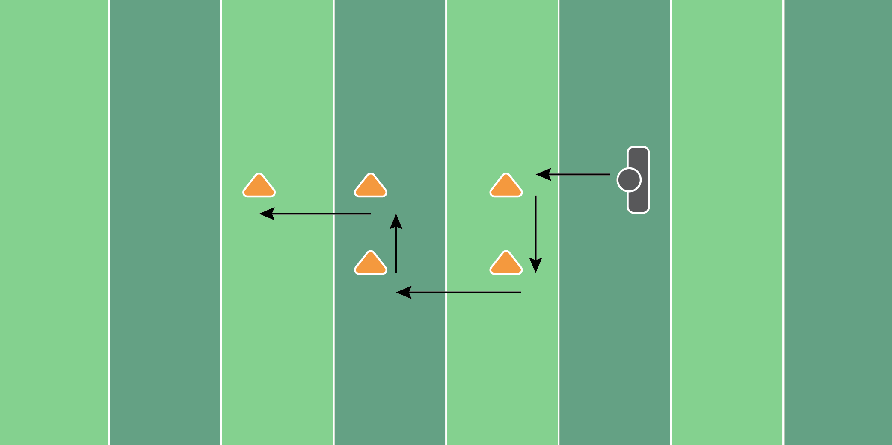
Figure 4.16

Wide Stance Box Drill

Equipment Needed: Cones

Purpose: Training 4-way directional movements.

Required Players: 1

Required Coaches: 0

Description: (1) The offensive lineman should start at the first cone in an athletic stance. (2) When the coach says go, the offensive lineman should follow the pattern detailed above, all with a wide stance. (3) Any backward movement should result in a pass/kick step. Any side or forward movements should have a wide base.

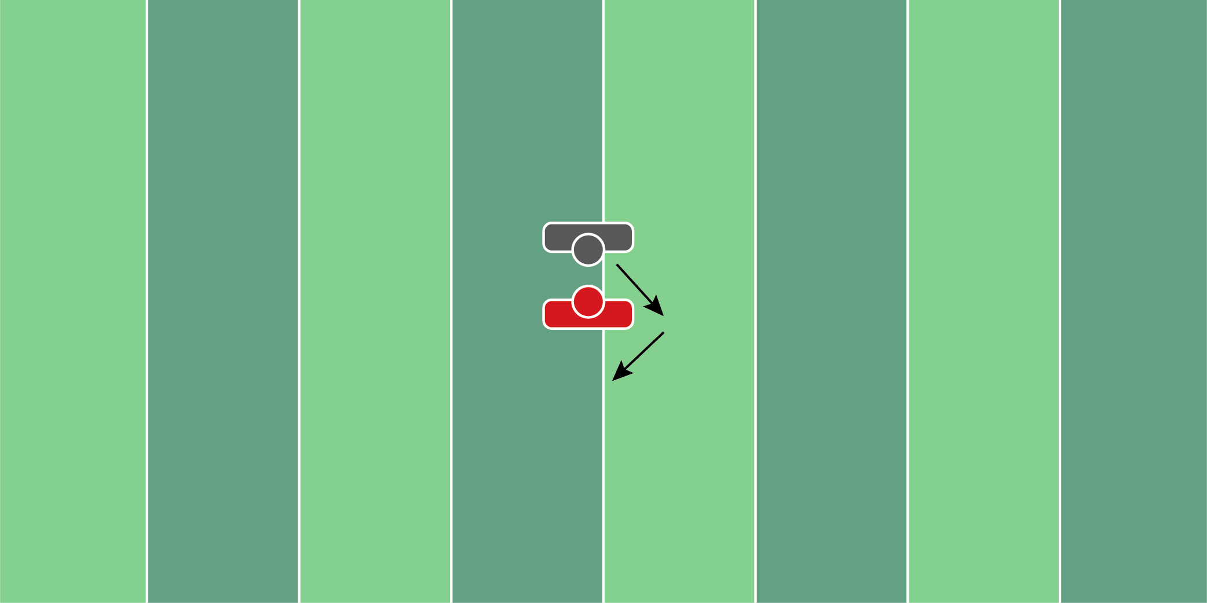
Figure 4.17

Up & Under Drill

Equipment Needed: Players/Coaches

Purpose: Training the hands and the feet to beat an up and under move from the defensive player.

Required Players: 2

Required Coaches: 0

Description: (1) The offensive lineman and defensive player should start engaged. (2) On movement, the defensive lineman should work to the outside leg of the offensive lineman. (3) Once the defensive lineman has made it 3-4 yards upfield, he should then rip back under for an inside move. (4) The offensive lineman should maintain contact and slide his feet based on the defensive lineman’s movement.

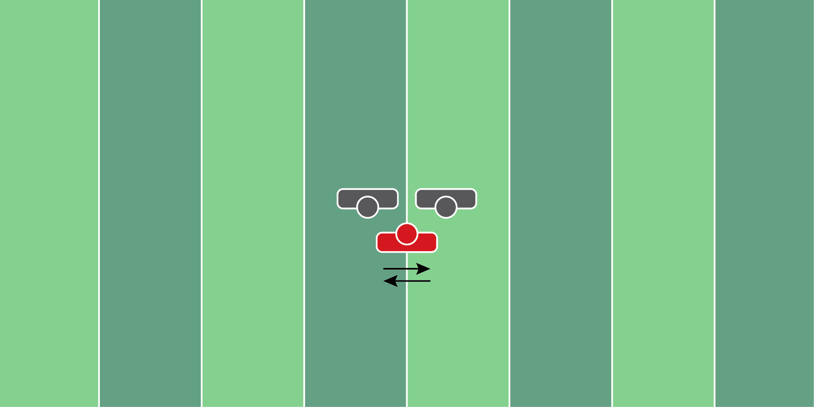
Figure 4.18

Slide & Fit Drill

Equipment Needed: Players/Coaches

Purpose: Training to strike the outside shoulder/armpit of the defender.

Required Players: 3

Required Coaches: 0

Description: (1) The offensive lineman should start in the middle of the 2 defensive players. (2) When ready, the offensive lineman should slide to each player and punch their outside shoulder/armpit. (3) Move back and forth to each player and focus on the hand placement and feet when striking.

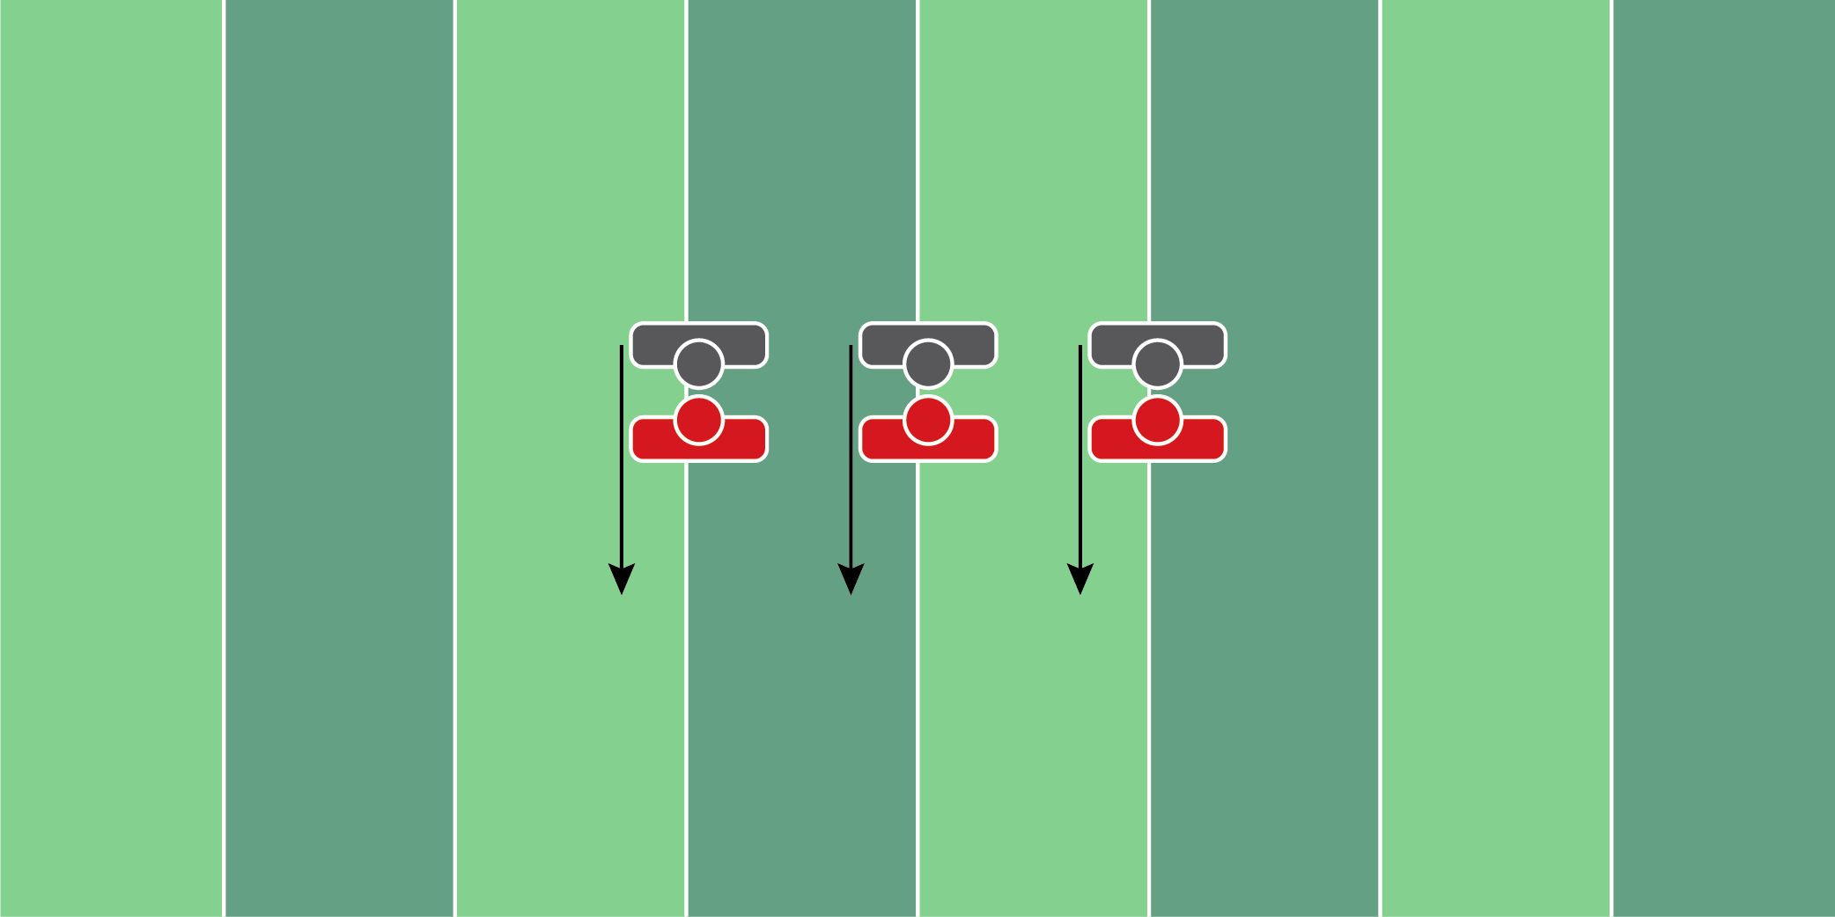
Figure 4.19

Drive & Finish Drill

Equipment Needed: Players/Coaches

Purpose: Training to drive and finish blocks after contact.

Required Players: 2

Required Coaches: 0

Description: (1) The offensive lineman and defensive player should start engaged. (2) On movement, the offensive lineman should drive the defensive lineman back with a low pad level. (3) After 2-3 yards, the offensive lineman should drive upwards and continue to use upwards leverage to put the defensive player off-balance.
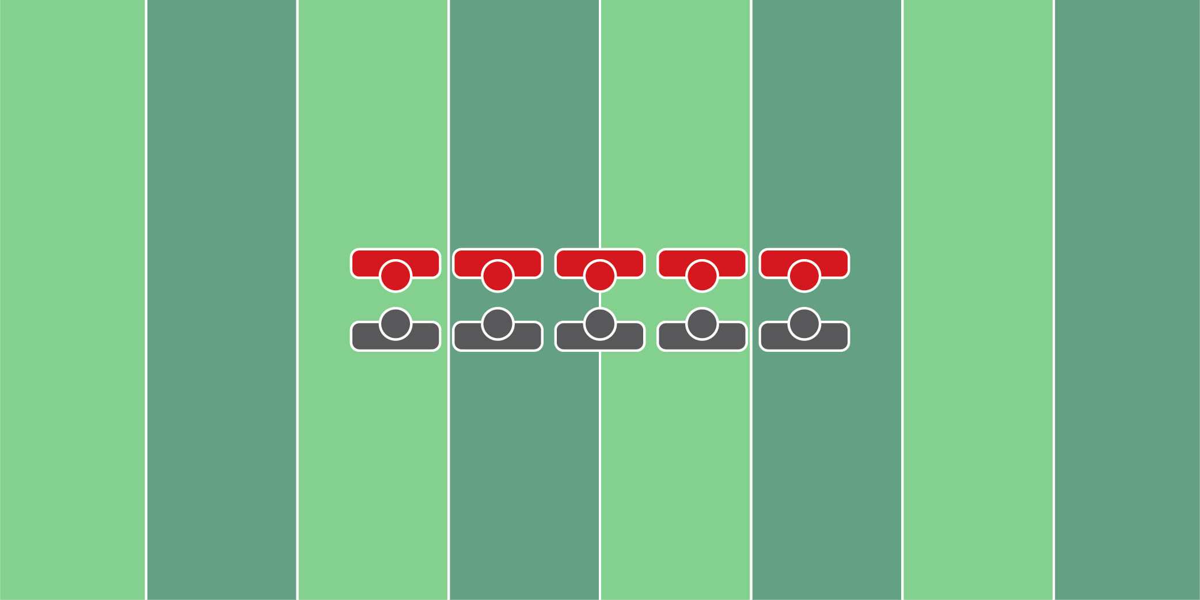
Figure 4.20

Inside Hand Replace Drill

Equipment Needed: Players/Coaches

Purpose: Training to reset the hands to the inside once leverage is lost.

Required Players: 2

Required Coaches: 0

Description: (1) The offensive lineman and defensive player should start engaged. (2) The defensive lineman will start with their hands inside of the offensive lineman. The defensive lineman will push the offensive lineman, forcing the offensive lineman to replace his hands to the inside and push back. Repeat this process 5-6 times.

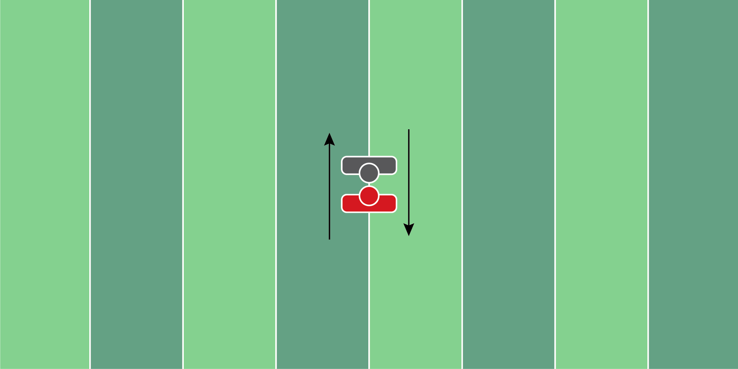
Figure 4.21

Bull Rush Switch Drill

Equipment Needed: Players/Coaches

Purpose: Training to reset the hands and feet on a bull rush.

Required Players: 2

Required Coaches: 0

Description: (1) The offensive lineman and defensive player should start engaged. The offensive lineman should drive the defensive player back 3-4 yards. (2) In one movement, the defensive player now turns into the offensive player and drives the other player backward. This requires them to reset their feet, get the hands back inside and drive the player backward. (3) Repeat this switch 4-5 times back and forth to get practice resetting for the bull rush.

DEFENSIVE
LINE
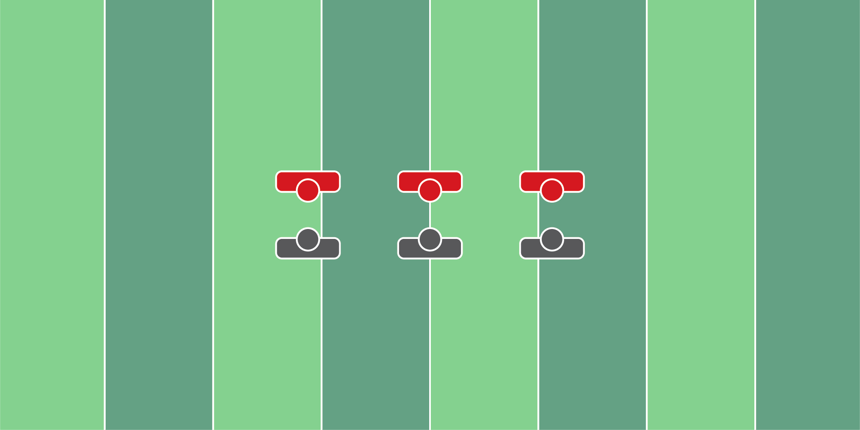
Figure 5.1

Chop & Dip Drill

Equipment Needed: Players/Coaches

Purpose: Training hand placement when pass rushing.

Required Players: 2

Required Coaches: 0

Description: (1) The defensive lineman will start on the right/left shoulder of the offensive lineman. (2) The offensive player will softly punch the lower hand. When the coach says “go”, the defensive player will chop the hand being punched then rip around the offensive player.

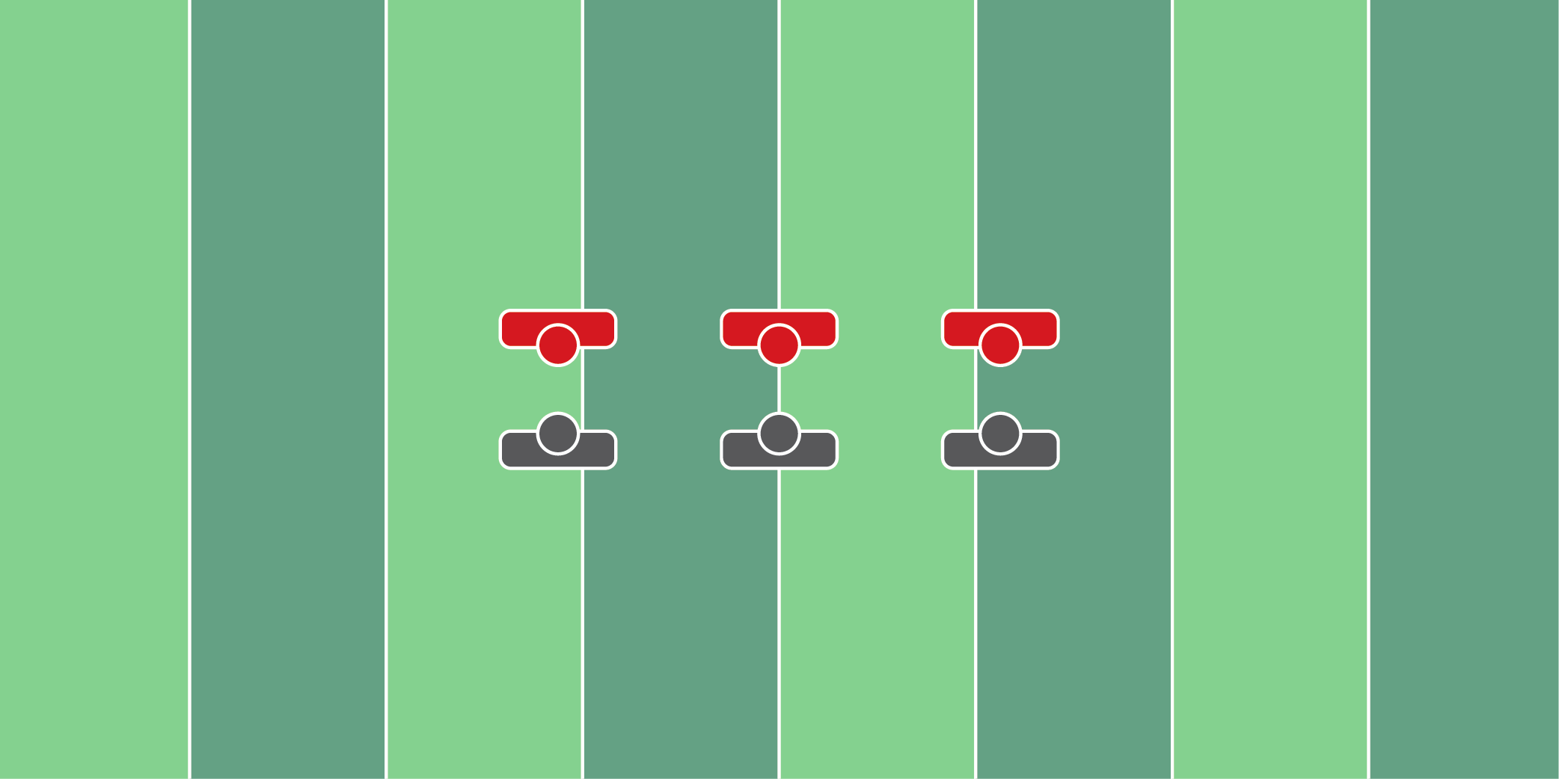
Figure 5.2

Kneeling Hip Fire Drill

Equipment Needed: Hand shields

Purpose: Training the hips and hands to fire off.

Required Players: 2

Required Coaches: 0

Description: (1) The defensive lineman will start on their knees, with an offensive player holding a hand shield on his chest. (2) When the coach says “go”, the defensive player will fire both hands onto the pad. The key is to try to hit the bag with as much force as possible.

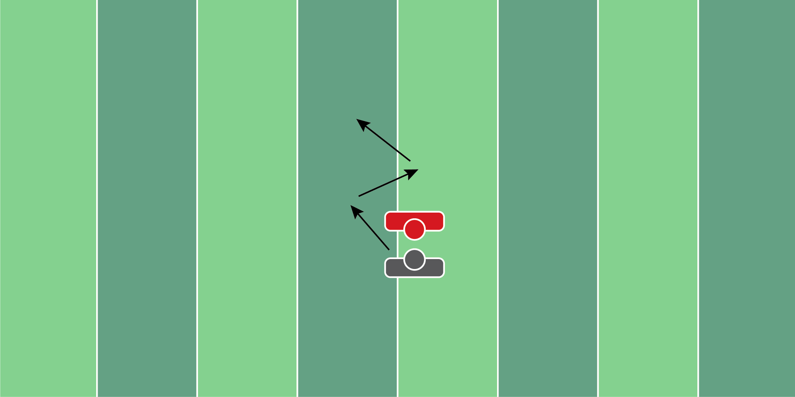
Figure 5.3

Steer Drill

Equipment Needed: Players/Coaches

Purpose: Understanding and owning leverage.

Required Players: 2

Required Coaches: 0

Description: (1) The defensive lineman and offensive player will stand engaged. (2) When the coach says “go”, the offensive player is going to try to reach (pin the defensive player to the inside) the defensive player. (3) As soon as the defensive player feels pressure, they will try to fight with pressure to turn the offensive player back square. (4) After 4-5 yards, switch to the other side. Repeat each side 2 times.

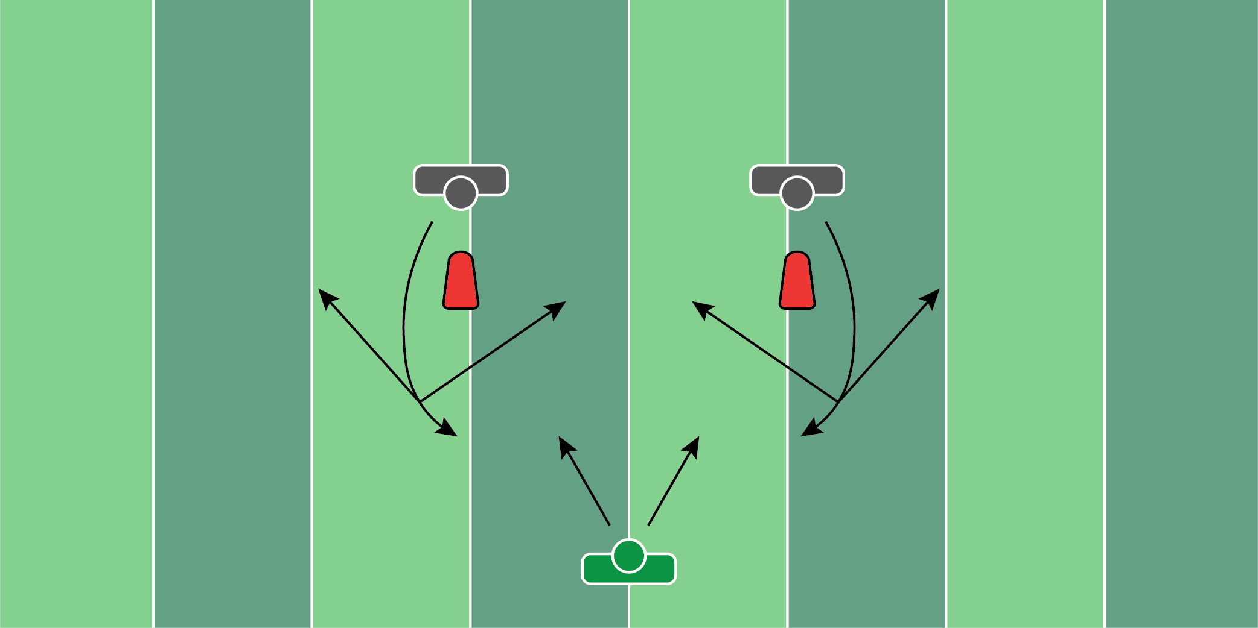
Figure 5.4

Retrace Drill

Equipment Needed: Pop up dummies

Purpose: Retrace and track down an offensive player after a quick pass.

Required Players: 2

Required Coaches: 1

Description: (1) The defensive lineman will start in their stance. When the coach says “go”, the defensive lineman will punch the popup dummy and rip by them. (2) Whichever way the coach points, the defensive lineman will chase down the offensive player, as if they were running across the field with the football. (3) The defensive player should finish with a backside strip of the football.
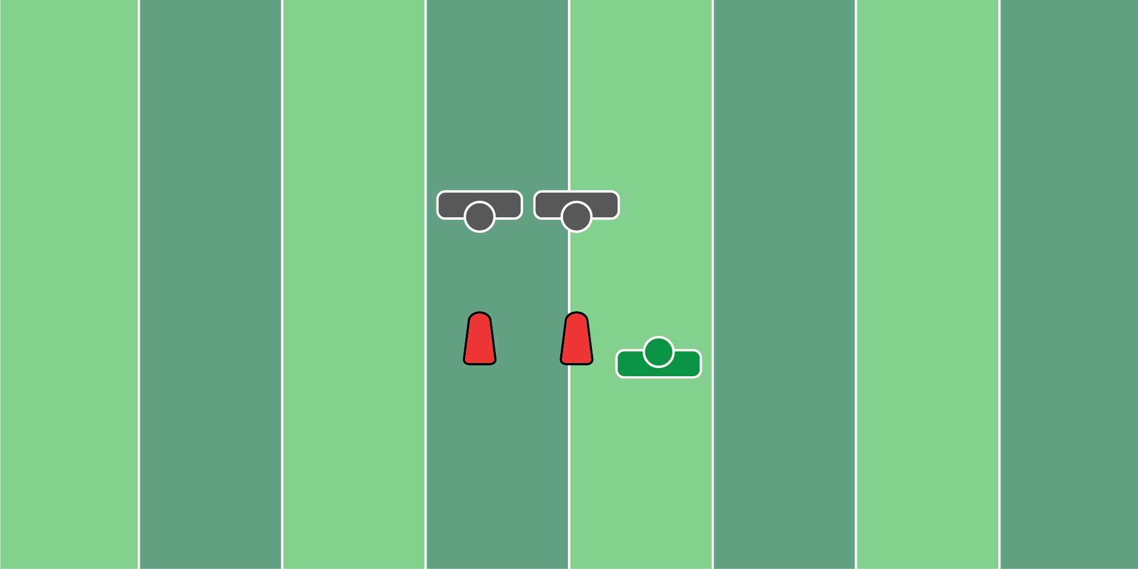
Figure 5.5

Punch & Peek Drill

Equipment Needed: Football Sled

Purpose: Engage the offensive player and look behind him to see the running back or quarterback.

Required Players: 1

Required Coaches: 1

Description: (1) The defensive lineman will start lined up directly in front of the sled. (2) When the coach says “go”, the defensive lineman should punch the sled with two hands and look on either side of the bag. (3) The coach should then point to the left or to the right. (4) Once the defensive lineman sees the coach point in a direction, they should then rip or swim in that direction.
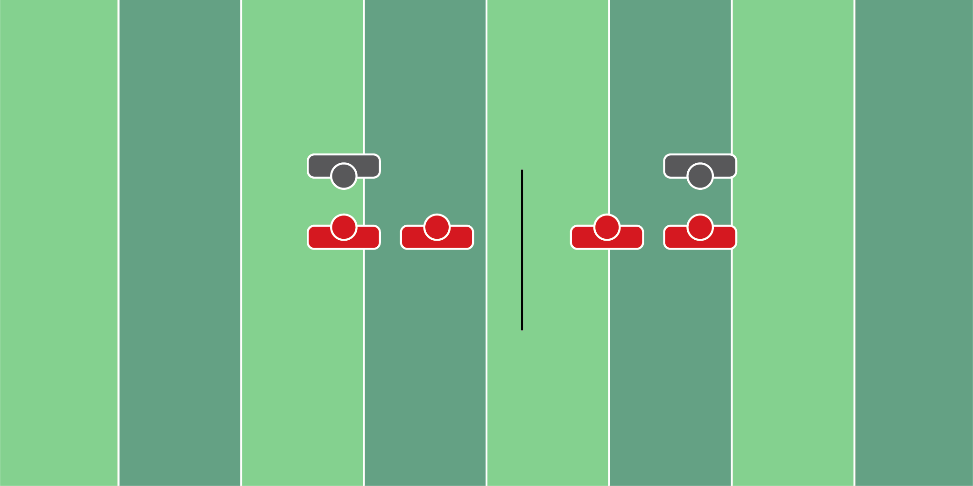
Figure 5.6

Half Line Drills

Equipment Needed: Players/Coaches

Purpose: Working defensive run fits with half of the line of scrimmage.

Required Players: 2-4

Required Coaches: 0

Description: (1) The coach should determine what half of the line he wants to be involved in the drill. (2) The focus of this drill is to recognize what your side of the line is doing and penetrate/hold your gap. (3) Tackle or make contact with the running back to end the drill.

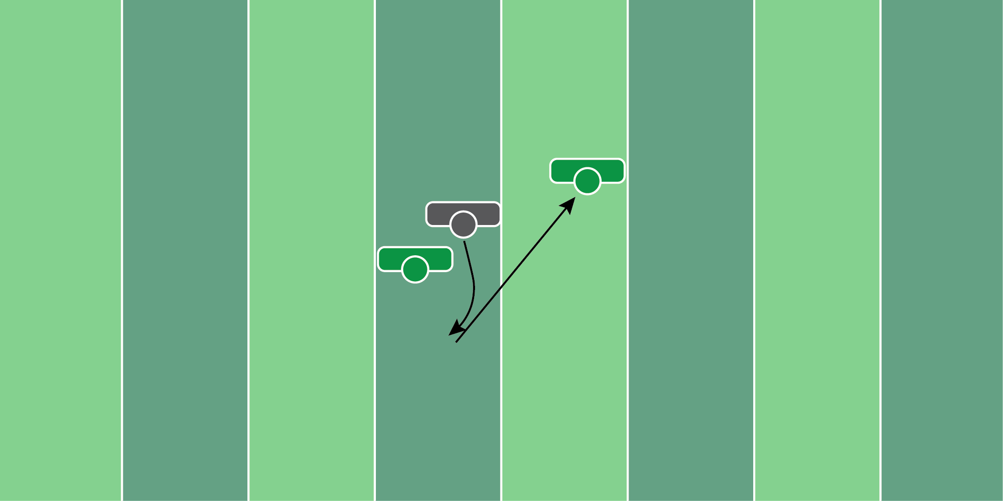
Figure 5.7

Retrace Drill (2)

Equipment Needed: Players/Coaches

Purpose: Retracing after clearing the pass to chase down an offensive player.

Required Players: 1

Required Coaches: 2 (or 2 players)

Description: (1) The defensive lineman will start in his stance facing the first coach (2) When the coach says “go”, the defensive player will get by the coach with a rip or swim move. (3) From here, the defensive player will chase down the second coach from behind, trying to strip the football from them.

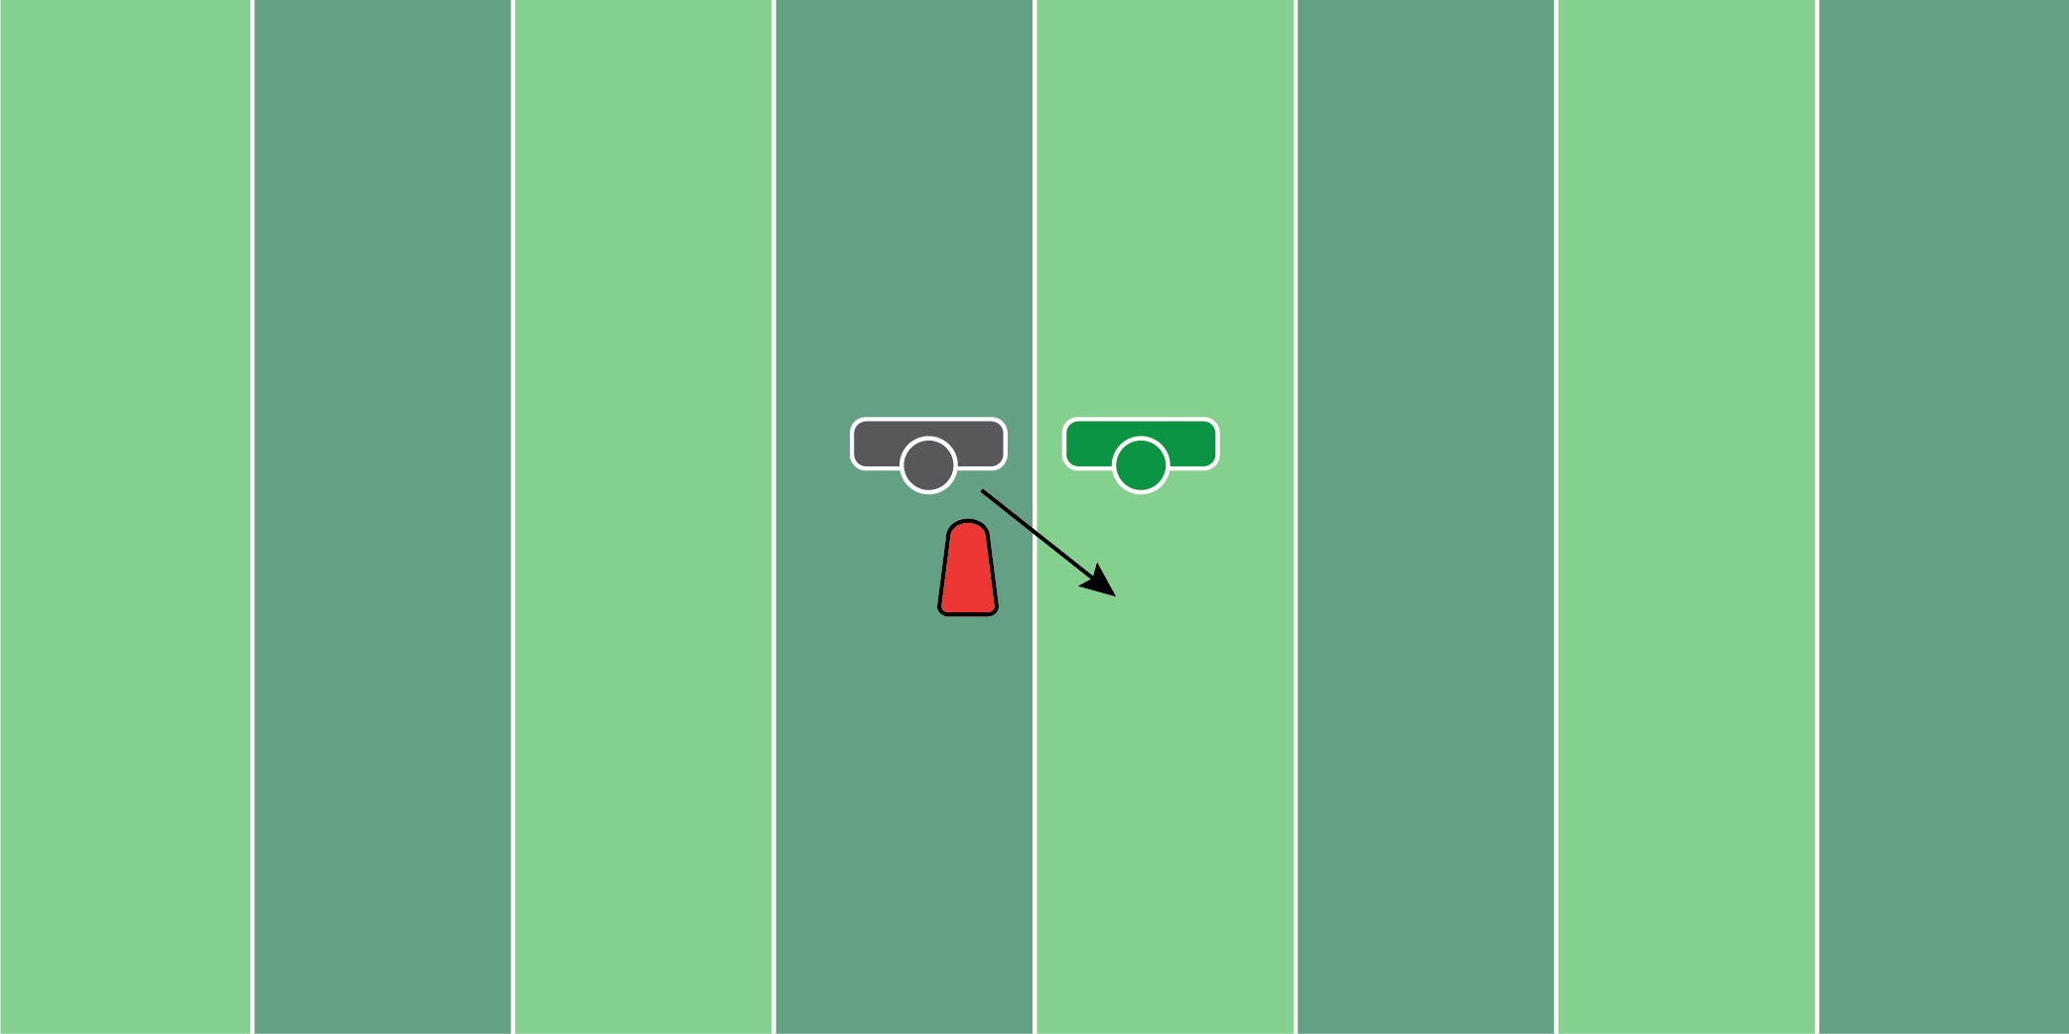
Figure 5.8

Double Team Drill

Equipment Needed: Football sled & a hand shield

Purpose: Training hand placement.

Required Players: 1

Required Coaches: 1

Description: (1) The defensive lineman will start in his stance facing the football sled. (2) When the coach says “go”, the defensive lineman will punch the sled with two hands. (3) As soon as the player punches the sled, the coach should then try to push the defensive lineman, creating a double team situation. (4) The defensive lineman should try to get skinny or fight the double team and finish with a swim off the popup dummy.
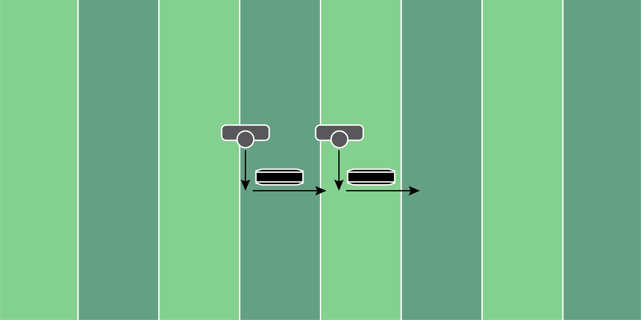
Figure 5.9

Chase Down Drill

Equipment Needed: Step over bags

Purpose: Working down the line of scrimmage to chase down an outside run or screen.

Required Players: 2

Required Coaches: 0

Description: (1) The 2 defensive lineman will start in their stance, in front of the step-over bag. (2) When the coach says “go”, the defensive players will make a rip or swim move to the side of the step-over bag. (3) After both players clear the bag, the player who is trailing is trying to catch the player in front of them. This encourages both players to move at full speed.
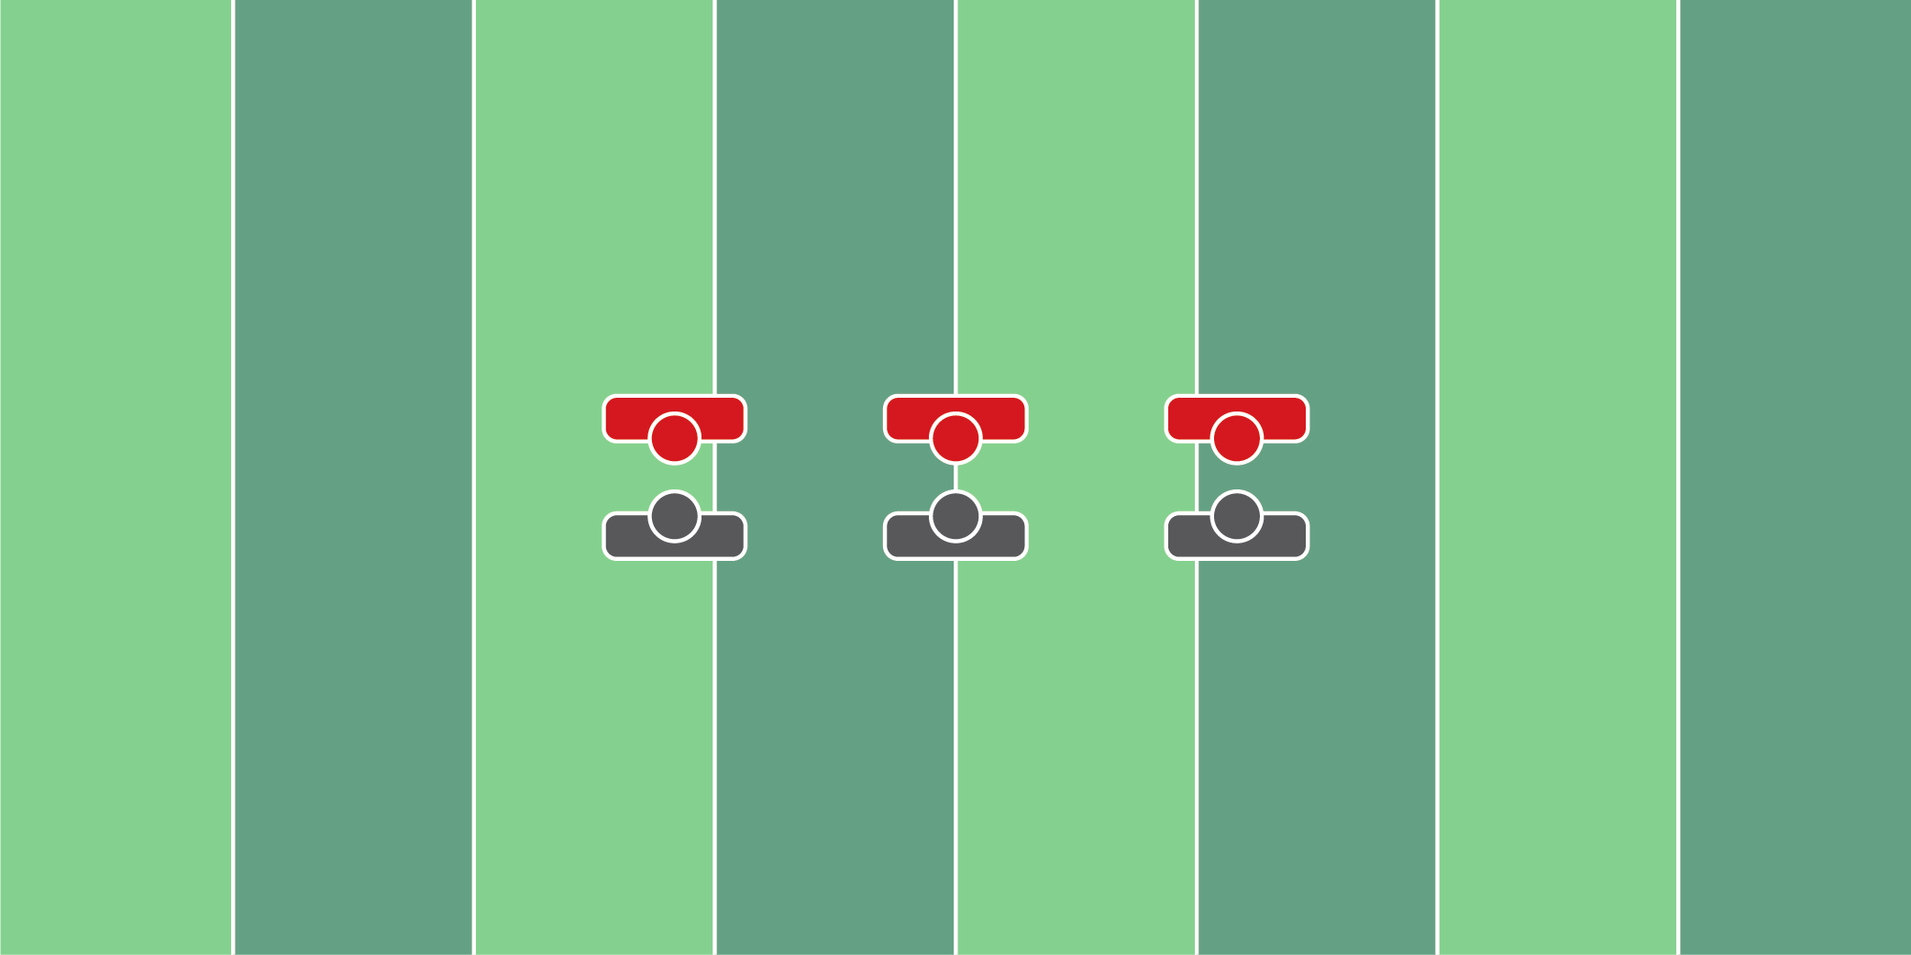
Figure 5.10

Forklift Drill

Equipment Needed: Players/Coaches

Purpose: Training players to disengage with the forklift technique.

Required Players: 2

Required Coaches: 0

Description: (1) The defensive lineman and offensive player should start engaged. The offensive player should have both hands locked out and engaged on the defensive player’s breastplate. (2) When the coach says “go”, the defensive player will grab the offensive player’s wrists, lift them in the air, and rip past them.

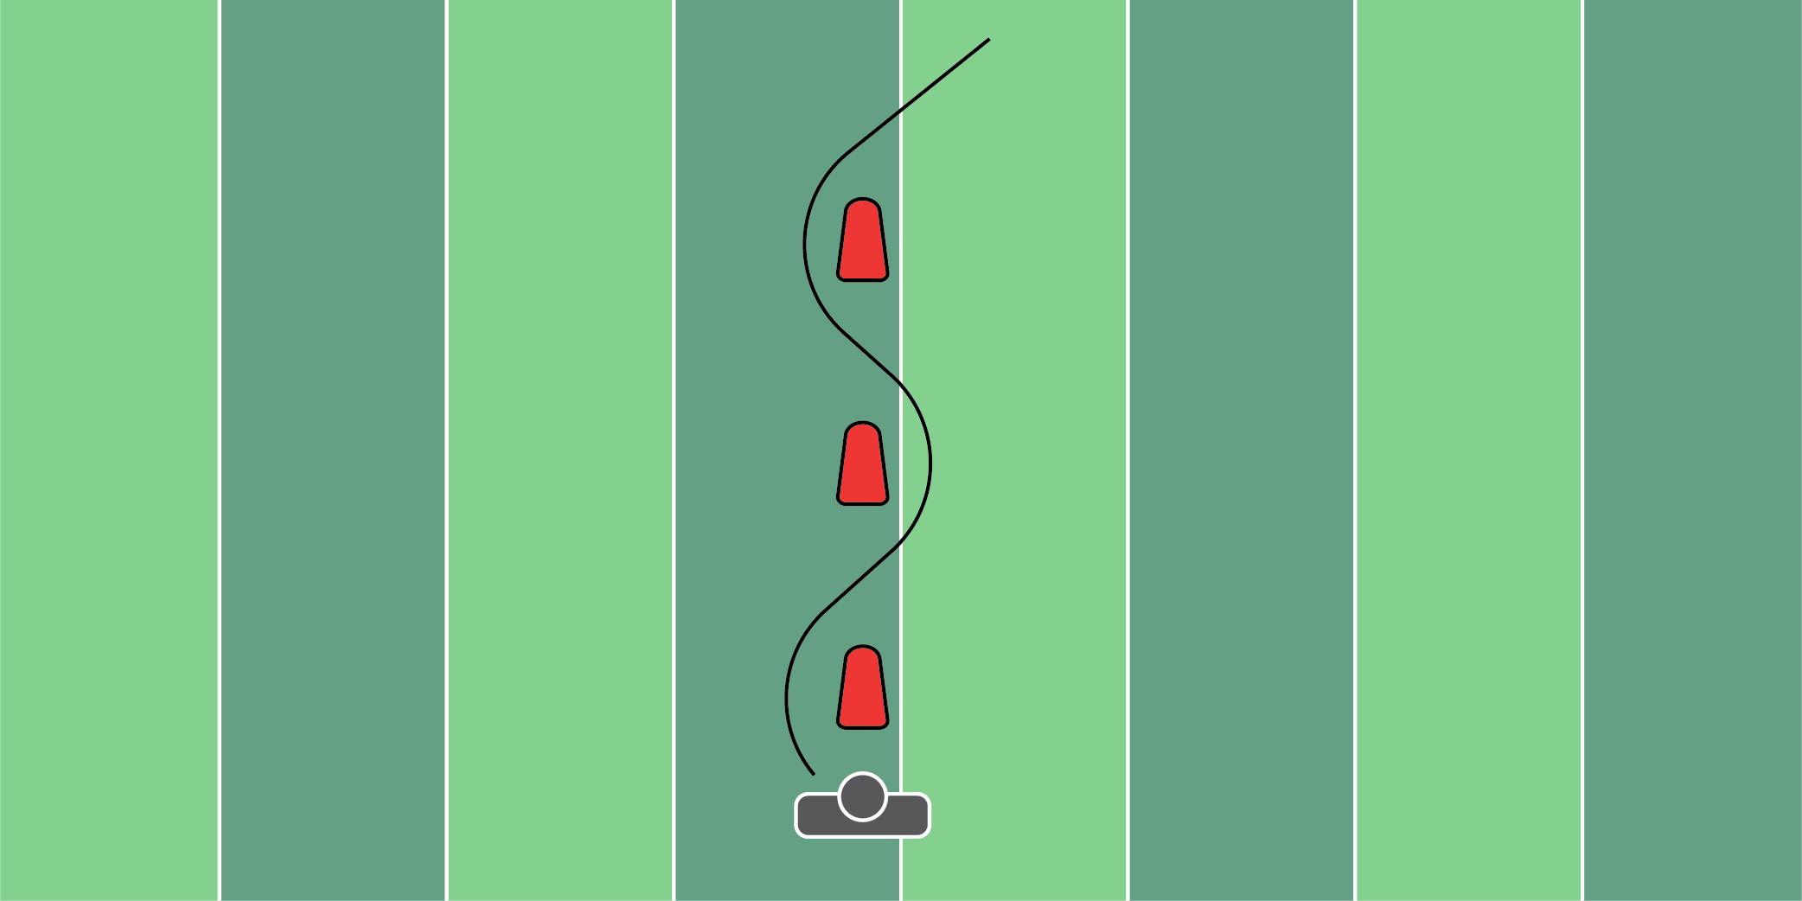
Figure 5.11

PVC Dip Drill

Equipment Needed: PVC pipe & pop up dummies

Purpose: Teaching the upper body and lower body to bend at the same time.

Required Players: 2

Required Coaches: 0

Description: (1) The defensive lineman will start with a PVC pipe resting on top of their shoulders. (2) When the coach says “go”, the defensive player should weave in and out of the popup dummies, bending and twisting at each mark, simulating a rip move.

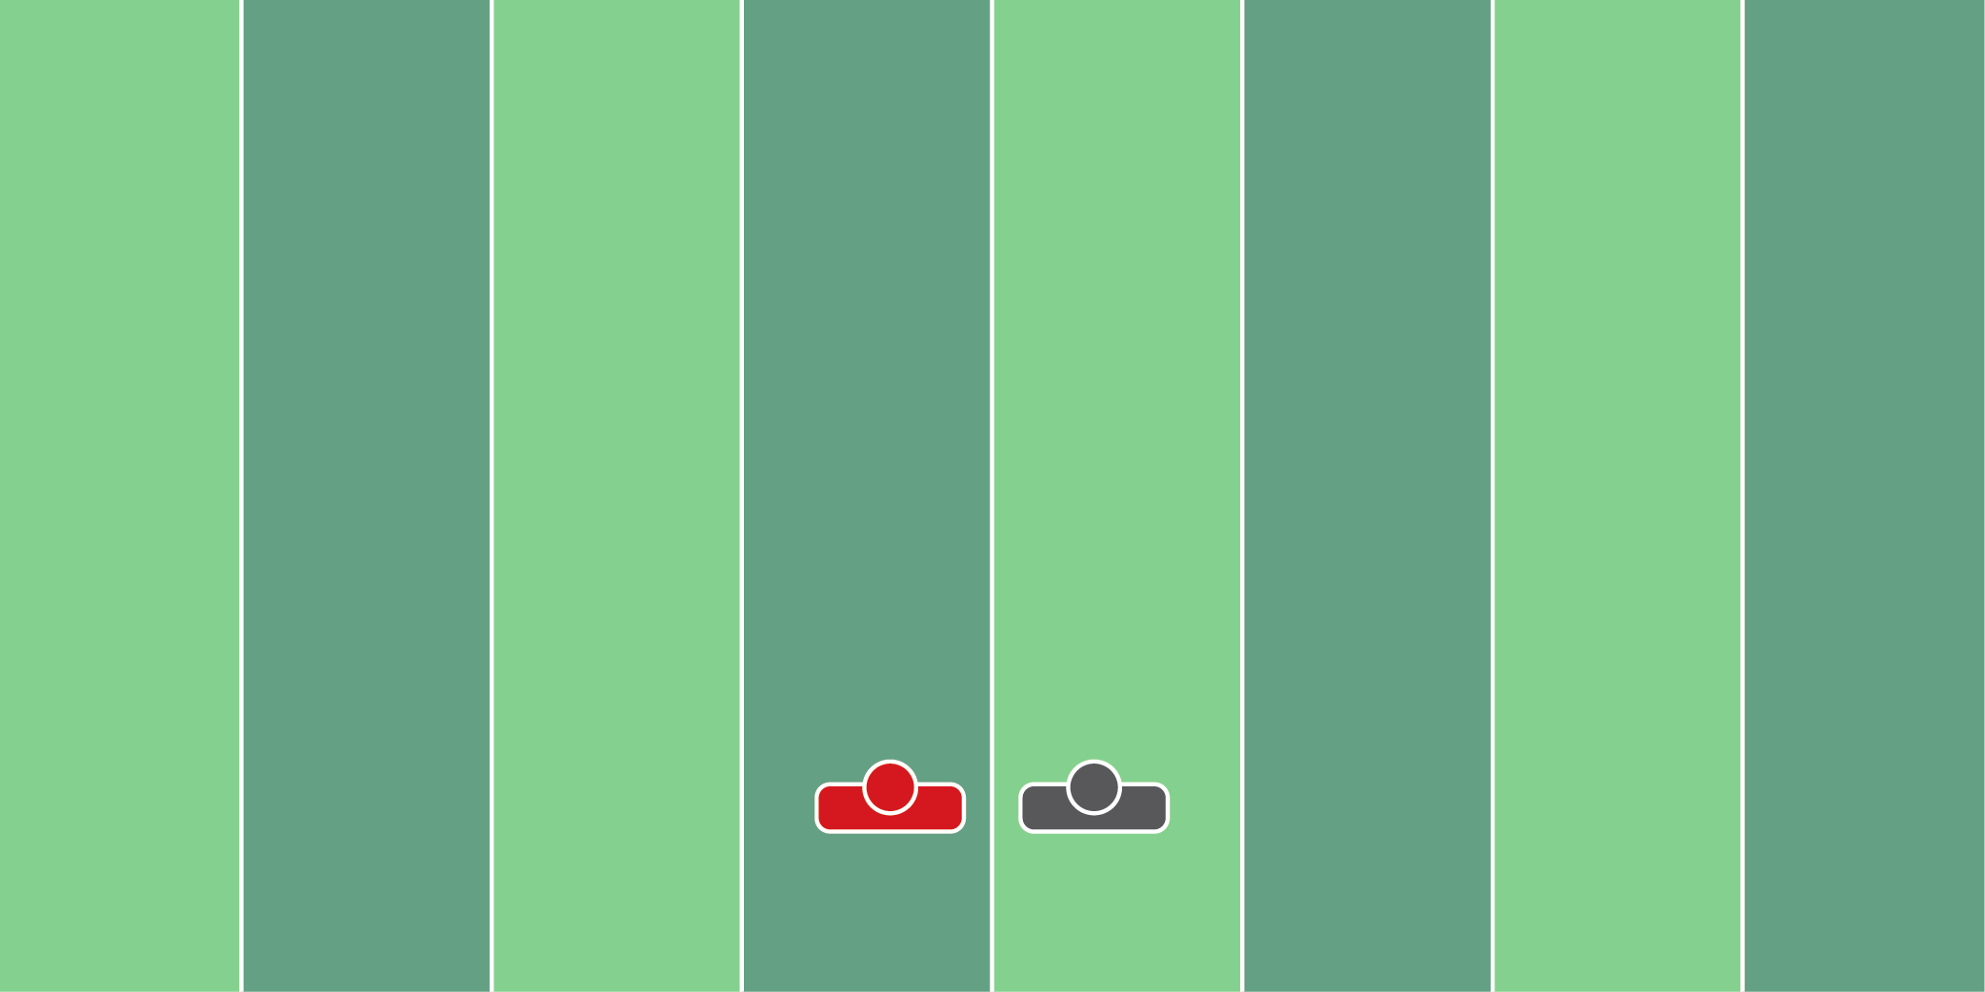
Figure 5.12

Press & Squeeze Drill

Equipment Needed: Players/Coaches

Purpose: Training to squeeze a hole by pressing the offensive player.

Required Players: 2

Required Coaches: 0

Description: (1) The defensive lineman will start with his hand on the chest of the offensive player. (2) The offensive lineman should put a considerable amount of weight on the defensive player. (3) The defensive player, with a low base, should be able to push and fend off the offensive player. (4) This drill is often done at ¼ to ½ speed to get the mechanics down.

LINEBACKERS
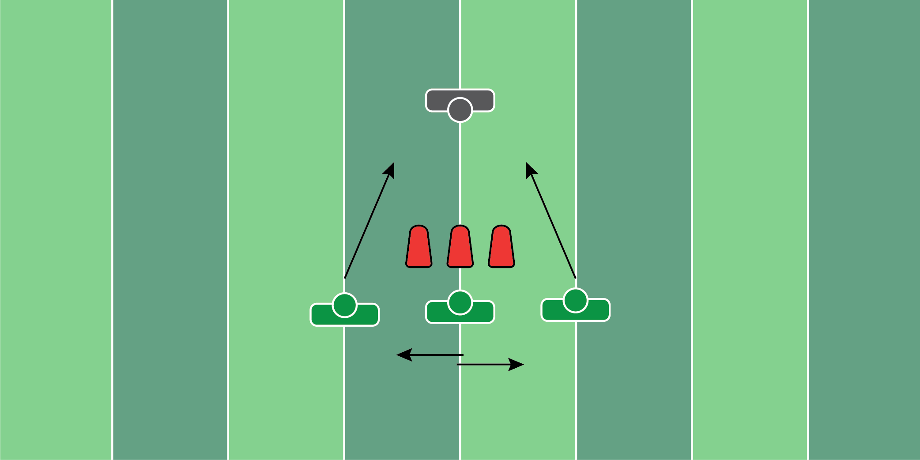
Figure 6.1

Pull/Scrape Drill

Equipment Needed: Players/Coaches

Purpose: Training eyes and hand placement.

Required Players: 1

Required Coaches: 2

Description: (1) The linebacker will line up in his stance. (2) One coach should position themselves as an offensive guard and the other an offensive tackle on the opposite side. (3) When the coach says “go”, the guard will make a motion as if they are pulling. The tackle should try to down block the linebacker. (4) Once the linebacker realizes the guard pulls, they should fight over the top of the tackle who is coming to block them. Finish at the line of scrimmage.
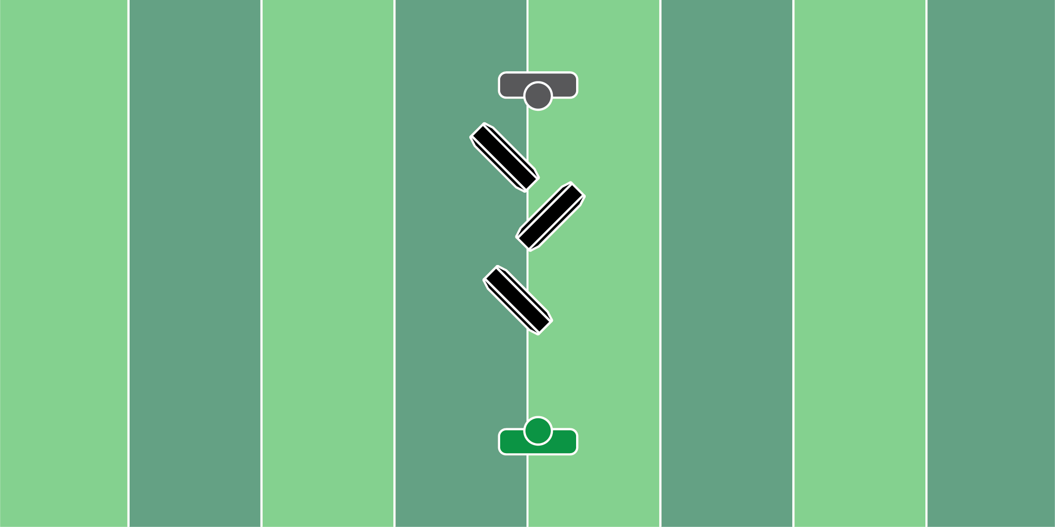
Figure 6.2

Chop & Dip Drill

Equipment Needed: Step over bags

Purpose: Training linebackers to track running backs downhill with a wide base.

Required Players: 1

Required Coaches: 0

Description: (1) The linebacker should start in an athletic stance. (2) When the coach says “go”, the linebacker should move forward at an angle and continue to shuffle downhill with a wide base. The key is to not cross the feet over one another. A wide base will help the linebacker work side to side with equal weight distribution.
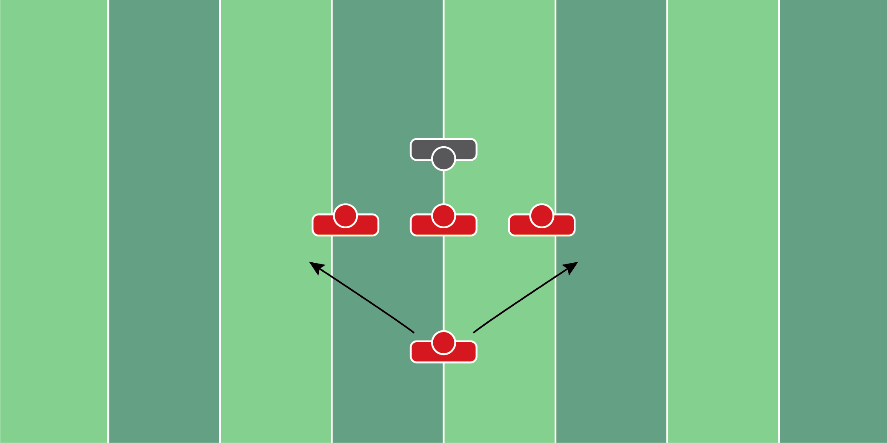
Figure 6.3

Interior Line Read Drill

Equipment Needed: Hand shields

Purpose: Reading the interior line for pulls and down blocks.

Required Players: 5

Required Coaches: 0

Description: (1) The coach should stand behind the defensive players, and tell them what he wants them to do. (2) When he says “go”, the defensive players will react to what the offensive lineman does. (3) Coaches can work zone reads, pull reads, trap reads, and any type of line-blocking scheme.
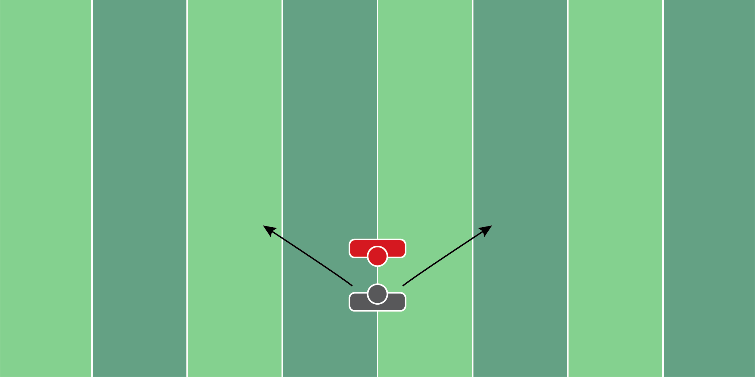
Figure 6.4

Shock & Shed Drill

Equipment Needed: Hand shield

Purpose: Training hands and feet to shock and shed offensive players.

Required Players: 1

Required Coaches: 1

Description: (1) The linebacker should start in an athletic stance about 3 yards away from the coach. (2) When the coach says “go”, move toward the coach and punch with two hands, extending the arms. (3) Once extended, swim or rip off the offensive player. The key is to make long, violent contact with the hand shield.
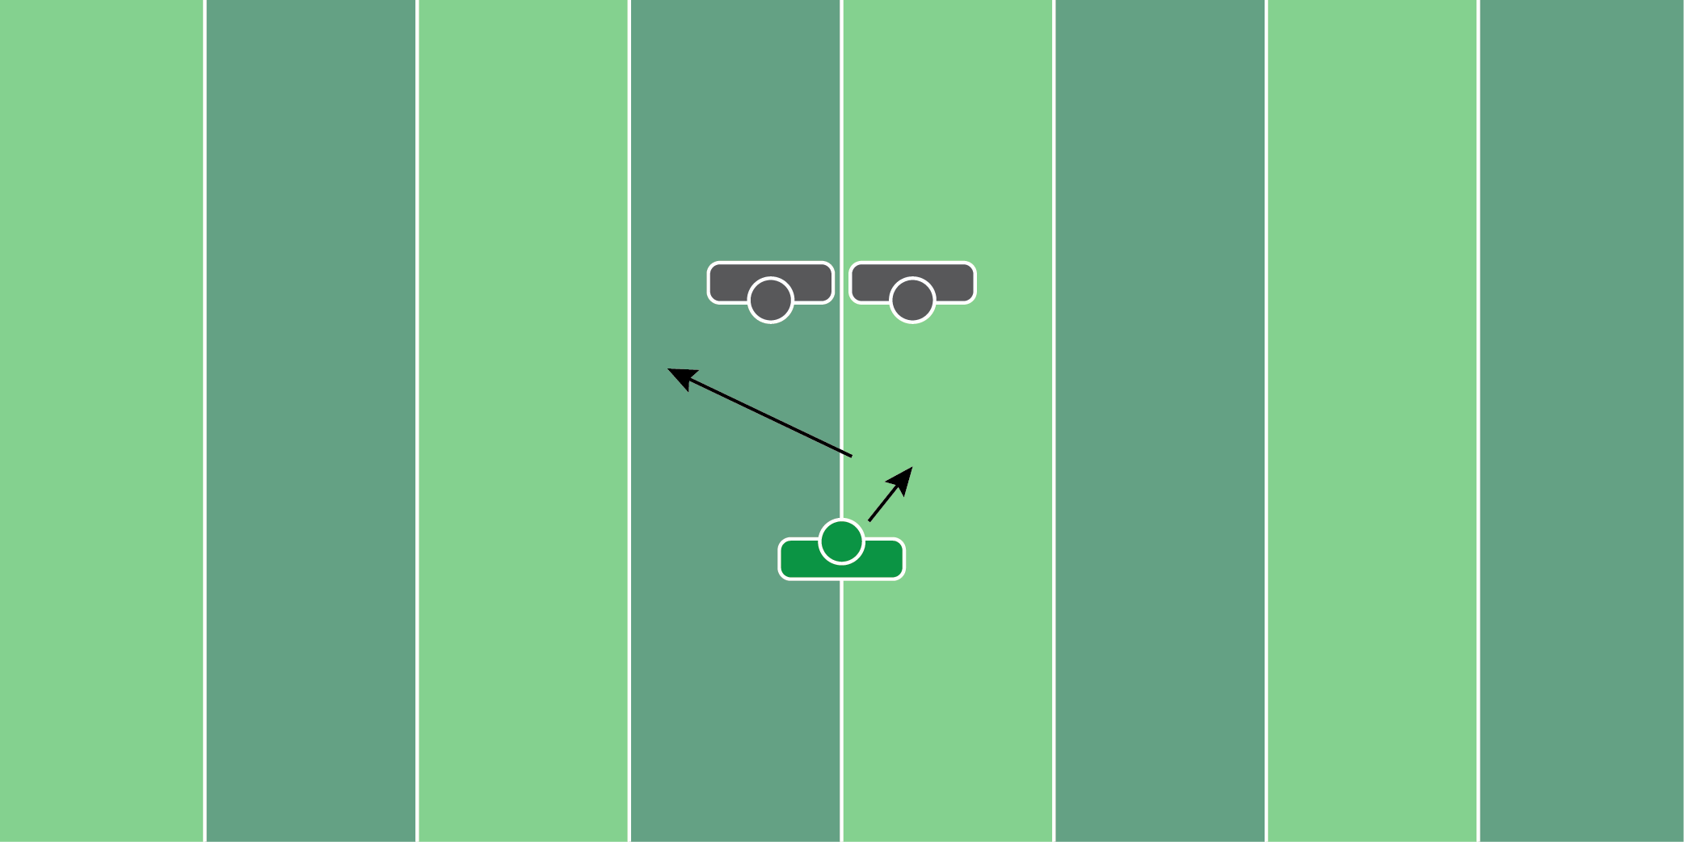
Figure 6.5

Shuffle Gather Drill

Equipment Needed: Players/Coaches

Purpose: Training the linebacker to not crossover his feet when moving downhill.

Required Players: 2

Required Coaches: 1

Description: (1) The two linebackers should start in athletic linebacker stances (2) When the coach says “go”, the linebackers should move downhill toward the coach. It’s important to not cross over the feet and to maintain a wide athletic base when tracking. (3) Continue to run the feet when approaching the coach.
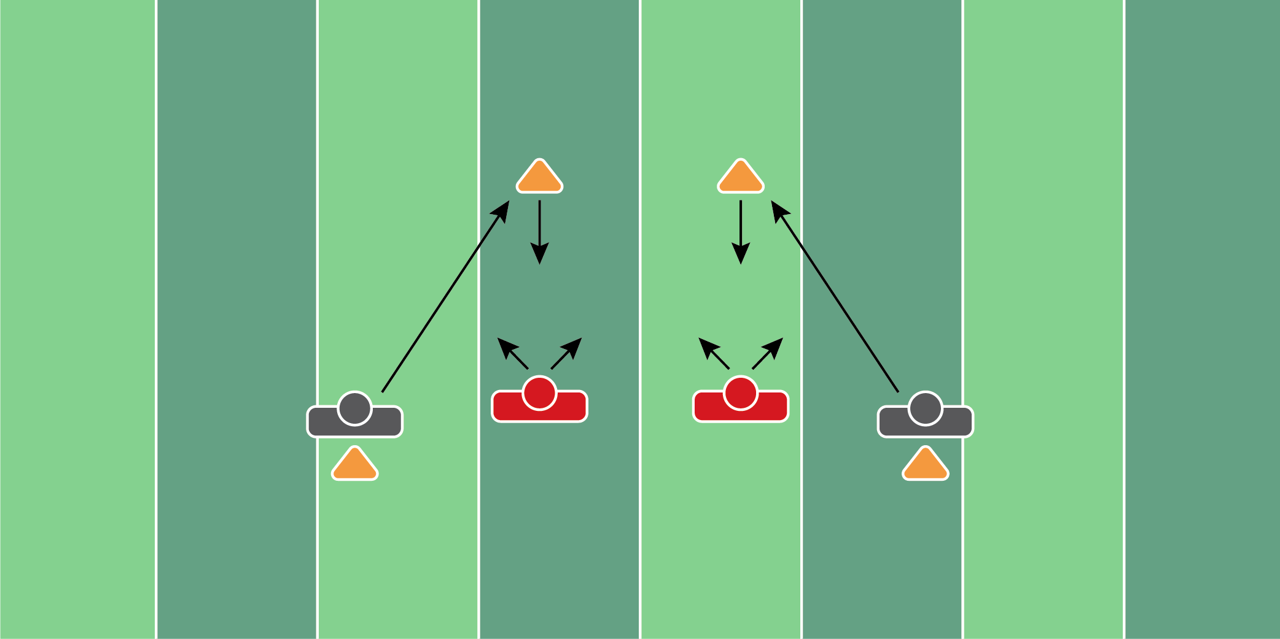
Figure 6.6

Collide & Carry Drill

Equipment Needed: Players/Coaches

Purpose: Collisioning a receiver and riding their hip.

Required Players: 2

Required Coaches: 0

Description: (1) The linebacker should start 5 yards behind the other player (2) When the coach says “go”, the linebacker should sprint to about 5 yards in front of the offensive player. The offensive player should then run in a straight line past the linebacker. (3) The linebacker should collide with the receiver, then ride their back hip as if they are playing man coverage.
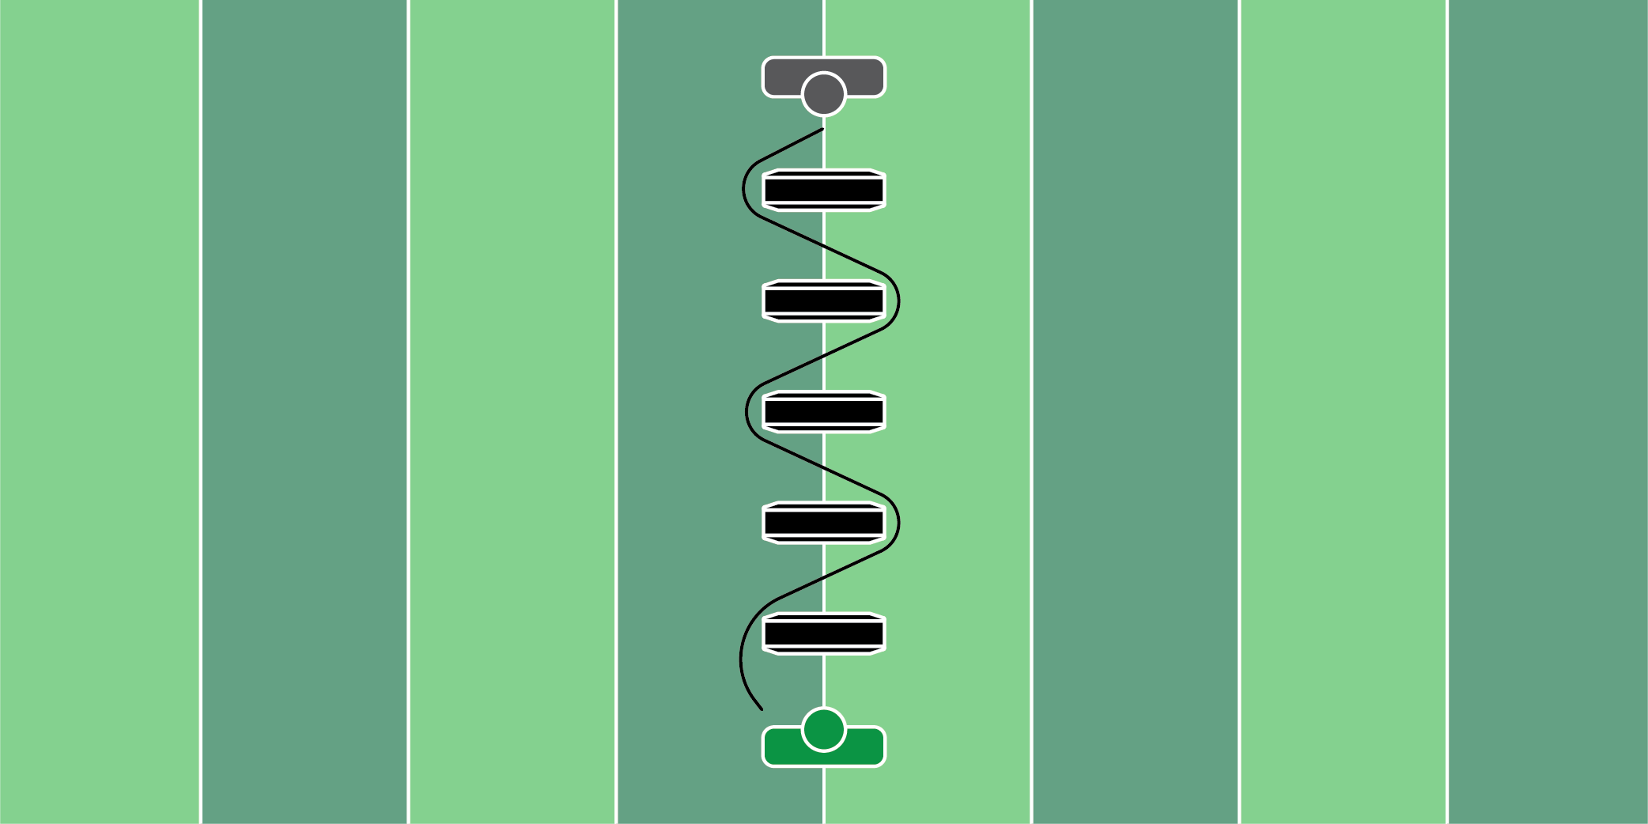
Figure 6.7

Step Over Bag Shuffle Drill

Equipment Needed: Step over bags

Purpose: Maintaining a wide and athletic base during downhill movements.

Required Players: 1

Required Coaches: 1

Description: (1) The linebacker should start behind the step-over bags in an athletic stance. (2) Weave through the step-over bags with a wide base, not crossing over the feet. (3) When the linebacker gets to the end of the step-over bags, throw a football or roll a fumble to the player to complete the drill.
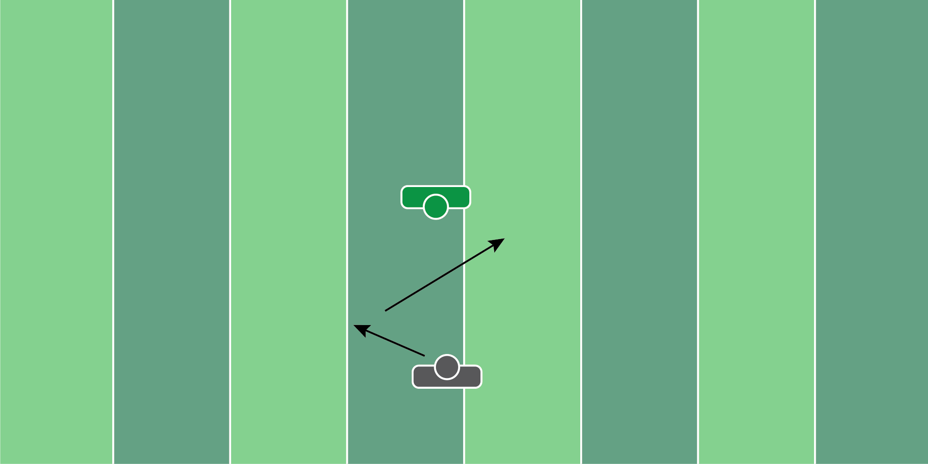
Figure 6.8

Tennis Ball Shuffle Drill

Equipment Needed: Tennis Balls

Purpose: Training to move downhill with an athletic base.

Required Players: 1

Required Coaches: 1

Description: (1) The linebacker should start 8-10 yards away from the coach. (2) The coach should start by rolling the tennis ball to the left, which the player should scoop with 1 hand. (3) Next, the coach should roll the tennis ball to the right, which the player should scoop with his empty hand. (4) The point of the drill is to make sure the linebacker is able to move toward the coach (downhill), as well as left/right without crossing over their feet.

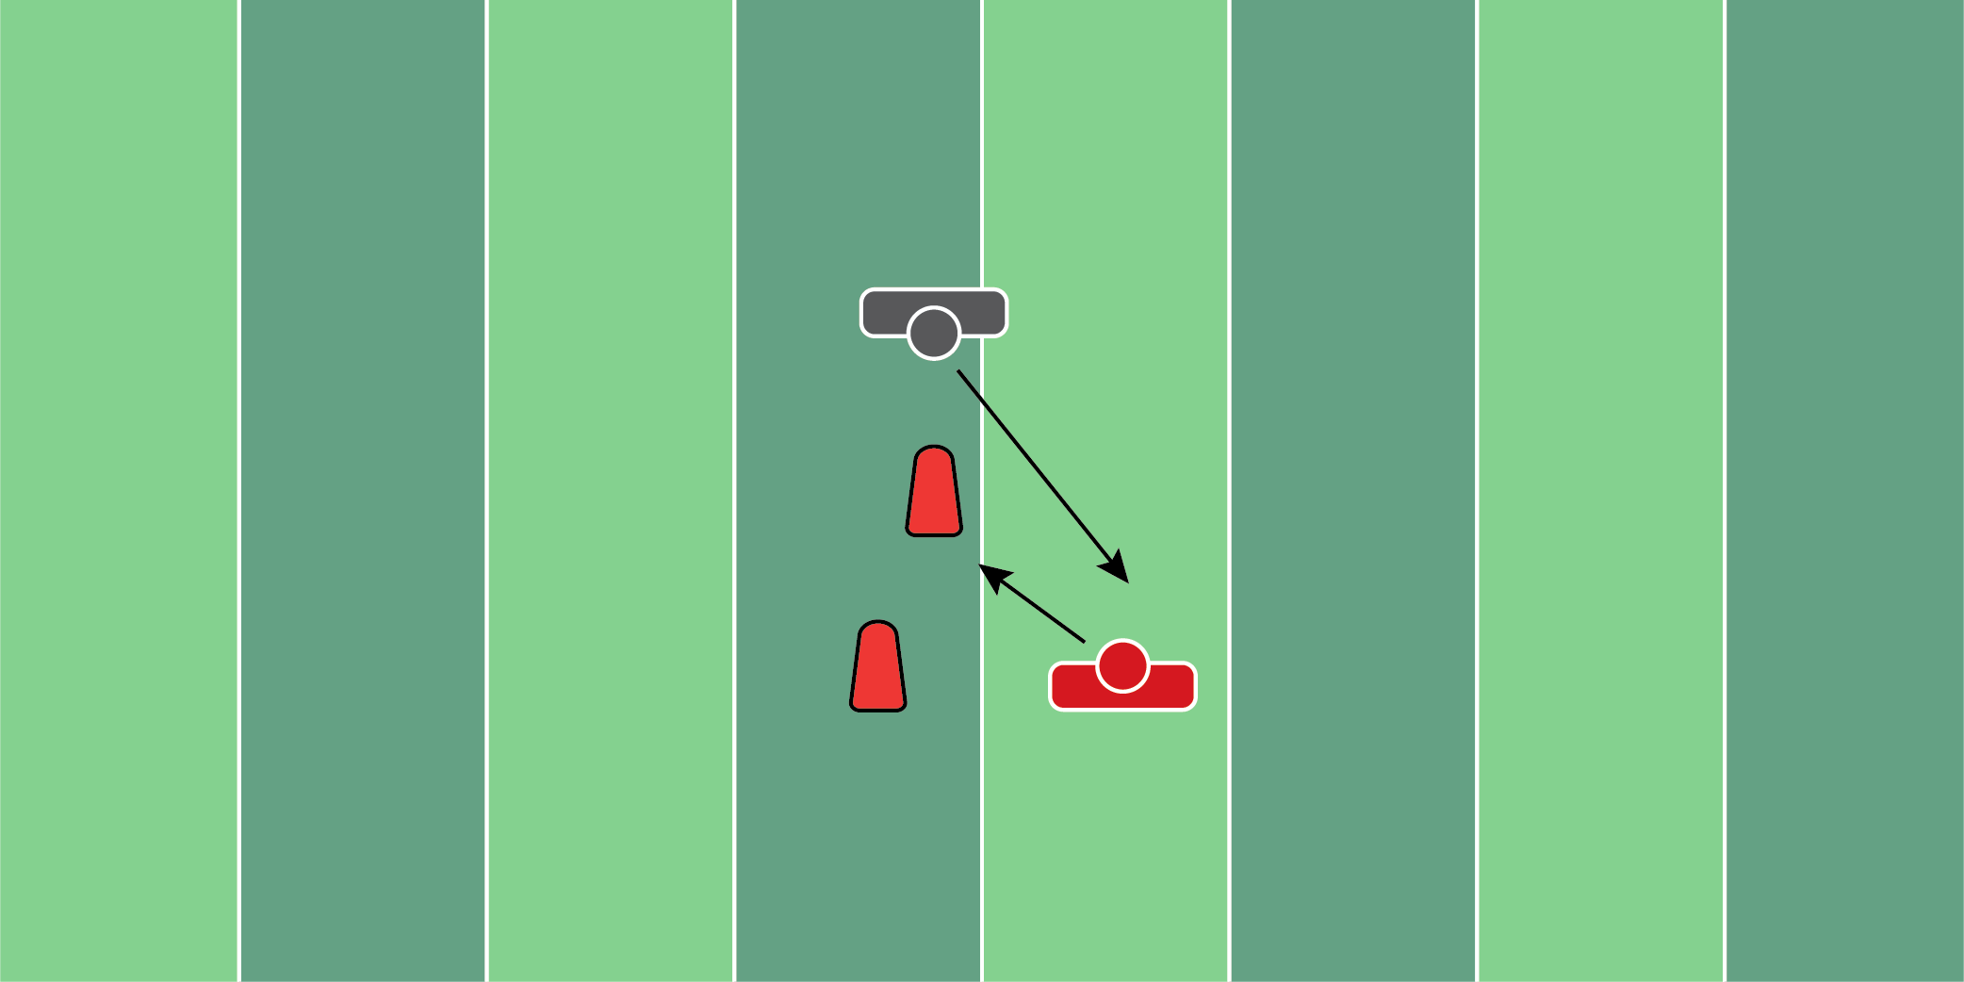
Figure 6.9

Squeeze & Shed Drill

Equipment Needed: Pop up dummies or step over bags

Purpose: Training the feet to work downhill and squeezing the blocks from the offensive lineman.

Required Players: 2

Required Coaches: 0

Description: (1) The linebacker should start a yard behind the cone. (2) When the coach says “go”, the linebacker should shuffle to the first cone, then to the second cone. (3) Once the second cone is cleared, the offensive lineman should try to block the linebacker. (4) The linebacker should try to get to the outside shoulder of the offensive lineman and squeeze the hole down.
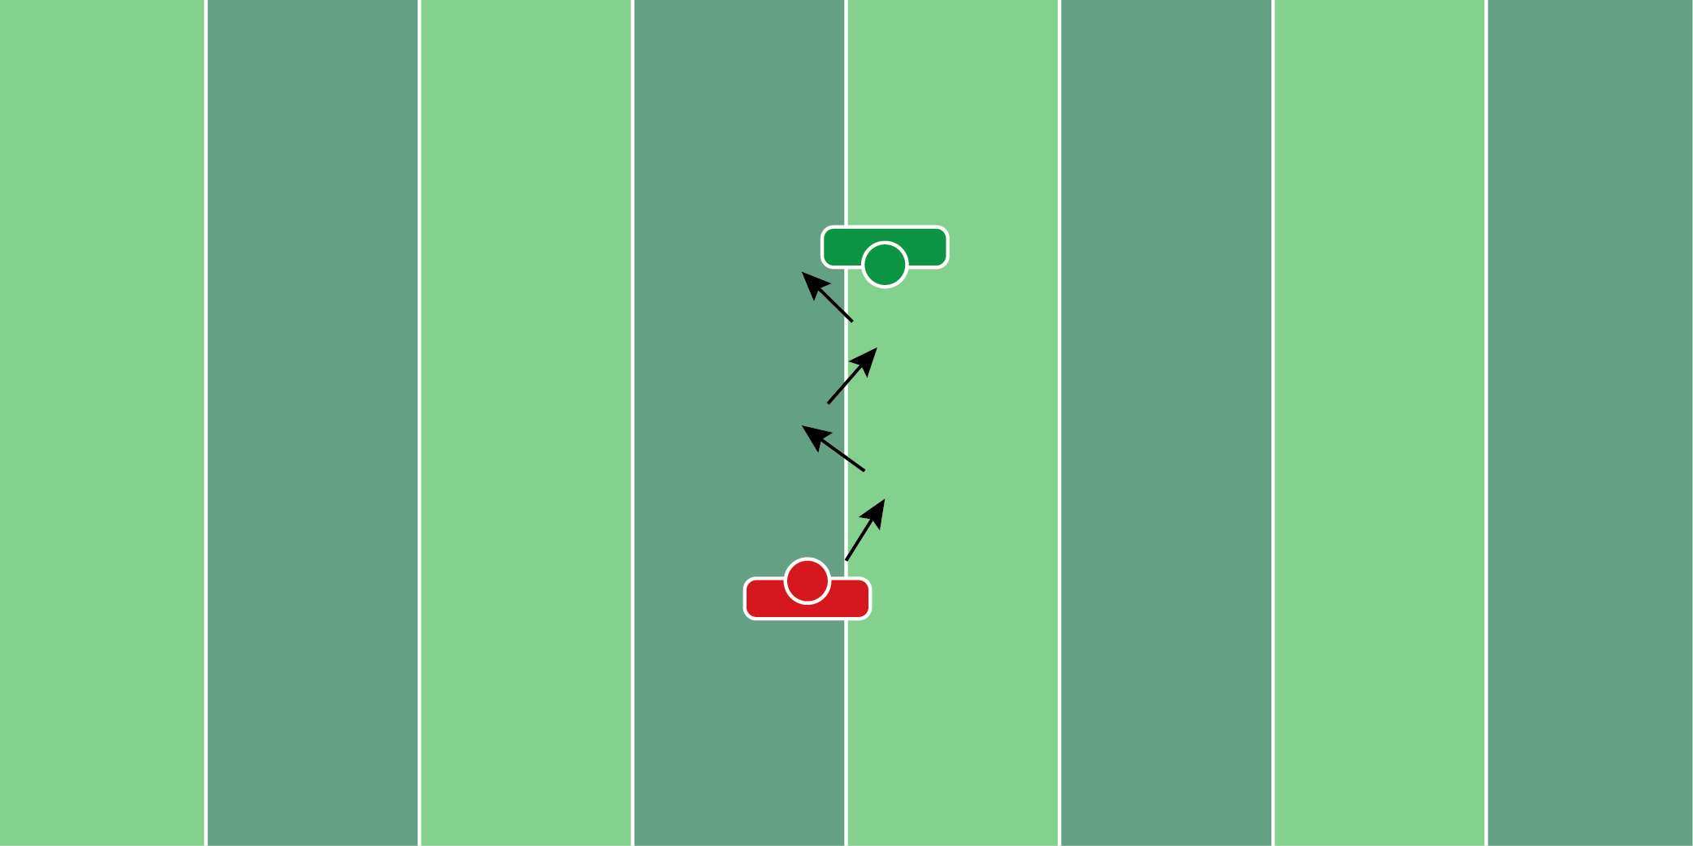
Figure 6.10

Catch Press Drill

Equipment Needed: Players/Coaches

Purpose: Practice reading the hips of a slot receiver.

Required Players: 2

Required Coaches: 0

Description: (1) The linebacker should be 5-6 yards away from the offensive player. (2) When the coach says “go”, the offensive player will make short, 45-degree cuts. (3) The linebacker should maintain athletic posture and focus on reading the hips. (4) Collide the receiver to finish the drill.
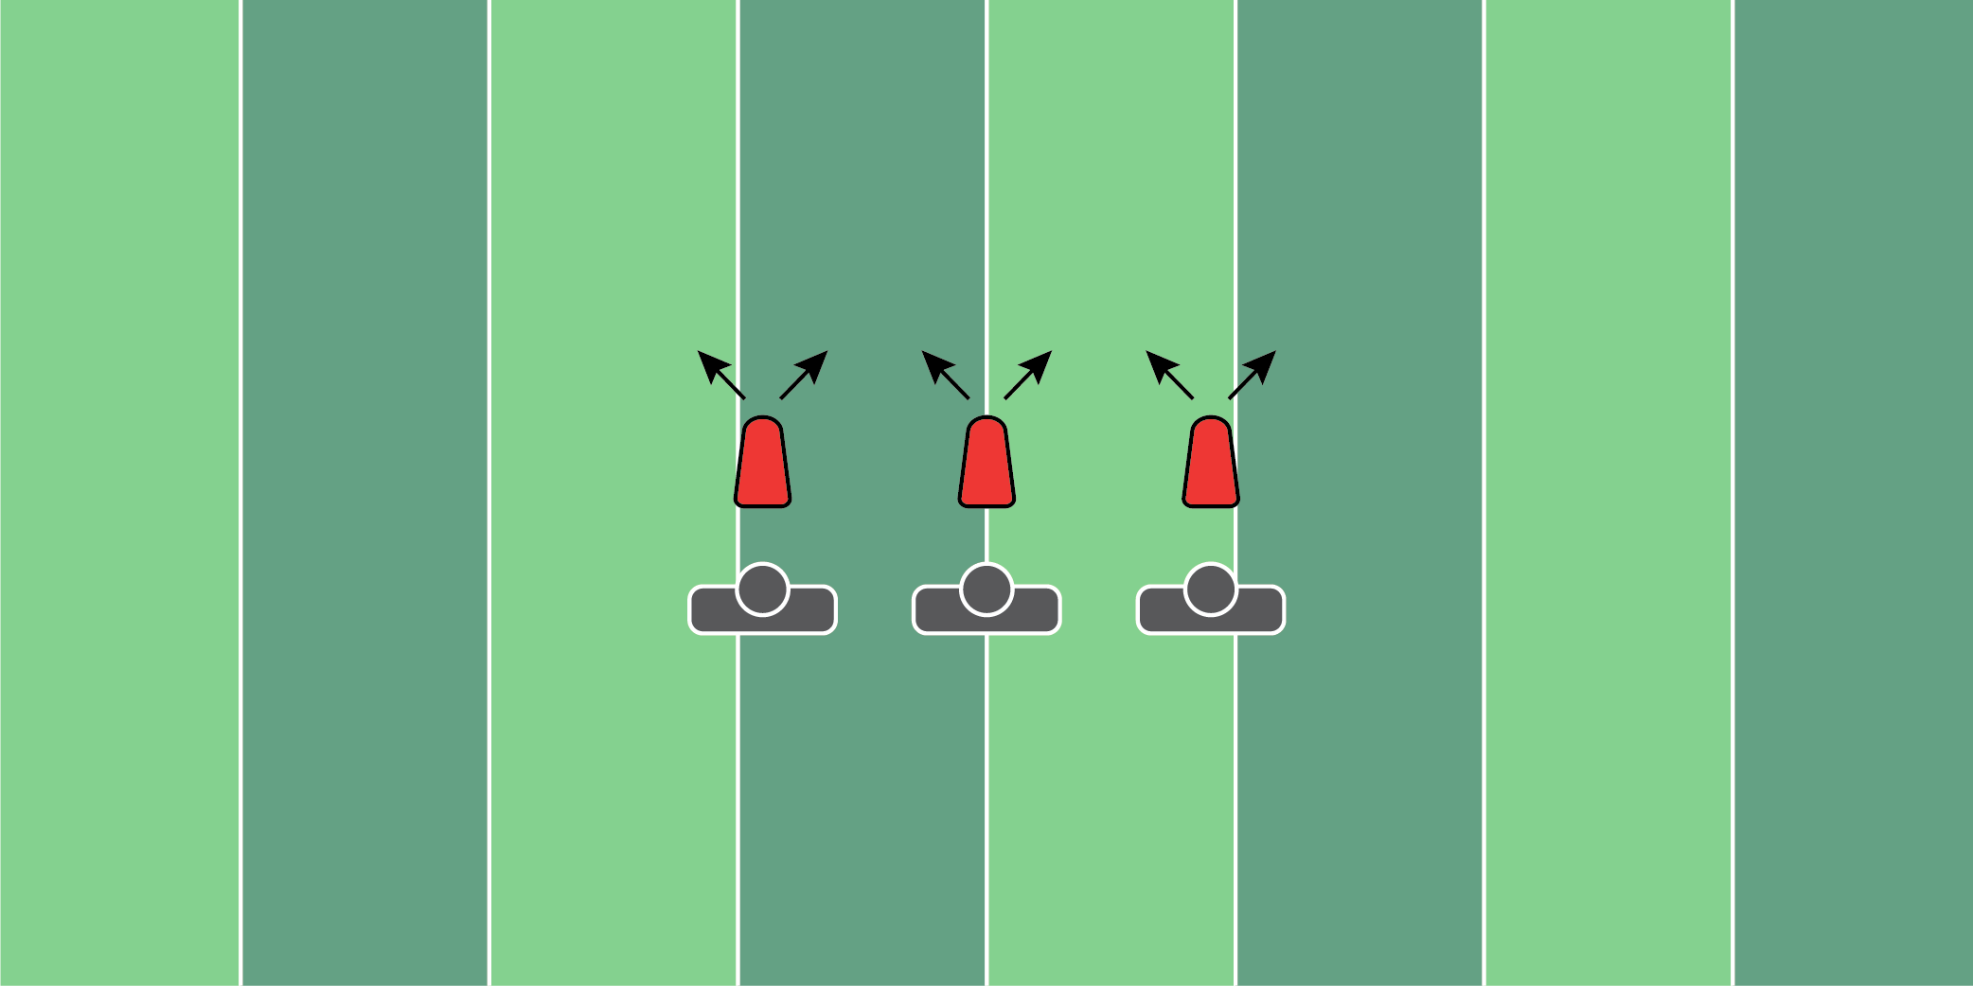
Figure 6.11

Shed & Gather Drill

Equipment Needed: Pop Up Dummies

Purpose: Teaching the player to violently shed blocks.

Required Players: 1

Required Coaches: 1

Description: (1) The linebacker should start the drill engaged with the popup dummy. (2) When the coach says “go”, the linebacker will violently shed the block and gather one yard in front of the popup dummy.

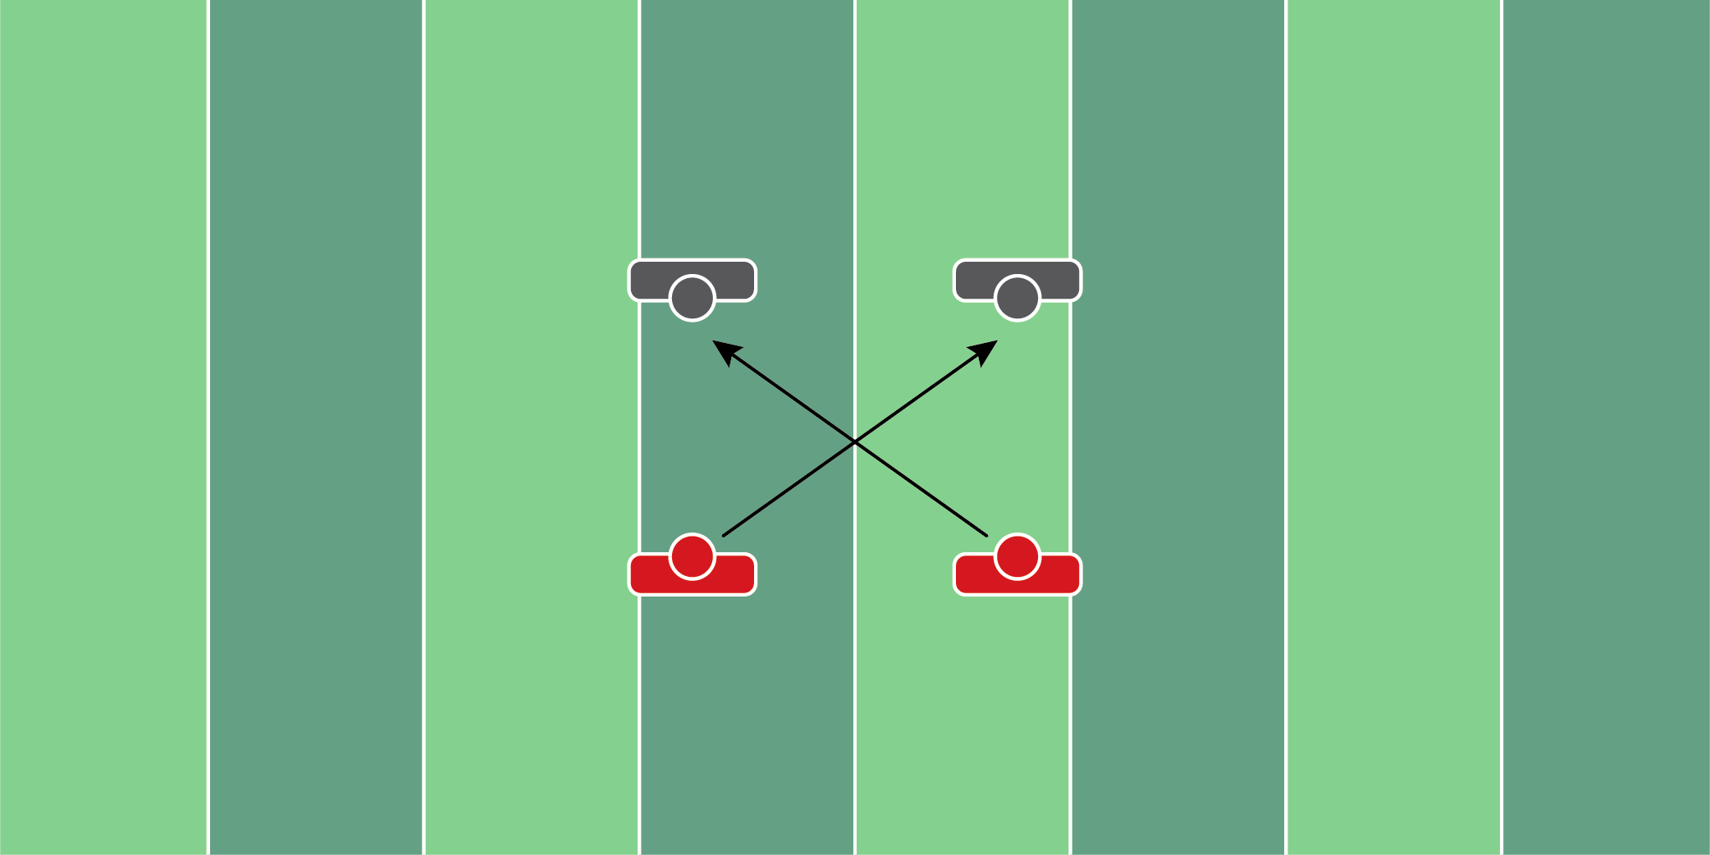
Figure 6.12

Down Block Reads Drill

Equipment Needed: Hand shields

Purpose: Reading the interior line for pulls and down blocks.

Required Players: 4

Required Coaches: 0

Description: (1) Both linebackers should start in their positions. They are reading the guard and tackle to their side. (2) When the inside linebacker realizes the guard moving to the outside, they must train their eyes to flash to the down block coming their way. (3) Fight over the down block.
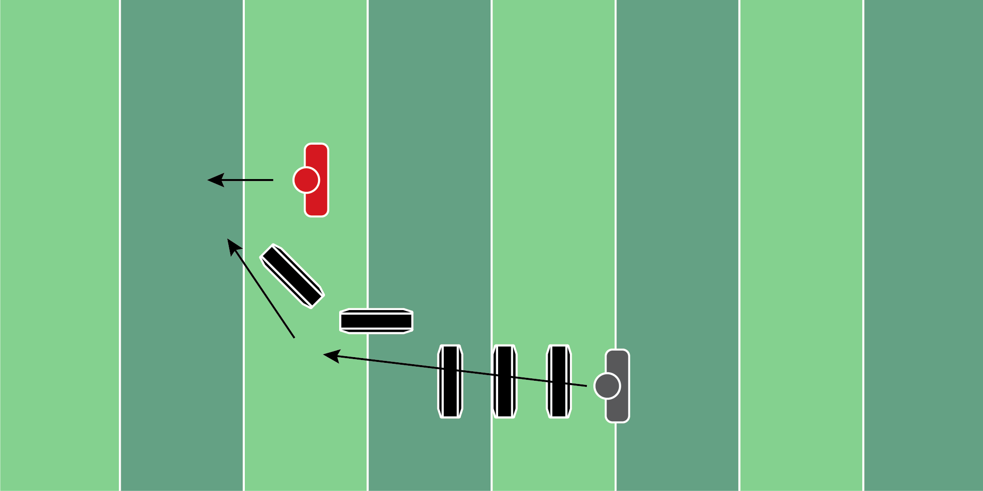
Figure 6.13

Hunt & Gather Drill

Equipment Needed: Step over bags

Purpose: Tracking the running back and staying on the near hip.

Required Players: 2

Required Coaches: 0

Description: (1) The linebacker should start at the top of the first step-over bag. (2) When the coach says “go”, the linebacker will step over each bag, and work downhill toward the running back. (3) When the linebacker gets to the last step-over bag, the running back will then run at a 45-degree angle. (4) The linebacker should make contact with the running back.
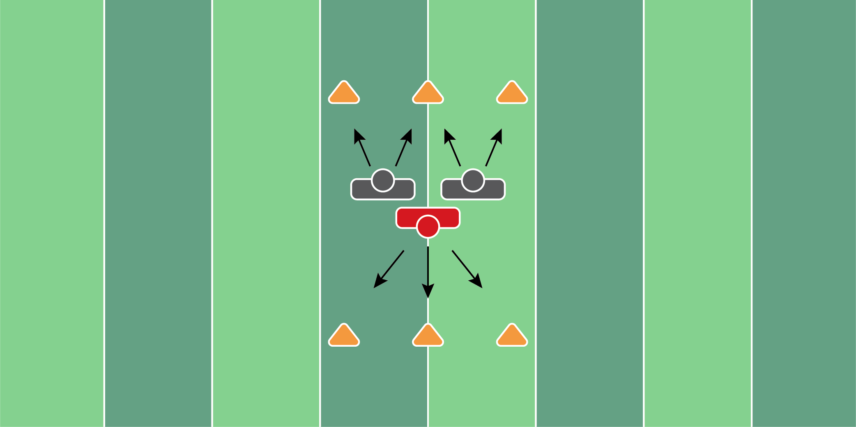
Figure 6.14

Vice Drill

Equipment Needed: Cones

Purpose: Vicing the ball carrier in space.

Required Players: 3

Required Coaches: 0

Description: (1) Both linebackers should start next to each other. The running back should also start behind the linebackers, facing the other way. (2) When the coach says “go”, the linebackers will run around the cones to their right/left. The running back will circle the cone in front of them. (3) The linebackers will then vice the running back and drive him back once he runs forward.
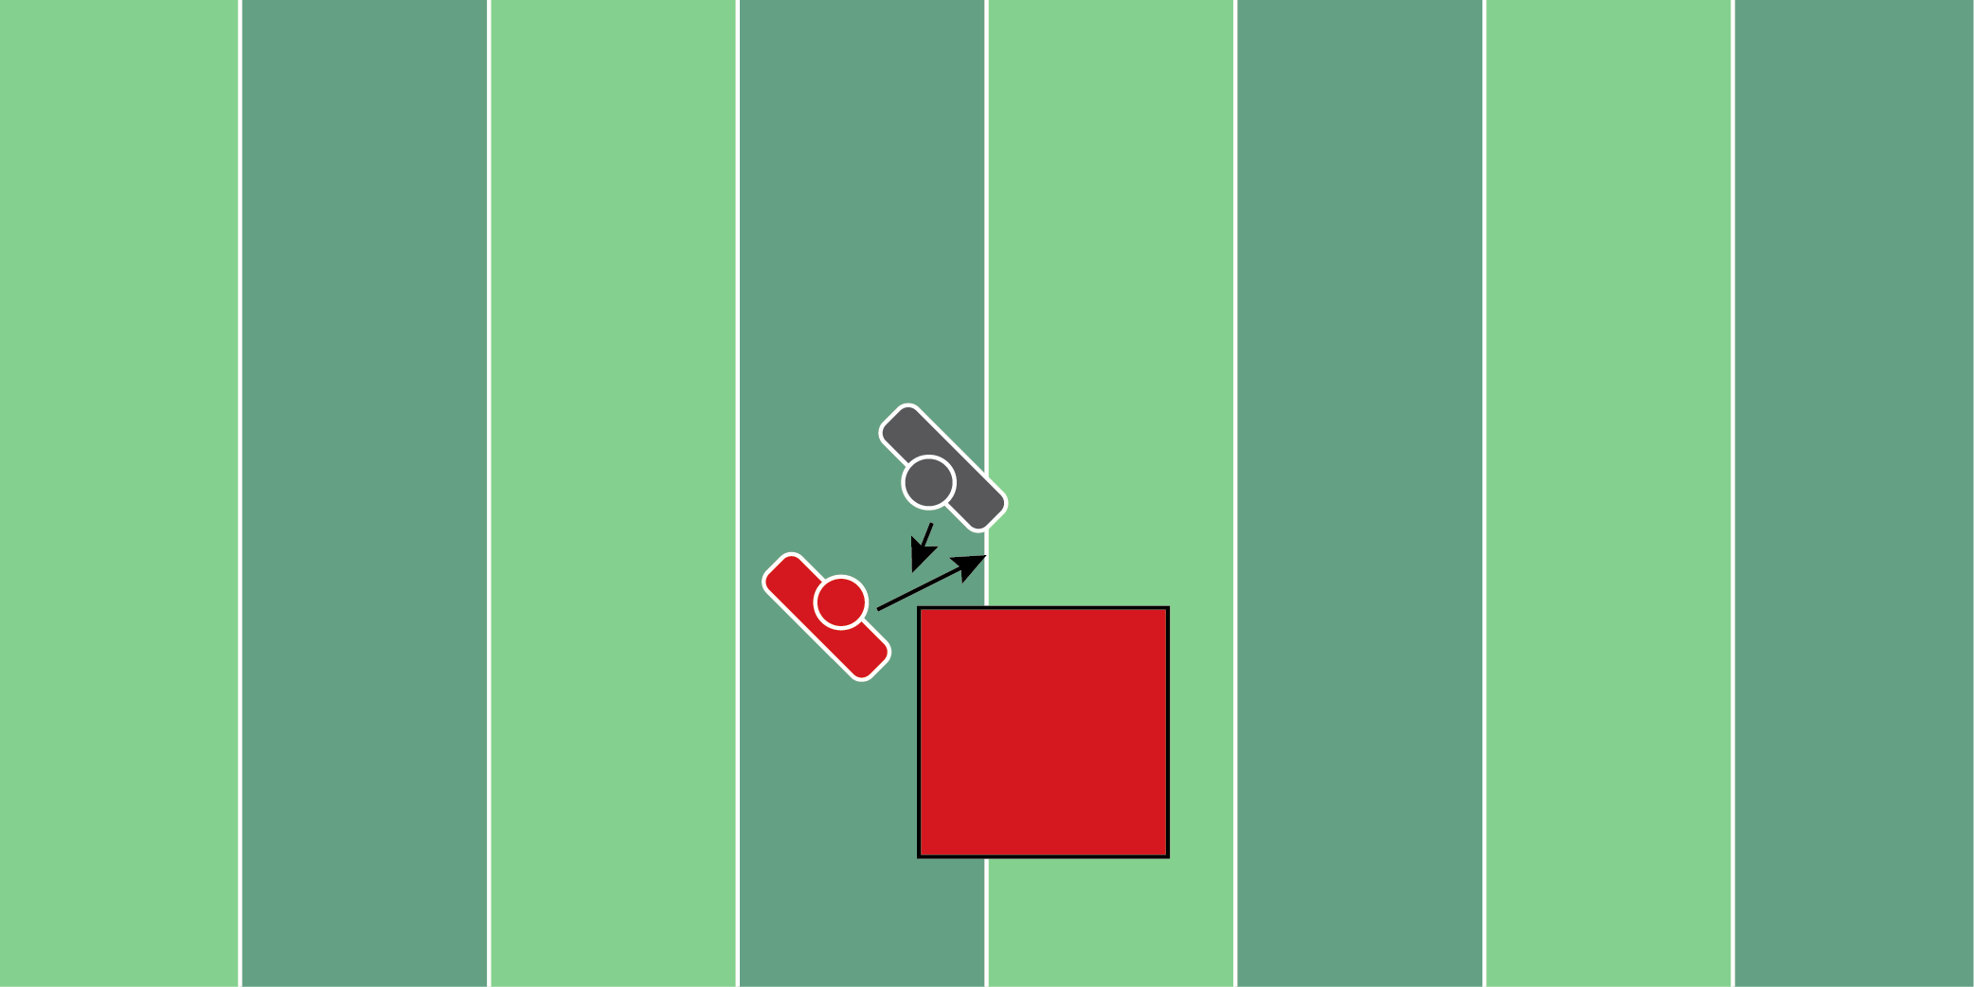
Figure 6.15

Crash Pad Tackle Drill

Equipment Needed: Crashpad or landing mats

Purpose: Teaching defenders how to tackle and land properly after contact.

Required Players: 2

Required Coaches: 0

Description: (1) Both players should start a yard away from each other. (2) When the coach says “go”, the defensive player will make contact with the offensive player, driving them to the ground.

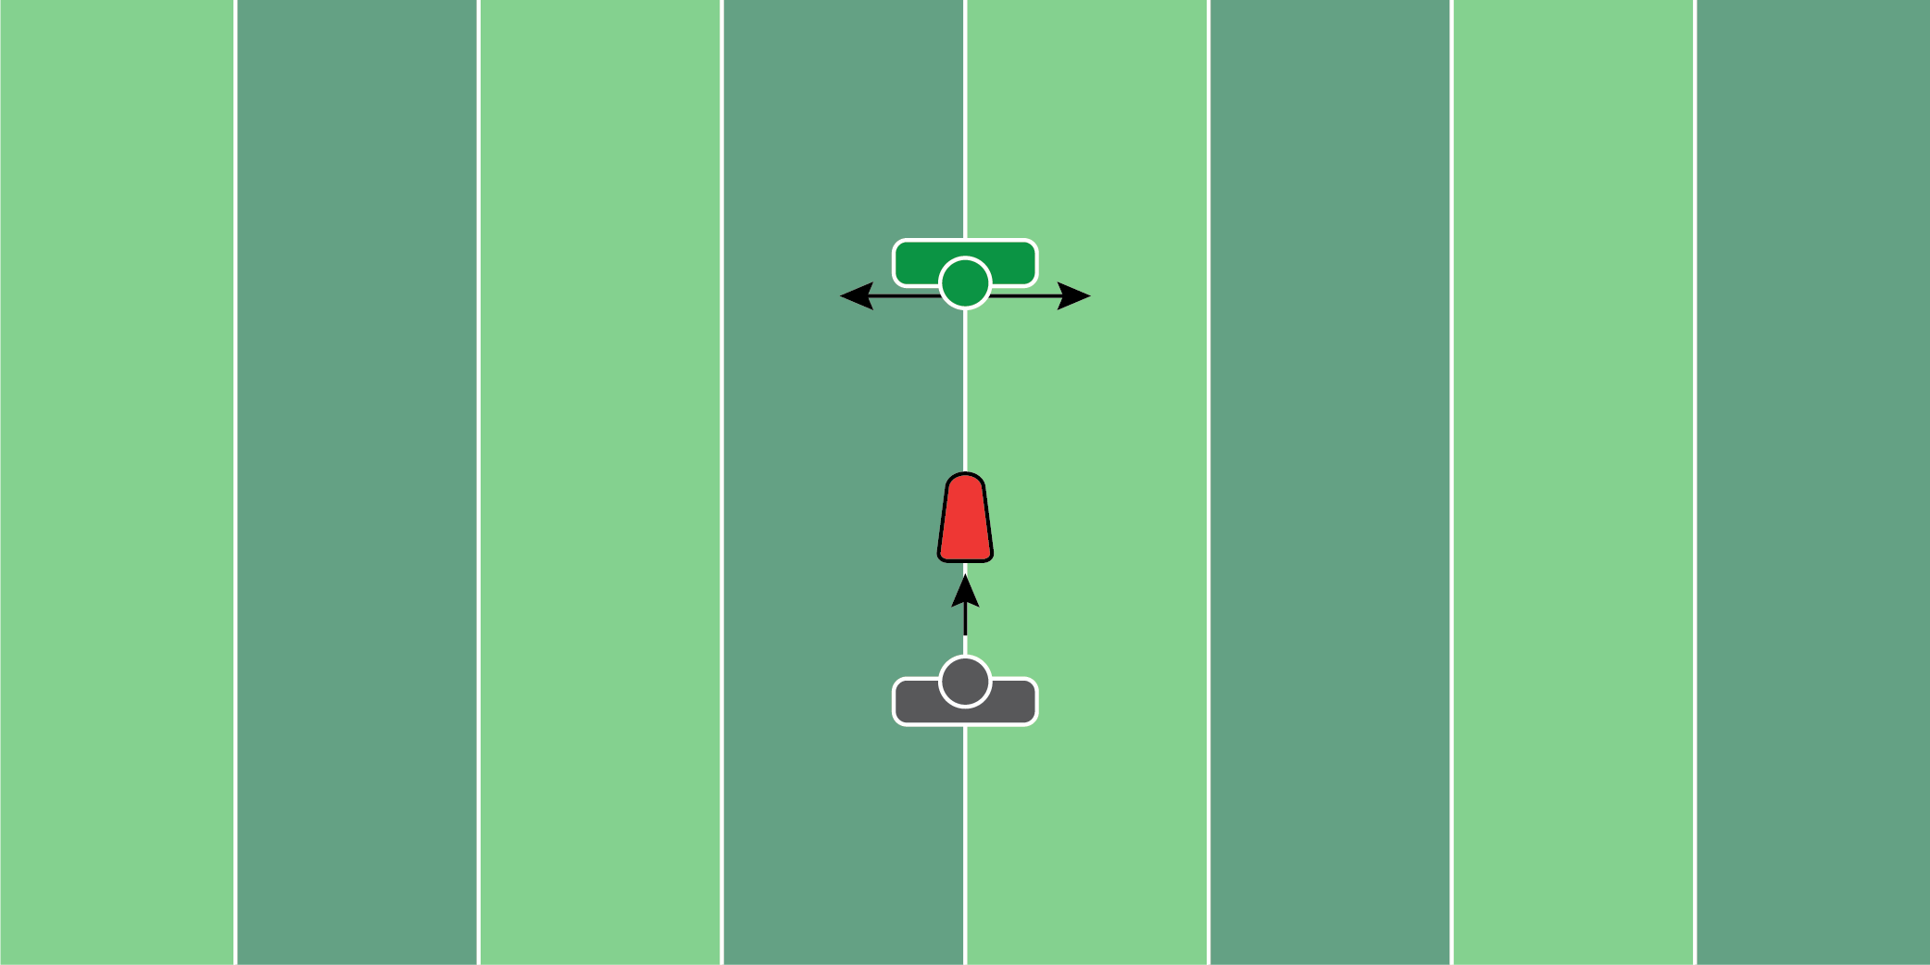
Figure 6.16

Shock Shed Drill

Equipment Needed: Single sled or pop up dummy

Purpose: Reading the interior line for pulls and down blocks.

Required Players: 1

Required Coaches: 1

Description: (1) The linebacker will start 5 yards away from the sled/dummy. (2) When the coach says “go”, the linebacker will shock and shed the sled/dummy. (3) During the shock and shed, look to find the coach who will be running right or left. Discard the sled/dummy and gather a yard away from the coach.
DEFENSIVE BACKS
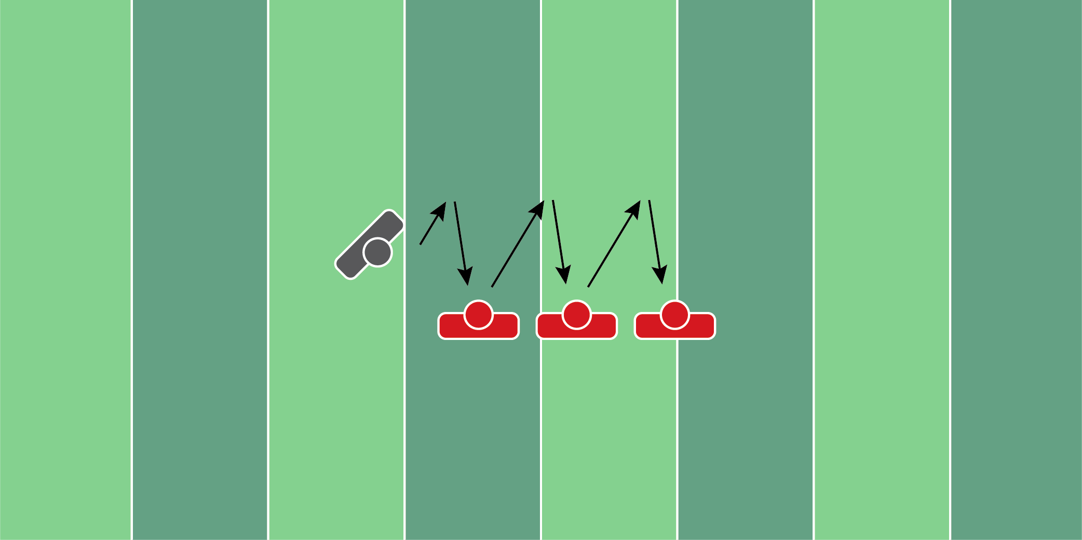
Figure 7.1

Transition “Thud” Drill

Equipment Needed: Players/Coach

Purpose: Practice transitioning and tackling while moving.

Required Players: 4

Required Coaches: 0

Description: (1) The defensive back will start in a backpedal. (2) After 3 yards, the defensive back will break toward the first offensive player. (3) After making contact with the first player, repeat the process of backpedaling and transitioning to the next offensive player. (4) Repeat this transition and tackle or thud.
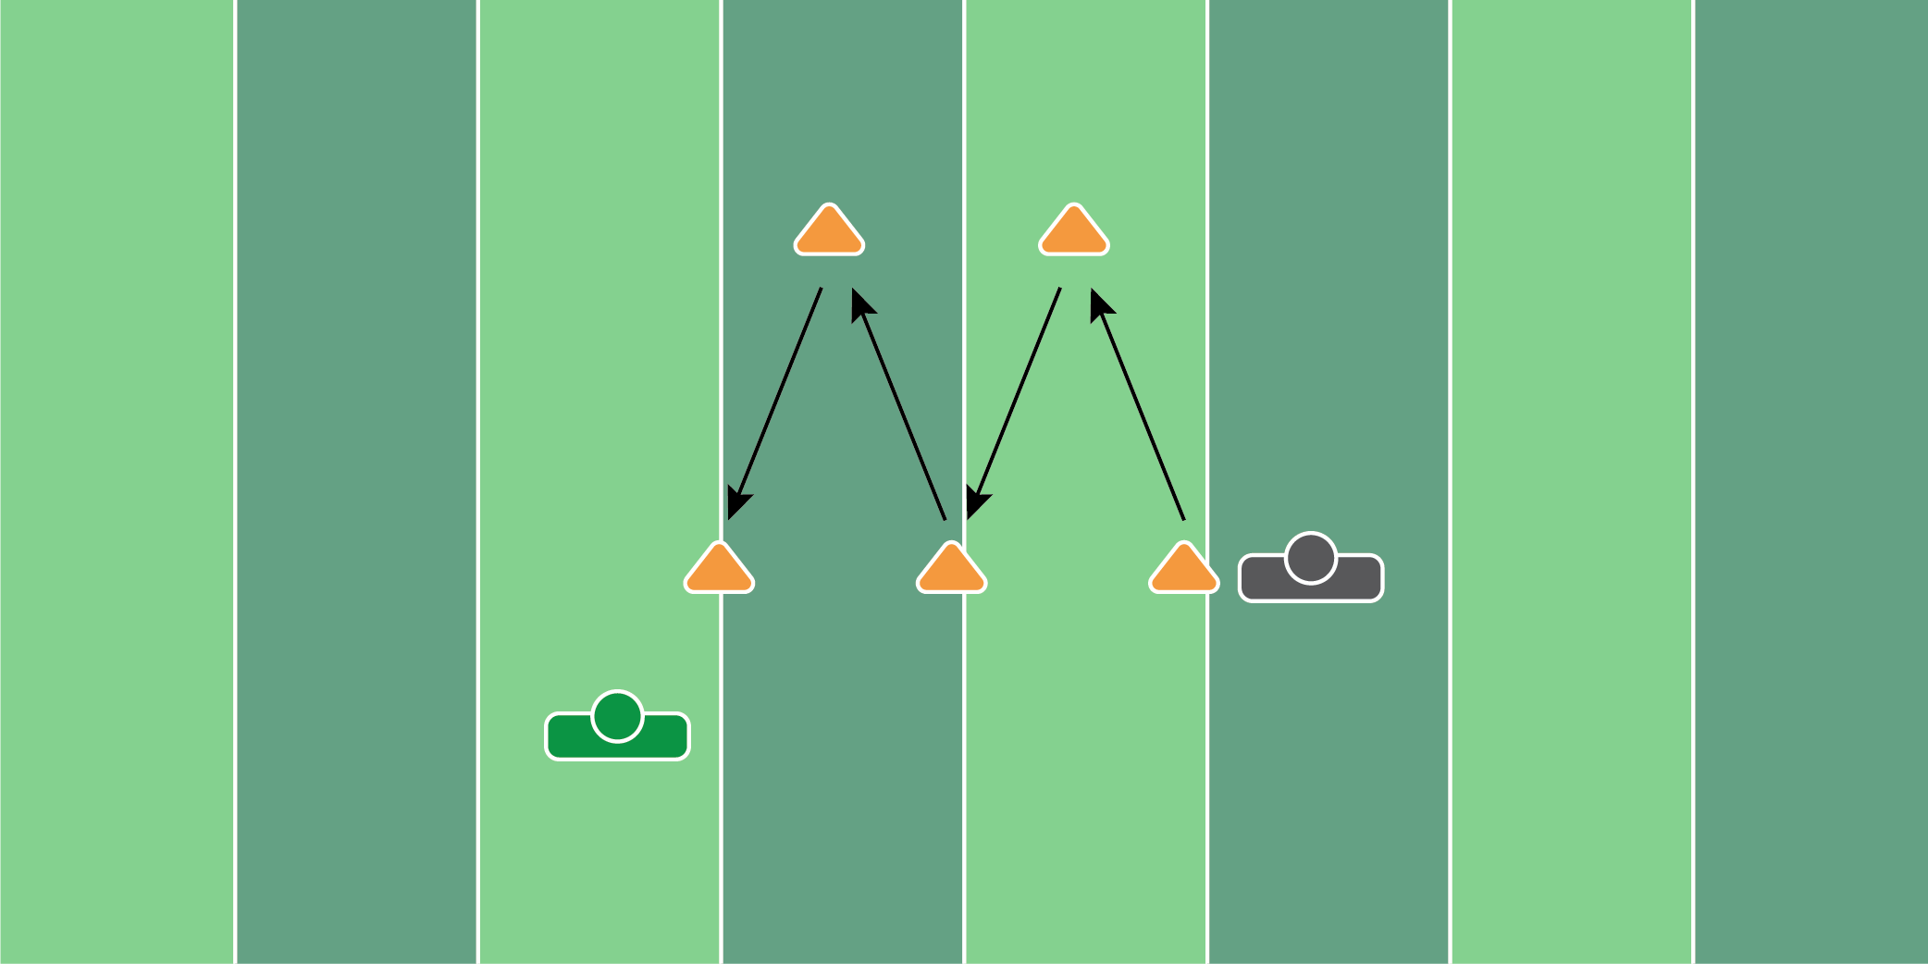
Figure 7.2

Hip Turn Transition Drill

Equipment Needed: Players/Coach

Purpose: Practice hip turning and transitioning downhill.

Required Players: 1

Required Coaches: 1

Description: (1) The defensive back will start in an open face toward the coach. (2) When the coach says “go”, shuffle to the back cone. (3) Once that cone is reached, sprint up to the next cone. (4) Once the next cone is reached, plant the outside foot in the ground and hip-turn to the next coach. (5) Baseball-turn on the last cone and catch the football from the coach.
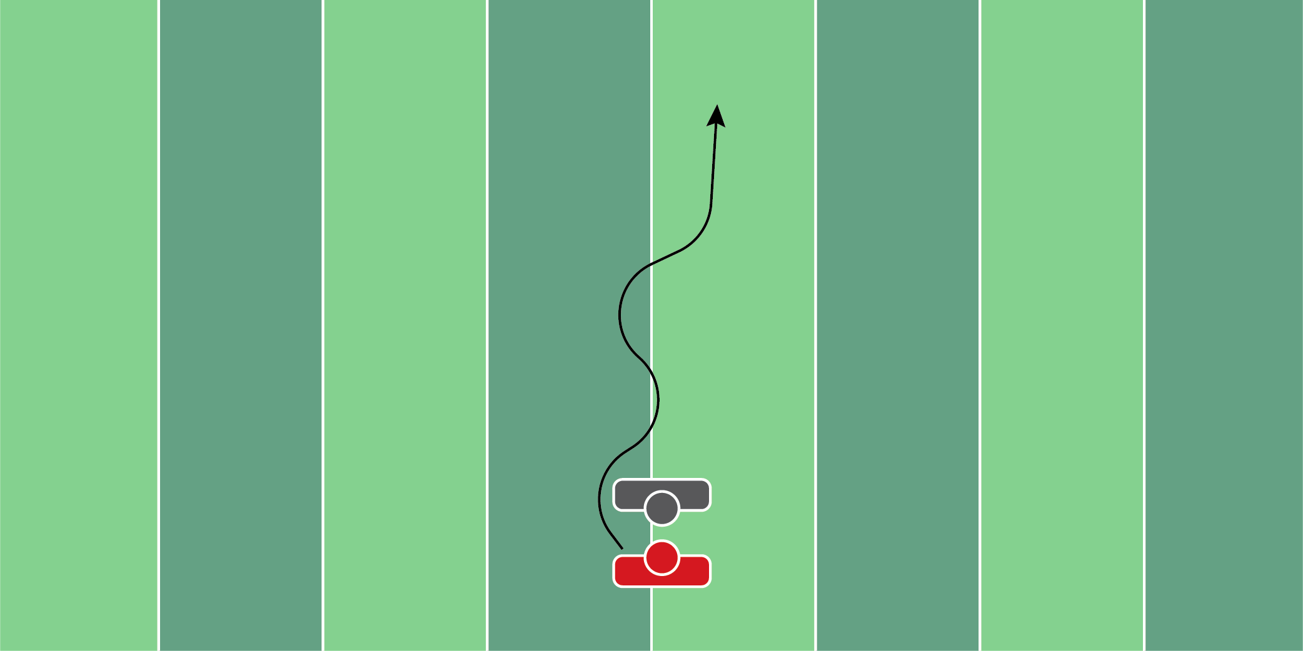
Figure 7.3

No Hands Mirror Drill

Equipment Needed: Players/Coach

Purpose: Learning to mirror wide receivers, focusing primarily on footwork and positioning.

Required Players: 2

Required Coaches: 0

Description: (1) The defensive back will start in a man coverage alignment. For the sake of the drill, the defensive back will start with his hands behind his back or to the side of his body. This is completely up to the coach. (2) When the wide receiver moves, the defensive back will mirror the player as if they were playing man coverage.
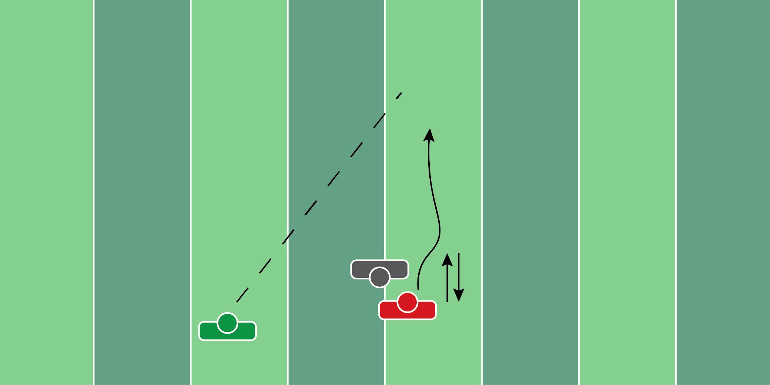
Figure 7.4

Out Of Phase Drill

Equipment Needed: Players/Coach

Purpose: Practice playing through the hands when out of phase.

Required Players: 2

Required Coaches: 1

Description: (1) The defensive back will start facing the wide receiver, with his back to the coach. (2) The coach will then yell “ball”, which he will throw the ball to the wide receiver. (3) The wide receiver will try to jump in the air and catch the football. It’s up to the defensive back to play through the hands of the receiver and knock the ball away.
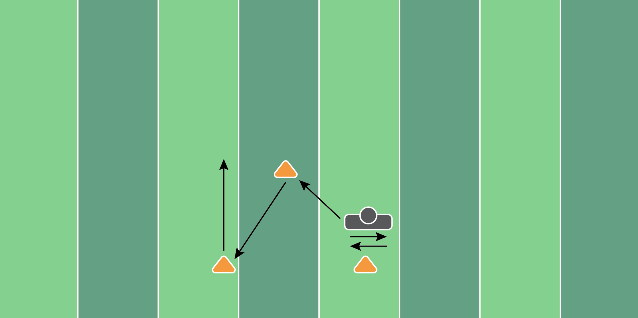
Figure 7.5

Press Pedal Drill

Equipment Needed: Cones

Purpose: Practicing all the movements a defensive back will encounter throughout the game.

Required Players: 1

Required Coaches: 1

Description: (1) The defensive back will start in his stance, directly in front of the coach. (2) When the coach says “go”, the defensive back will start by shuffling left and right, as if they’re playing man coverage. (2) Next, the player should backpedal until they reach the cone 5 yards behind the original position. Transition forward to the next cone at a 45 degree. (3) Finish with opening the hips to the outside and running 5-10 yards.
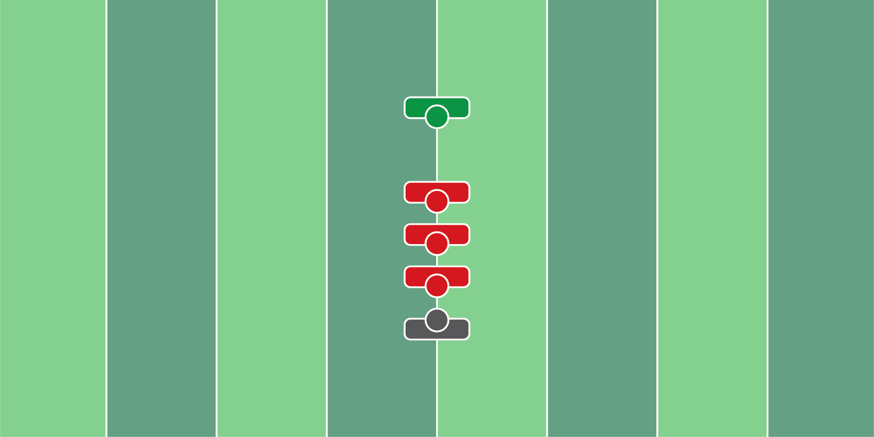
Figure 7.6

Shock Shed Train Drill

Equipment Needed: Players/Coach

Purpose: Training hand placement when shocking and shedding an opponent.

Required Players: 4

Required Coaches: 1

Description: (1) The defensive back will start in an athletic position in front of the first offensive player. (2) On each whistle, the defensive player will shoot his hands toward the breastplate of the offensive player and violently shed them. (3) Repeat this process until every offensive player has been shed. (4) Finish with a fumble recovery from the coach.

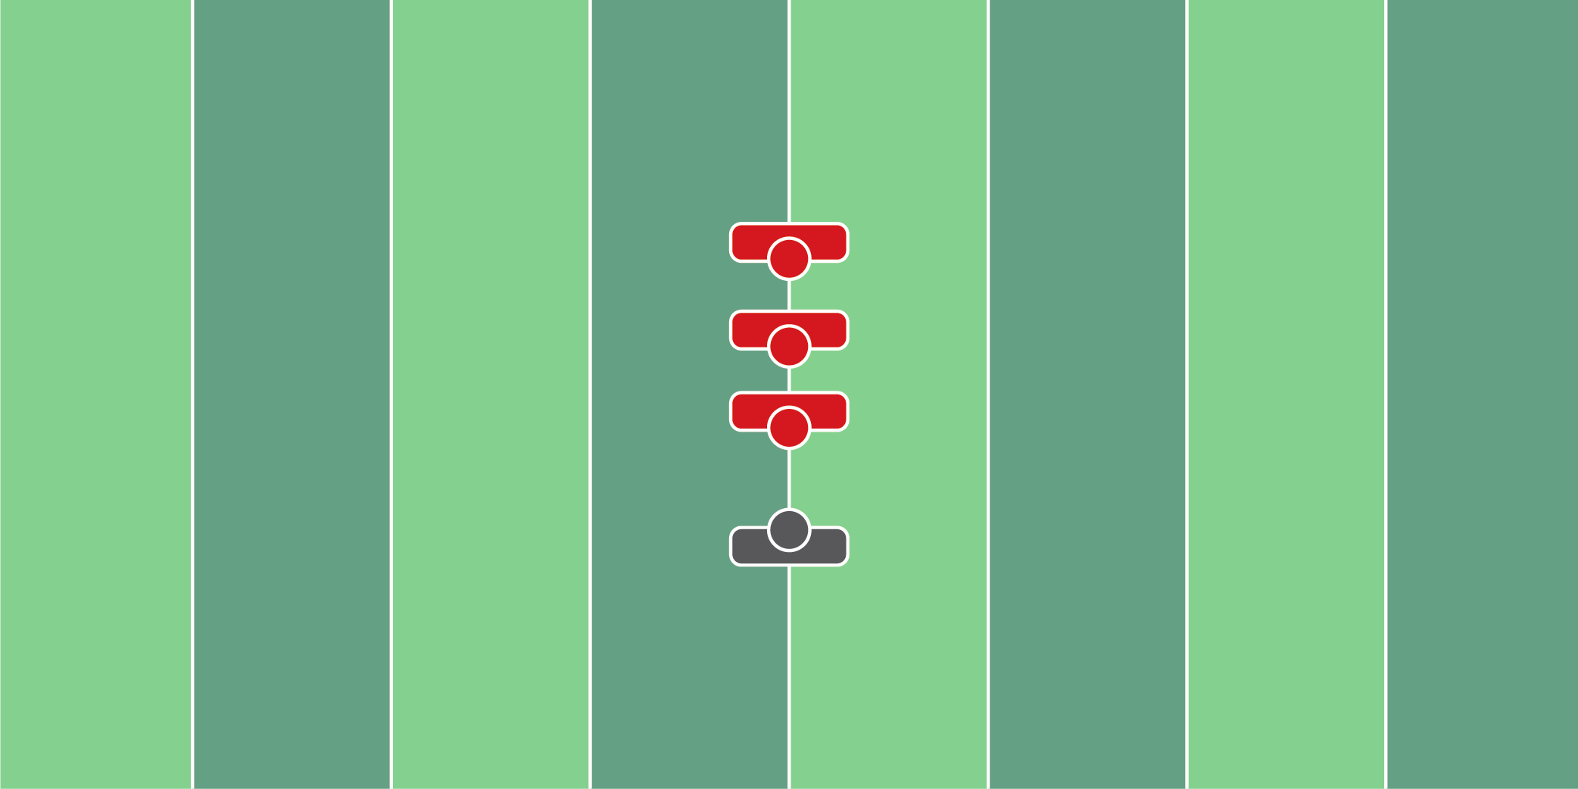
Figure 7.7

Shock Shed Tackle Drill

Equipment Needed: Players/Coach

Purpose: Training hand placement when shocking and shedding an opponent; finish with a tackle.

Required Players: 4

Required Coaches: 0

Description: (1) The defensive back will start in an athletic stance. When the coach says “go”, the defensive player will shock and shed the first two offensive players running at him. (2) Once the first two players have been shed, finish with a tackle on the third player.

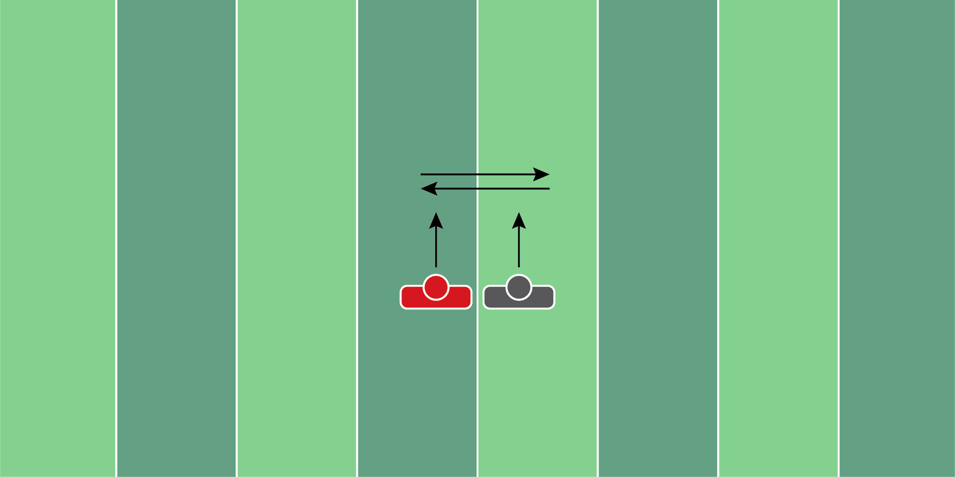
Figure 7.8

Break Compete Drill

Equipment Needed: Players/Coach

Purpose: Training to drive, react and undercut throws.

Required Players: 2

Required Coaches: 1

Description: (1) The defensive back will start next to another defensive back. When the coach says “go”, both players will backpedal side by side. (2) When the coach points to a direction, both players will break in that position. The outside player turns into the offensive player and the inside player turns into the defensive player. Both are competing for the football as the coach throws it.
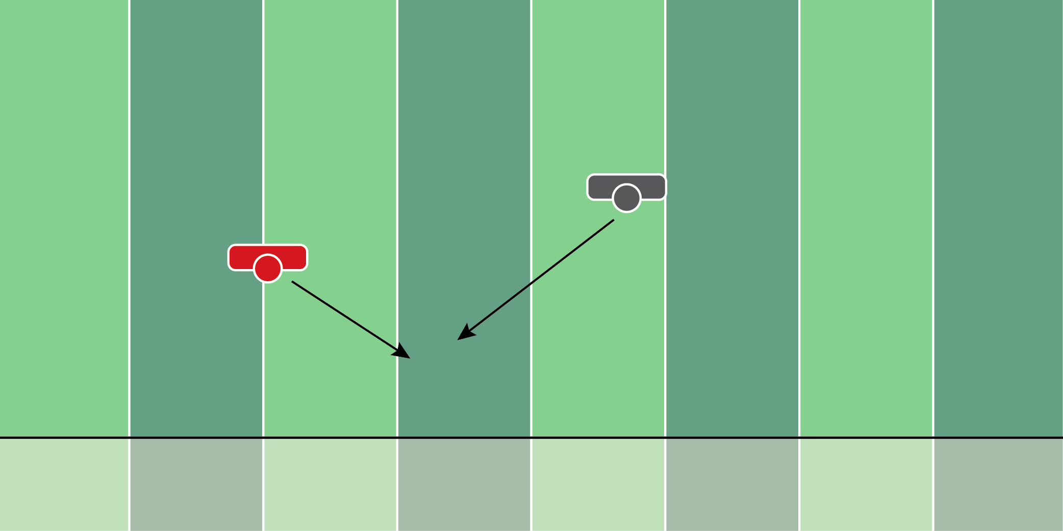
Figure 7.9

Inside - Out Tackling Drill

Equipment Needed: Players/Coach

Purpose: Training defensive backs on how to run the alley and tackle in space.

Required Players: 2

Required Coaches: 0

Description: (1) The cornerback will start in an athletic position, whether that’s facing the line of scrimmage or open-faced. (2) When the coach says “go”, the running back should run toward the cornerback, trying to make him miss. (3) The cornerback should try to make a tackle on the running back.

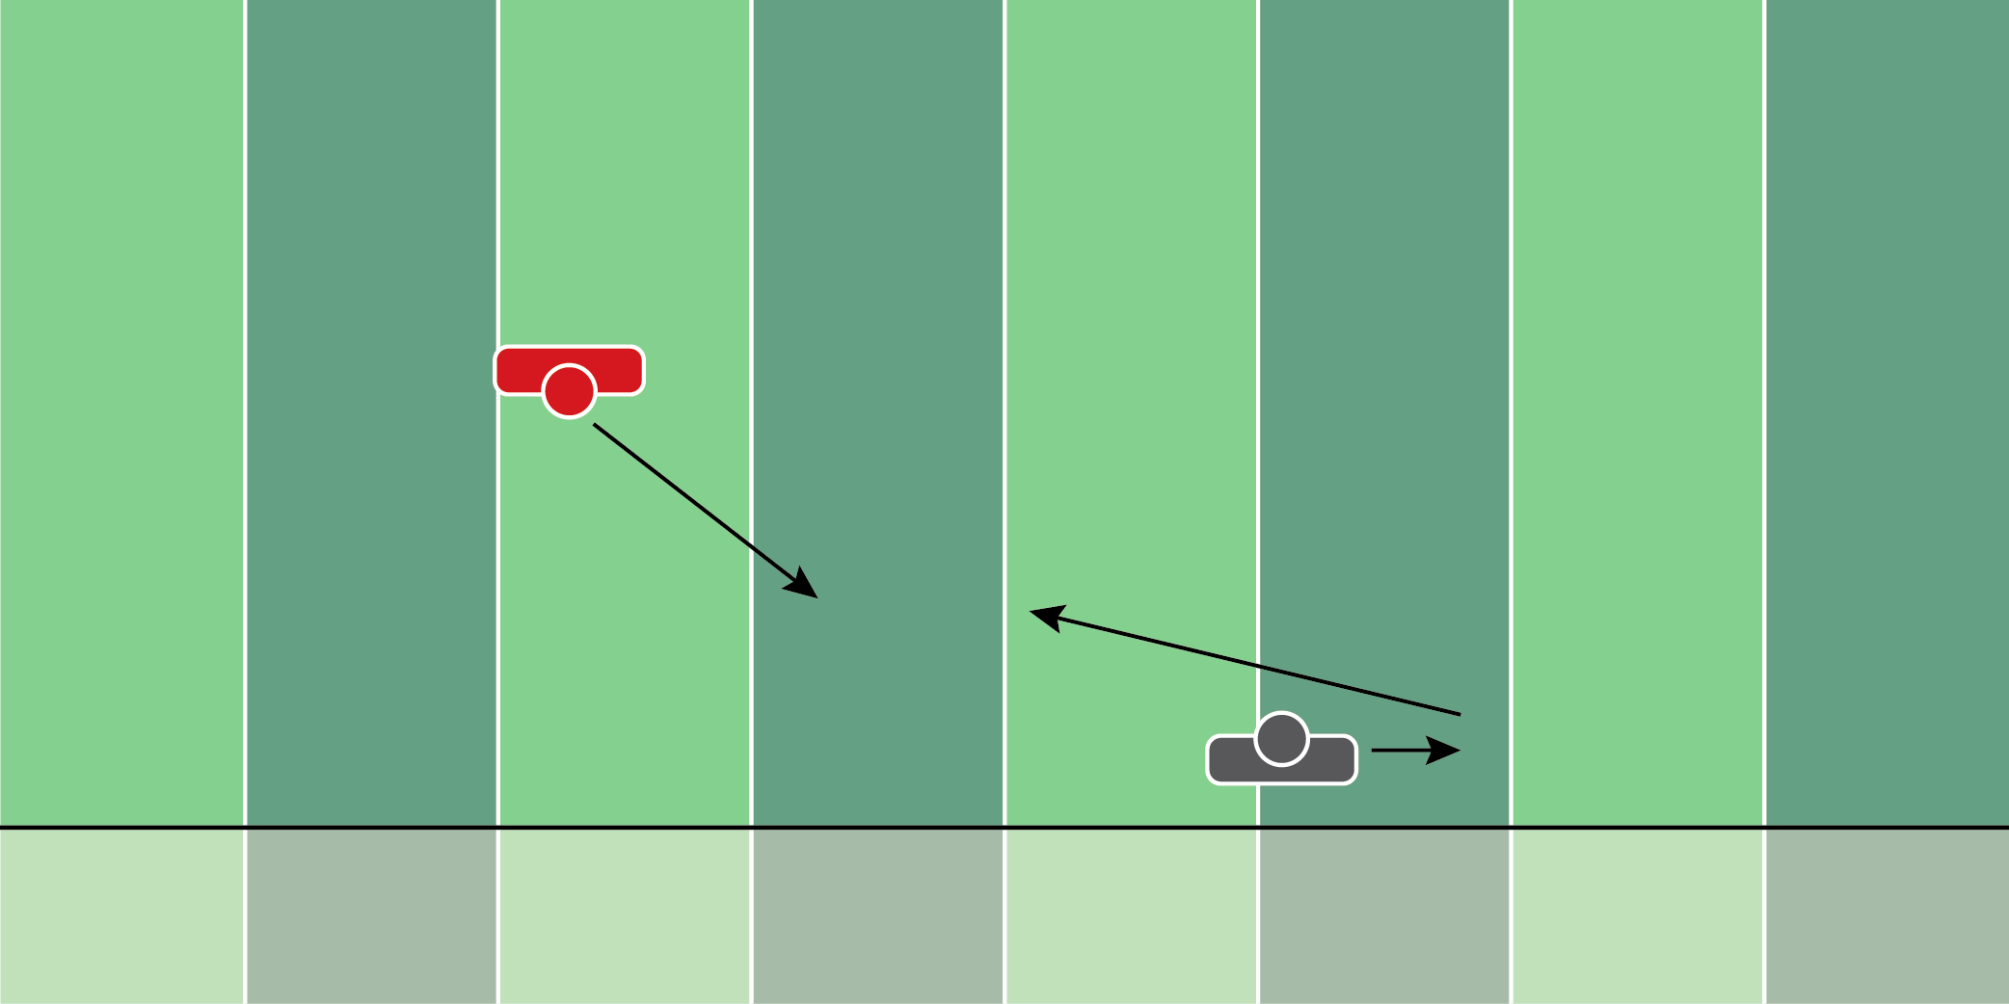
Figure 7.10

Outside Angle Tackling Drill

Equipment Needed: Players/Coach

Purpose: Training cornerbacks on how to angle tackle from the outside-in.

Required Players: 2

Required Coaches: 0

Description: (1) The cornerback will start in an athletic position, whether that’s facing the line of scrimmage or open-faced. (2) When the coach says “go”, the running back should run toward the cornerback, trying to make him miss. (3) The cornerback should try to make a tackle on the running back. The point of the drill is to teach cornerbacks about tackling from different angles.

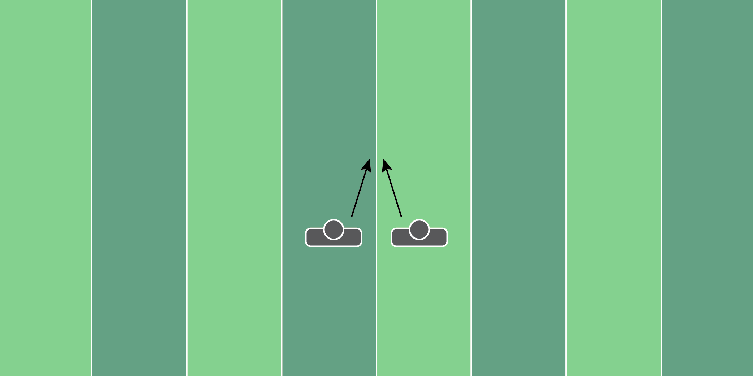
Figure 7.11

Vice & Strip Tackling Drill

Equipment Needed: Popup dummy or player

Purpose: Training players how to vice and drive on an offensive player.

Required Players: 2 (or 3 if not using pop up dummy)

Required Coaches: 0

Description: (1) The two defensive backs will start 3 yards away from the popup dummy. (2) When the coach says “go”, both players should make contact with the dummy. (3) The coach behind the popup dummy is bracing the dummy and providing enough force so it doesn’t fall over. (4) While players are pushing the dummy, they should work on punching the dummy as if they would the football.
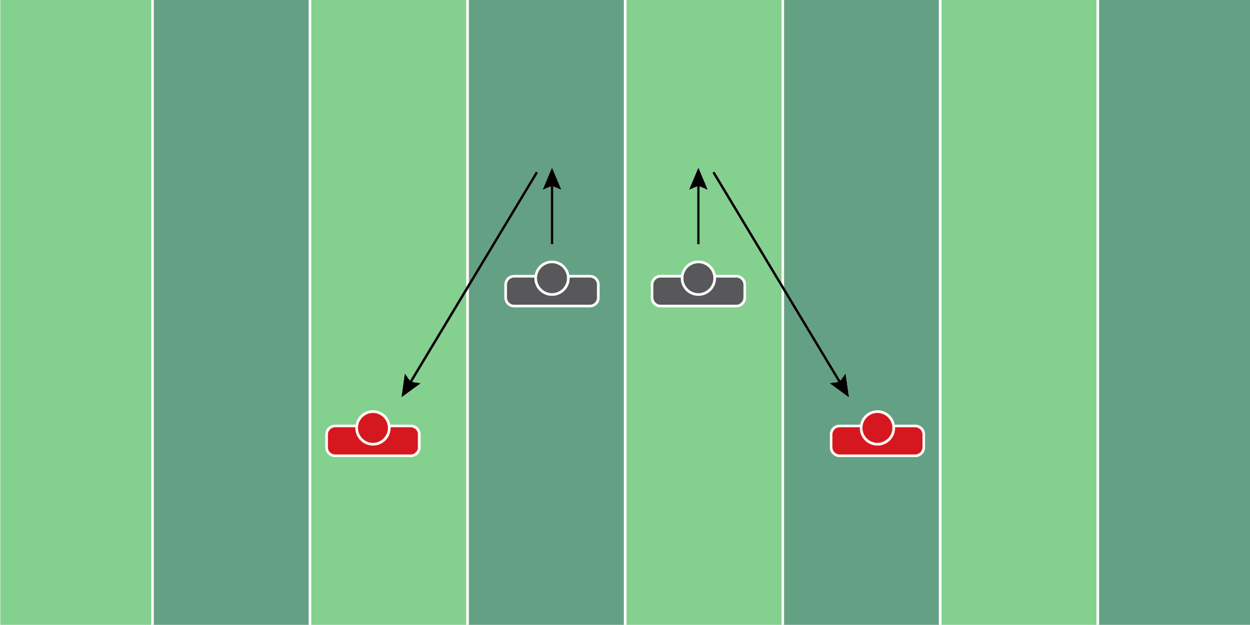
Figure 7.12

Drive & Disrupt Drill

Equipment Needed: Players/Coach

Purpose: Training cornerbacks on how to angle tackle.

Required Players: 2

Required Coaches: 2

Description: (1) The cornerbacks will start 5 yards away from each other. The coaches will be positioned 5 yards forward and 5 yards to the outside of the defensive back. (2) When the coach says “go”, both players will open their hips to the inside and crossover run. (3) When the coach says “break”, they will break and drive toward the coach who will be holding a football. The defensive back should take the angle toward the ball and disrupt the hands of the coach who’s holding the ball.

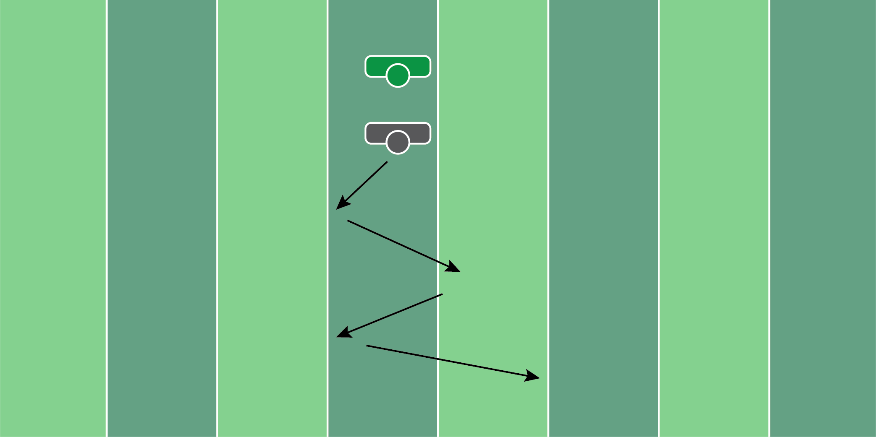
Figure 7.13

Hip Flip Deep Ball Drill

Equipment Needed: Players/Coach

Purpose: Training defensive backs to read the QB’s movements and track down deep balls.

Required Players: 1

Required Coaches: 1

Description: (1) The defensive back will start in an athletic position in front of the coach. (2) When the coach says “go”, the defensive back will start to backpedal. From here, the coach should move the ball to the left or right, to signal to the defensive back to open their hips that way. (3) Move the defensive back right and left several times, before throwing the football deep.

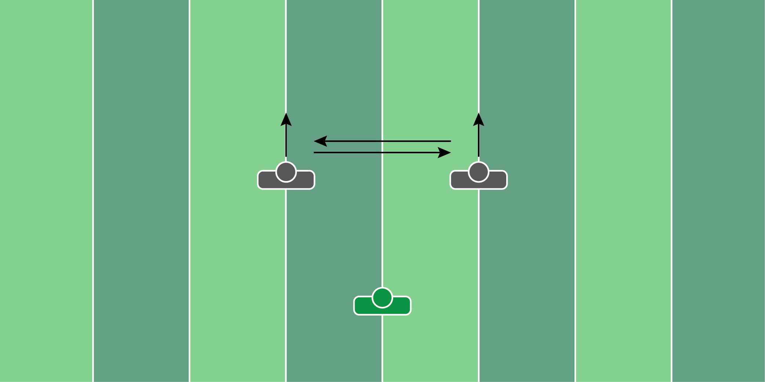
Figure 7.14

90 Degree Compete Drill

Equipment Needed: Players/Coach

Purpose: Training players to break at 90 degrees and disrupt the offensive player.

Required Players: 2

Required Coaches: 1

Description: (1) The defensive backs will start 10 yards away from each other. (2) When the coach says “go”, both players will backpedal. Whichever player the coach points or looks to, becomes the offensive player. This player will stand still and not move. (3) The opposite player will break toward that player, trying to knock the ball away.
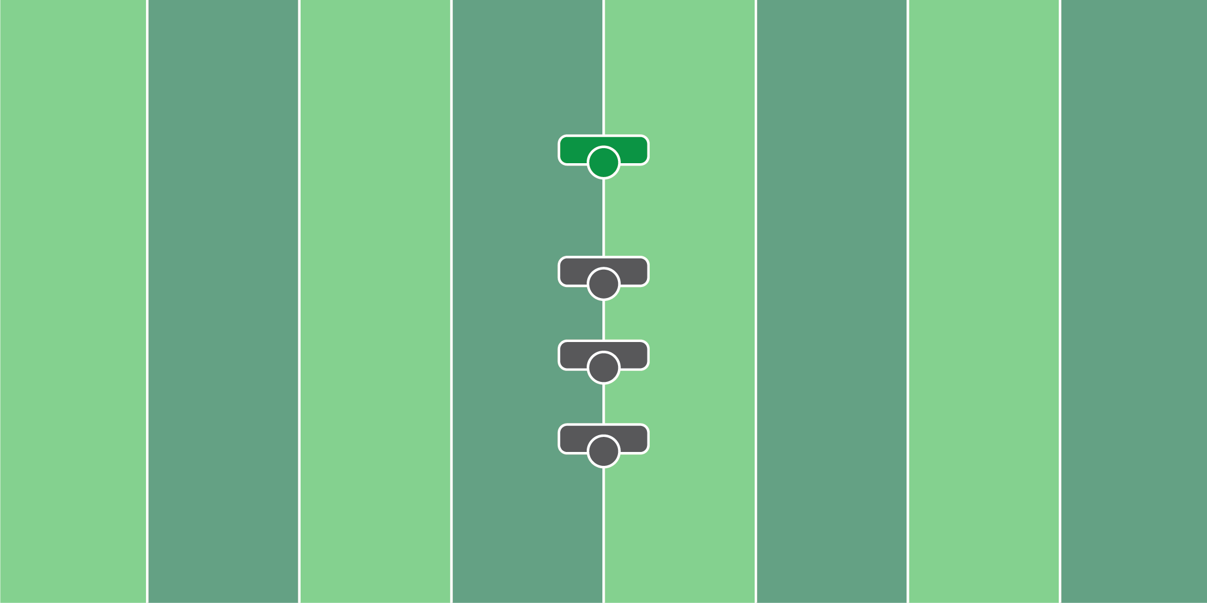
Figure 7.15

First Step Man Drill

Equipment Needed: Players/Coach

Purpose: Training cornerbacks on the importance of the first step in man coverage.

Required Players: 1

Required Coaches: 1

Description: (1) The cornerback will start in an athletic position as if they’re playing man coverage. (2) When the coach says “go”, the player will move 3 steps to the outside or inside as if their man is running a fade or an inside slant. (3) The coaching point is to make sure the hands and the feet are working together as one.
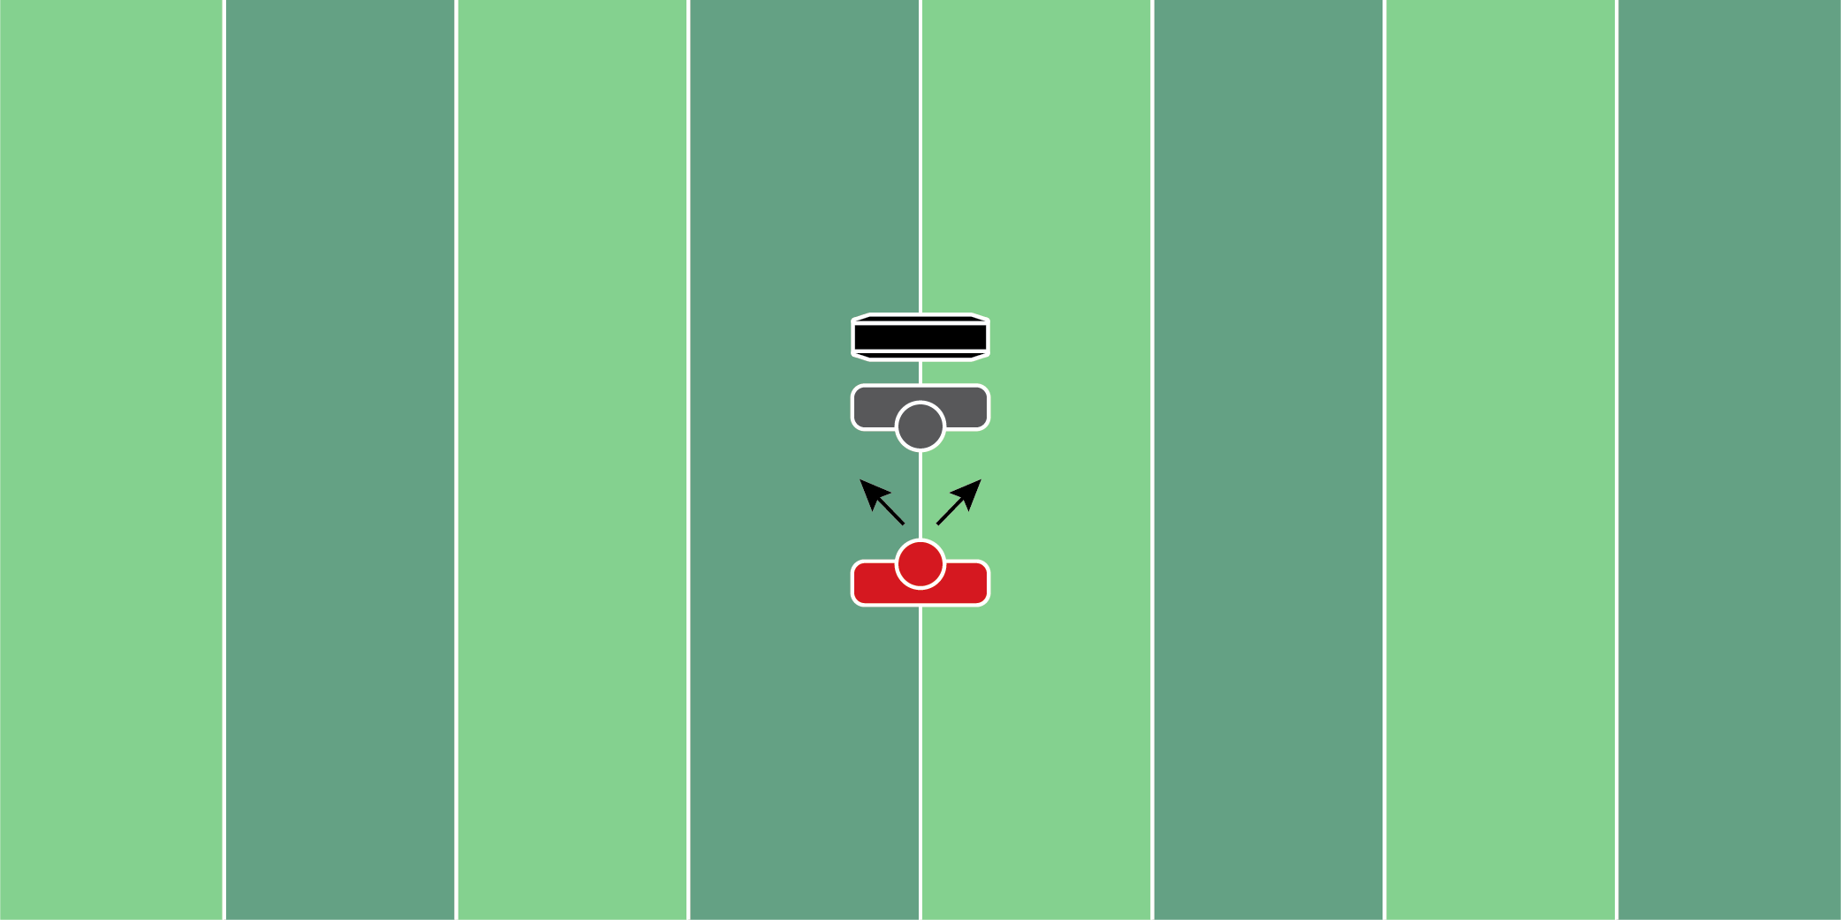
Figure 7.16

Lateral Man Coverage Drill

Equipment Needed: Hand shield

Purpose: Training cornerbacks to keep their hips closed, by using a hand shield behind their feet.

Required Players: 2

Required Coaches: 0

Description: (1) The cornerback will start in an athletic position as if they’re playing man-to-man coverage on the receiver. (2) Place a hand shield directly behind the defensive player. This will help them keep their hips closed, and move laterally. (3) When the coach says “go”, work to deny the receiver who is trying to work vertically.

TACKLING
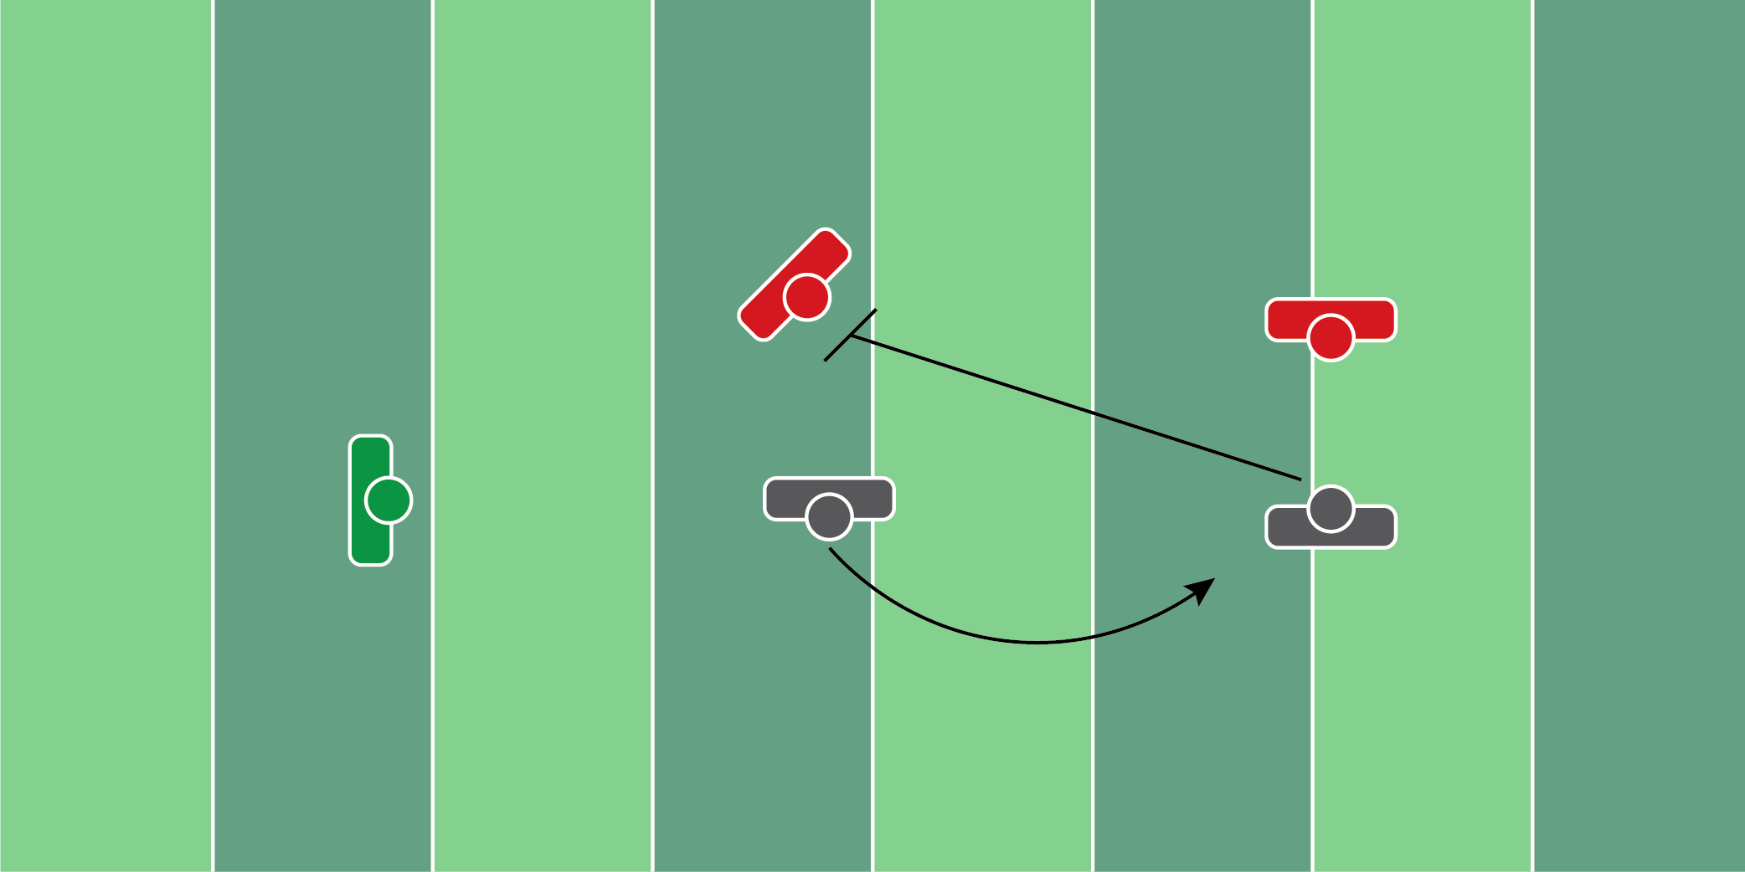
Figure 8.1

2x2 Perimeter Drill

Equipment Needed: Players/Coaches

Purpose: Train perimeter tackling on the edge.

Required Players: 4

Required Coaches: 1

Description: (1) The offense will line up in a 2x2 formation with 2 receivers to one side. (2) When the coach says “go”, he will throw the football to the inside receiver, while the outside receiver blocks. (3) The two defenders need to chase down and shed the block of the offensive players.
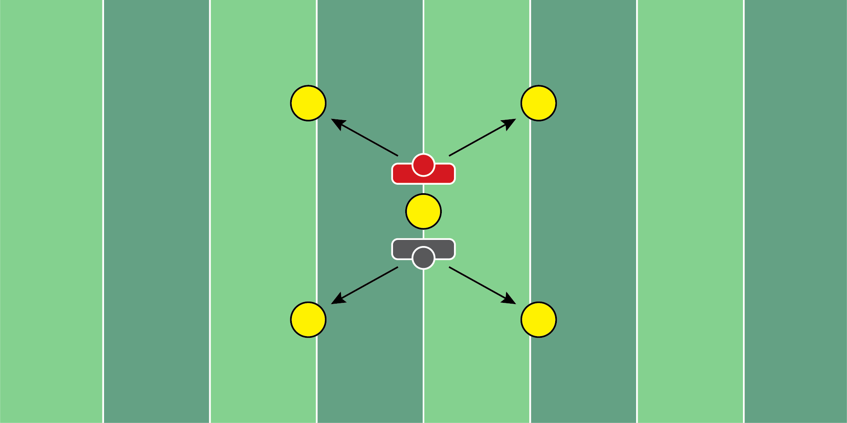
Figure 8.2

2 Cone Drill

Equipment Needed: Cones

Purpose: Training defenders to turn, locate, and take the proper angle to the ball carrier.

Required Players: 2

Required Coaches: 0

Description: (1) Both players will start back to back. One player will be the defense, the other player will be the ball carrier. (2) When the coach says “go”, both players will run to a cone of their choice, and run around it. (3) When they circle the cones, the offensive player will try to make the defensive player miss. The defensive player will try to make a tackle.

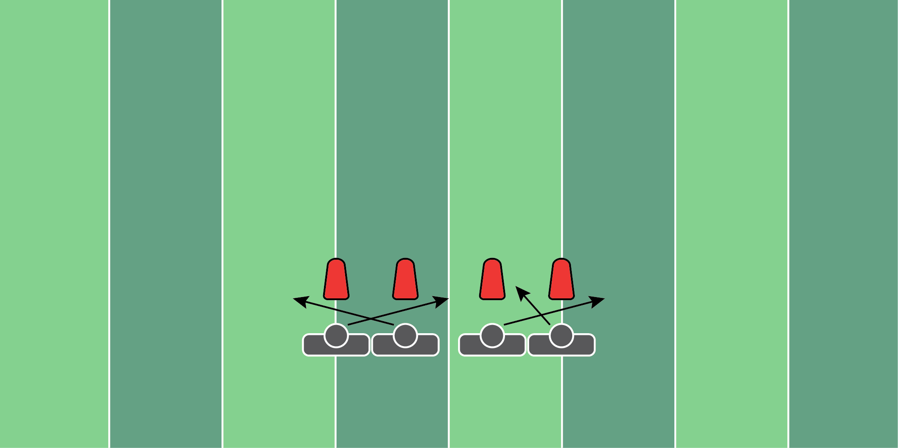
Figure 8.3

Twist Pursuit Drill

Equipment Needed: Pop up dummy or hand shields

Purpose: Training players to get after the football when running a stunt.

Required Players: 5

Required Coaches: 0

Description: (1) The defensive players will line up in their normal positions. When the coach says “go”, the defensive will run their twist stunt. (2) Once the stunt is run, the offensive player will try to get to the edge of the defense. It’s up to the defense to contain the offensive player while running the stunt.

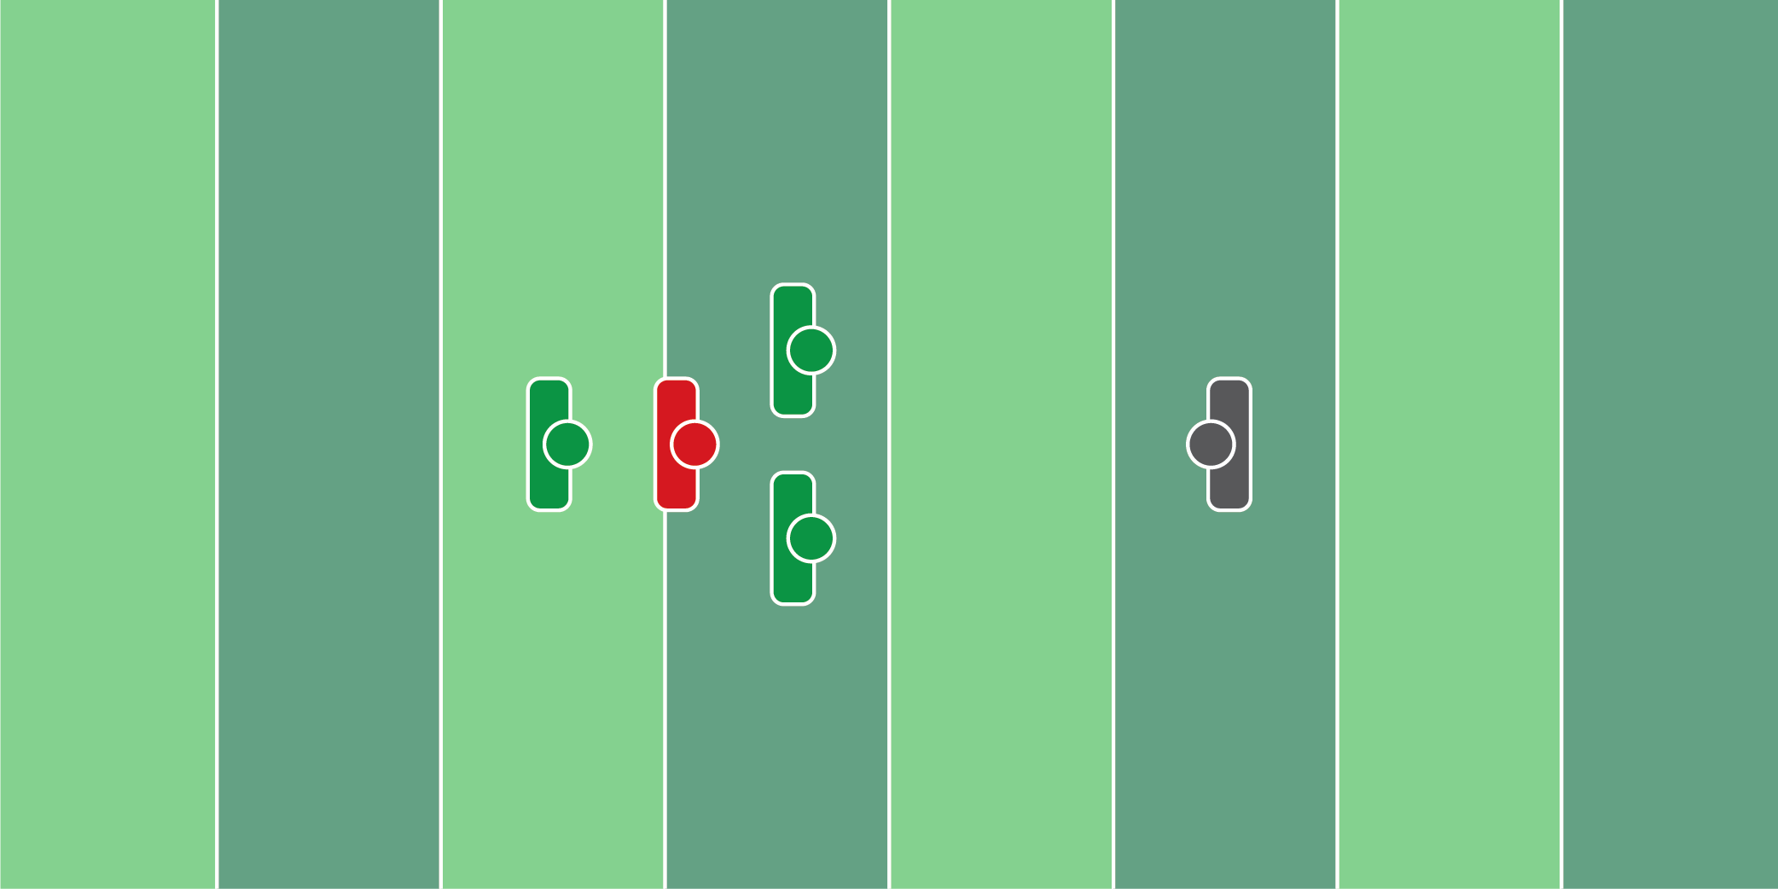
Figure 8.4

Open Field YAC Tackling Drill

Equipment Needed: Hand shield & cones

Purpose: Training players to tackle in the open field after the receiver has caught the football.

Required Players: 2

Required Coaches: 3

Description: (1) The defensive player will start 15 yards away from the coaches with the shields. The offensive player will start 5 yards away from the coaches with the shields. (2) When the coach says “go”, the receiver will catch the football thrown from the coach, who will run through the 2 coaches holding the hand shields. (3) The defensive player will do an up-down, get up, and try to make a tackle on the receiver when he clears the coaches with the hand shields.

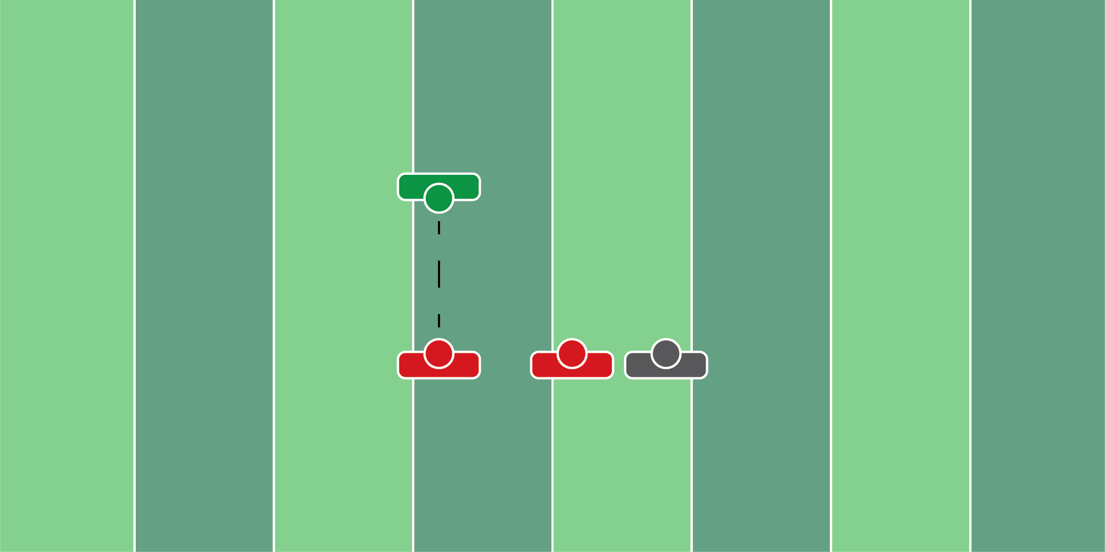
Figure 8.5

Post Contact Shed Drill

Equipment Needed: Players/Coaches

Purpose: Training defensive backs to shed receivers and tackle the wide receiver.

Required Players: 3

Required Coaches: 1

Description: (1) The defensive back and the first wide receiver will start engaged. (2) When the coach says “go”, the coach will throw the ball to the wide receiver. The defensive player will try to shed the offensive player he’s engaged with and make a tackle.

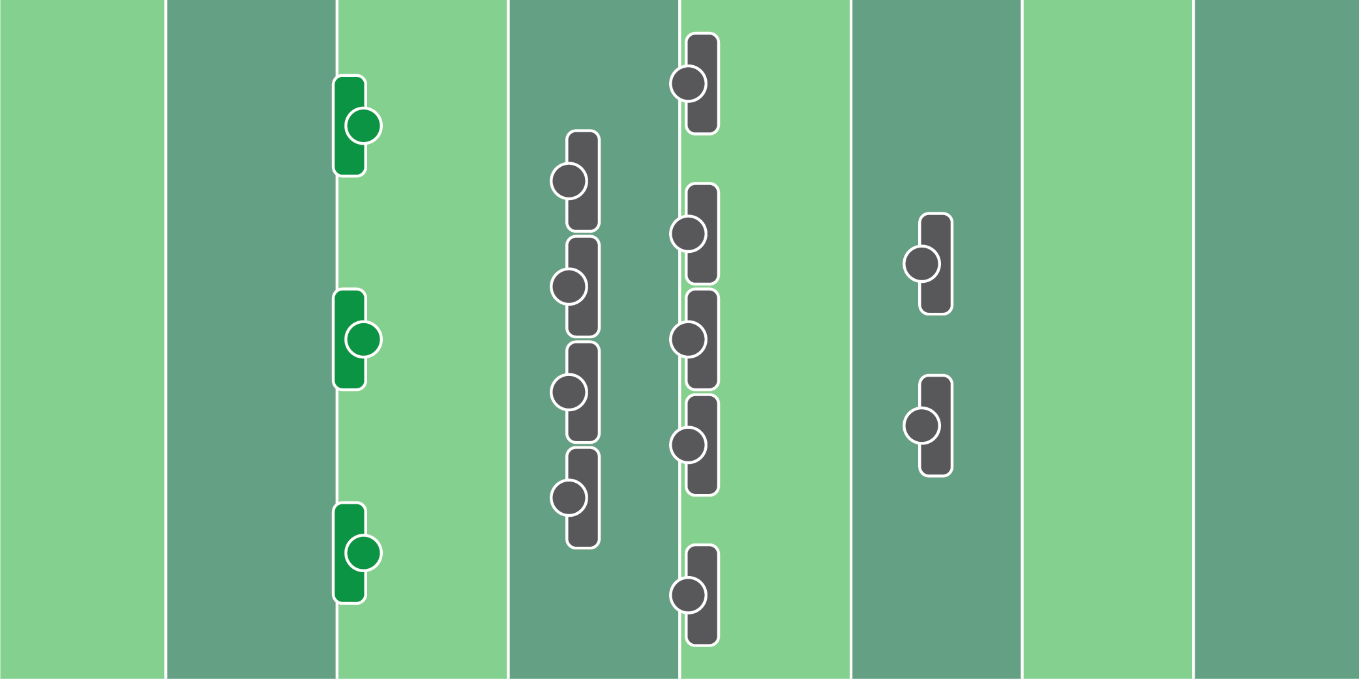
Figure 8.6

Pursuit Drill With Fumble

Equipment Needed: Cones

Purpose: Training the entire defense to run to the football.

Required Players: 11

Required Coaches: 3

Description: (1) The entire defense should line up in their positions. (2) When the coach says “go”, the defense should do an up-down then look to see where the coach is pointing. Once the entire defense runs to the cone, the second coach should roll the football on the ground and the defense should scoop the ball and score.

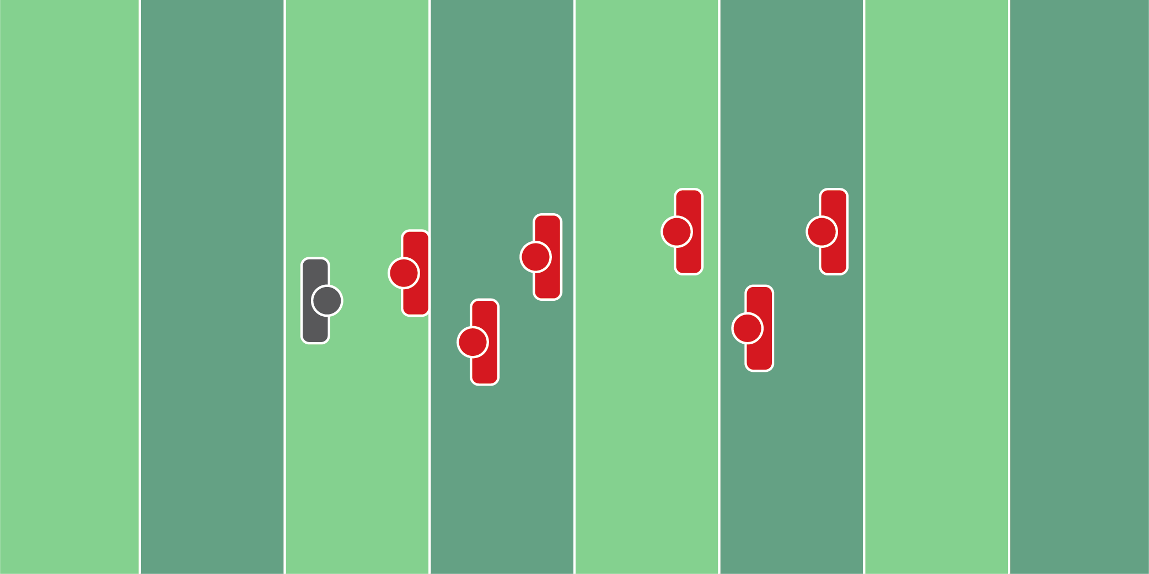
Figure 8.7

Multiple Player Ring Drill

Equipment Needed: Players/Coaches

Purpose: Training players to effectively shed offensive players while trying to track down the ball carrier.

Required Players: 6

Required Coaches: 0

Description: (1) The drill begins when the coach says “go”. The defensive player attacks the offensive player with ball carrier #1 behind him. The defensive player should try to shed the offensive player and tackle the first ball carrier. (2) When the coach feels the tackle is successful, he will blow the whistle, signaling the defensive player to move to the next combination of blocker & ball carrier. The drill ends when the tackle is made on the second ball carrier.

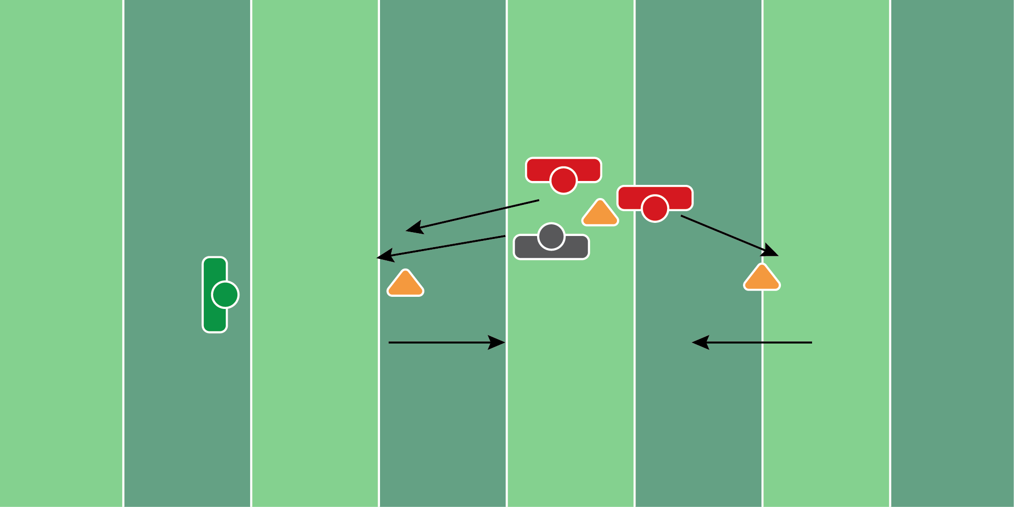
Figure 8.8

Defensive Chase Drill

Equipment Needed: Cones

Purpose: Training players to chase down ball carriers and tackle in the open field.

Required Players: 3

Required Coaches: 1

Description: (1) The two defensive players will start back to back, while the offensive player will start in front. (2) When the coach says “go”, the offensive player will run toward the first cone and catch the football. (3) Once the receiver catches the football, he should turn around the cone and try to make the second defender miss. (4) The trailing defender should try to catch/strip the offensive player. The second defender should try to tackle the receiver.

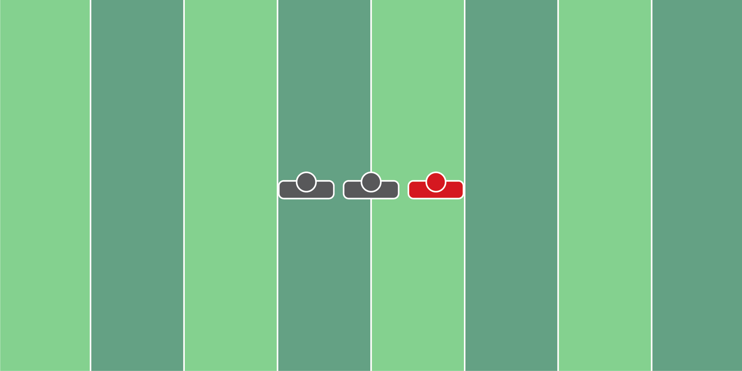
Figure 8.9

Strip Drill

Equipment Needed: Players/Coaches

Purpose: Training players how to strip the football and recover it properly.

Required Players: 2

Required Coaches: 0

Description: (1) The offensive player will start with the football, followed by two defensive players behind. (2) The first defensive player should strip the football from the offensive player. The second defensive player should pick up the football, scoop, and score.

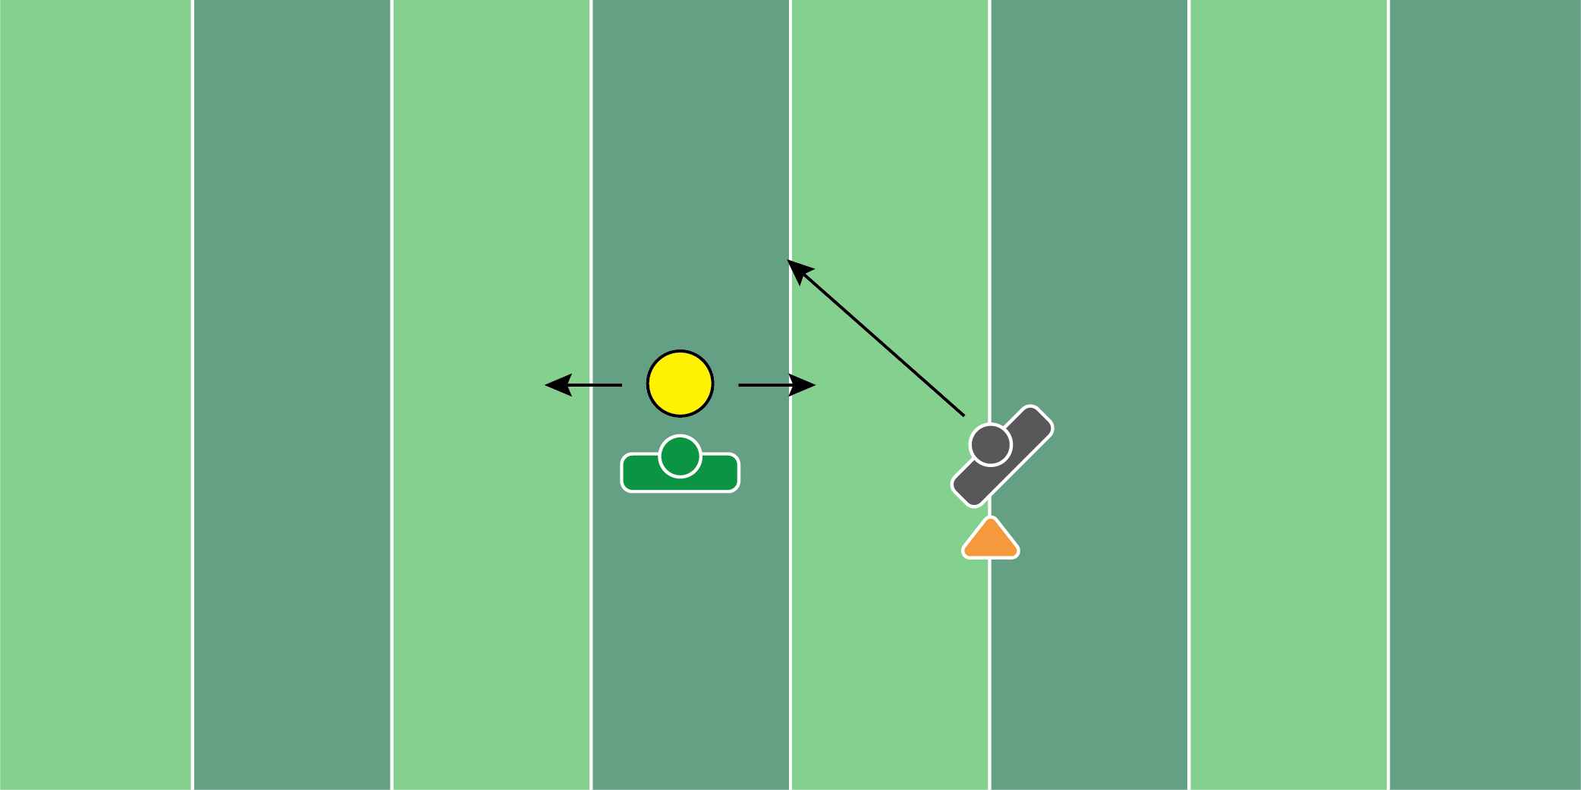
Figure 8.10

Zone Drop & Drive Drill

Equipment Needed: Tackling Rings

Purpose: Training linebackers to zone drop and drive on ball carriers.

Required Players: 1

Required Coaches: 1

Description: (1) The linebacker will start in their normal position. (2) When the coach says “go”, the linebacker will drop into their zone. (3) Once the coach feels like the linebacker has gained enough depth, roll the tackling ring and the player should tackle it.
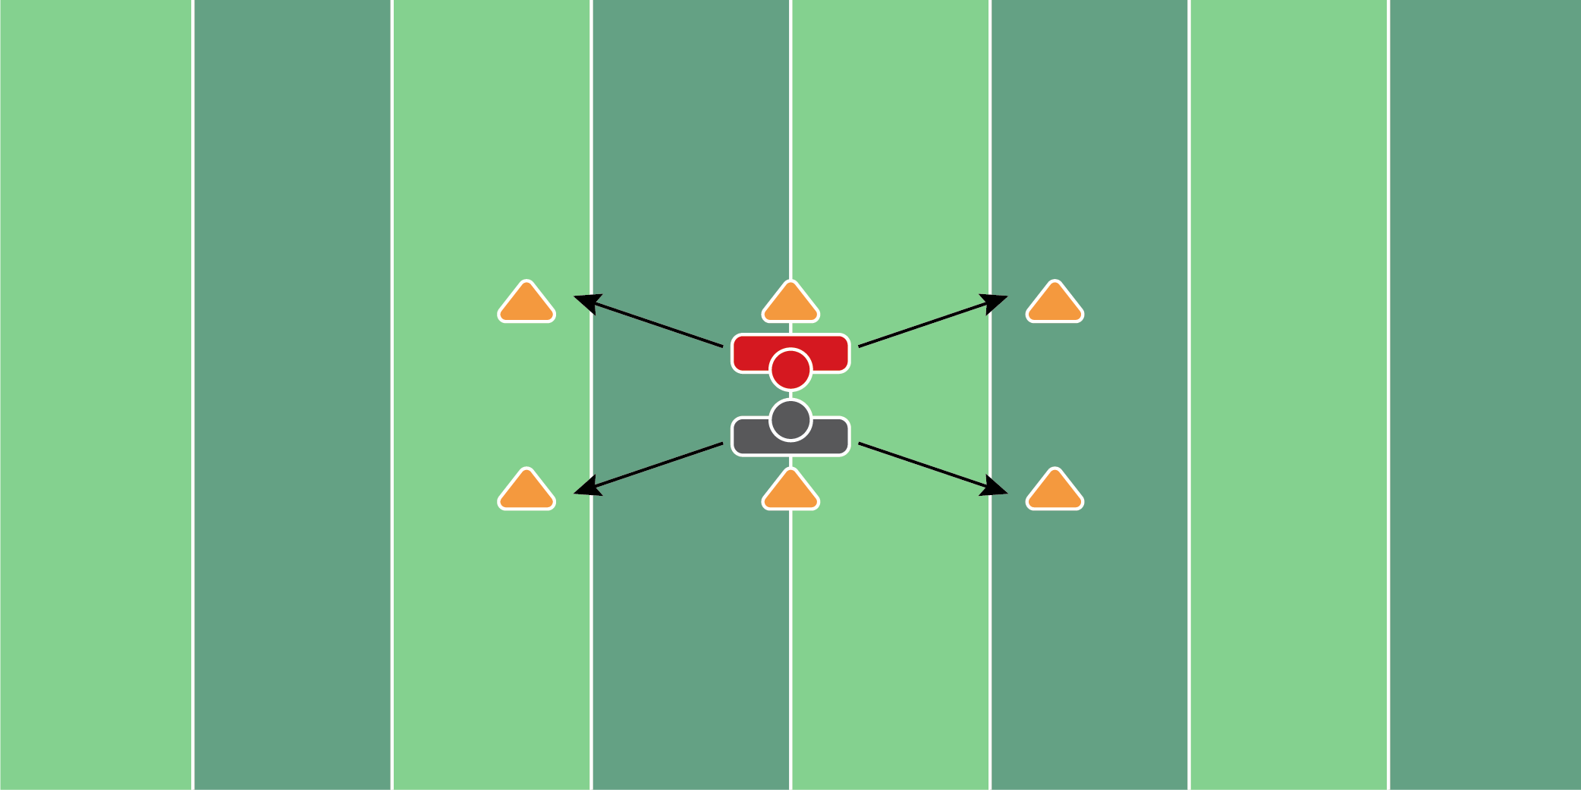
Figure 8.11

6 Cone Lateral Tackling Drill

Equipment Needed: Cones

Purpose: Training the defender to tackle from different angles.

Required Players: 2

Required Coaches: 0

Description: (1) The defensive and the offensive player will start back to back. (2) When the coach says “go”, both players will pick a cone to run around. (3) Once each player runs around the cone, the defensive player will then try to make an open-field tackle on the offensive player.

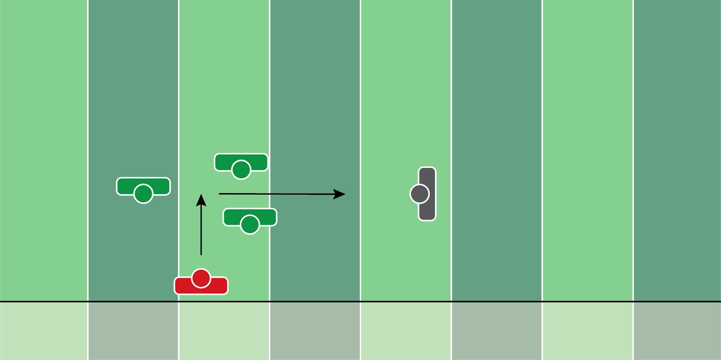
Figure 8.12

Midline Tackling Drill

Equipment Needed: Hand shields

Purpose: Training defenders to tackle receivers in the open field after they catch the football.

Required Players: 2

Required Coaches: 3

Description: (1) The defensive player will start 15 yards away from the coaches with the shields. The offensive player will start on the sideline, 5 yards away from the coaches with the hand shields. (2) When the coach says “go”, the receiver will catch the football thrown from the coach, who will run through the 2 coaches holding the hand shields. (3) The defensive player will do an up-down, get up, and try to make a tackle on the receiver when he clears the coaches with the hand shields.

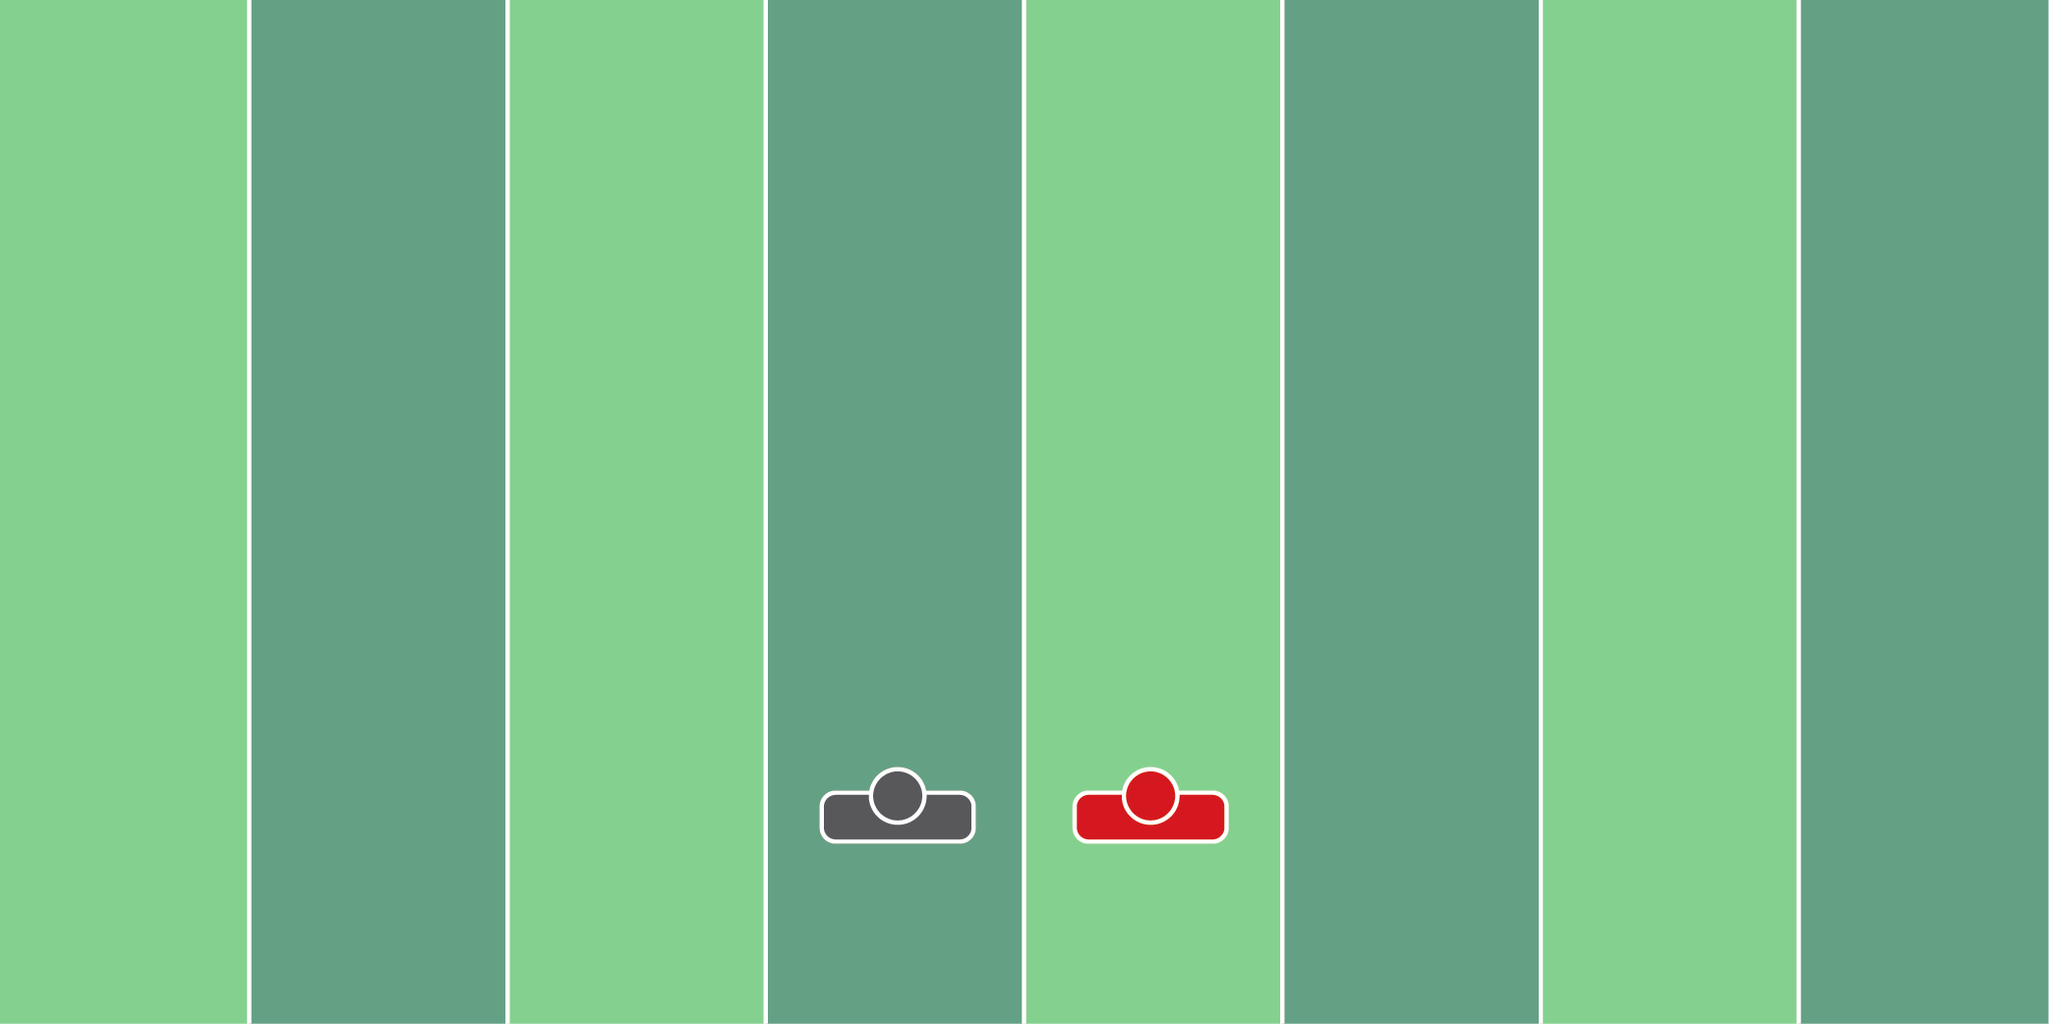
Figure 8.13

Form Tackling Drill

Equipment Needed: Players/Coach

Purpose: Training defensive players how to properly tackle.

Required Players: 2

Required Coaches: 0

Description: (1) The defensive players should start on one knee, one yard away from the offensive player. (2) When the coach says “go”, the defensive player should shoot his hands around the ball carrier, driving the shoulder in the thighs. Take the player to the ground. Reset and continue for 2-3 more reps.

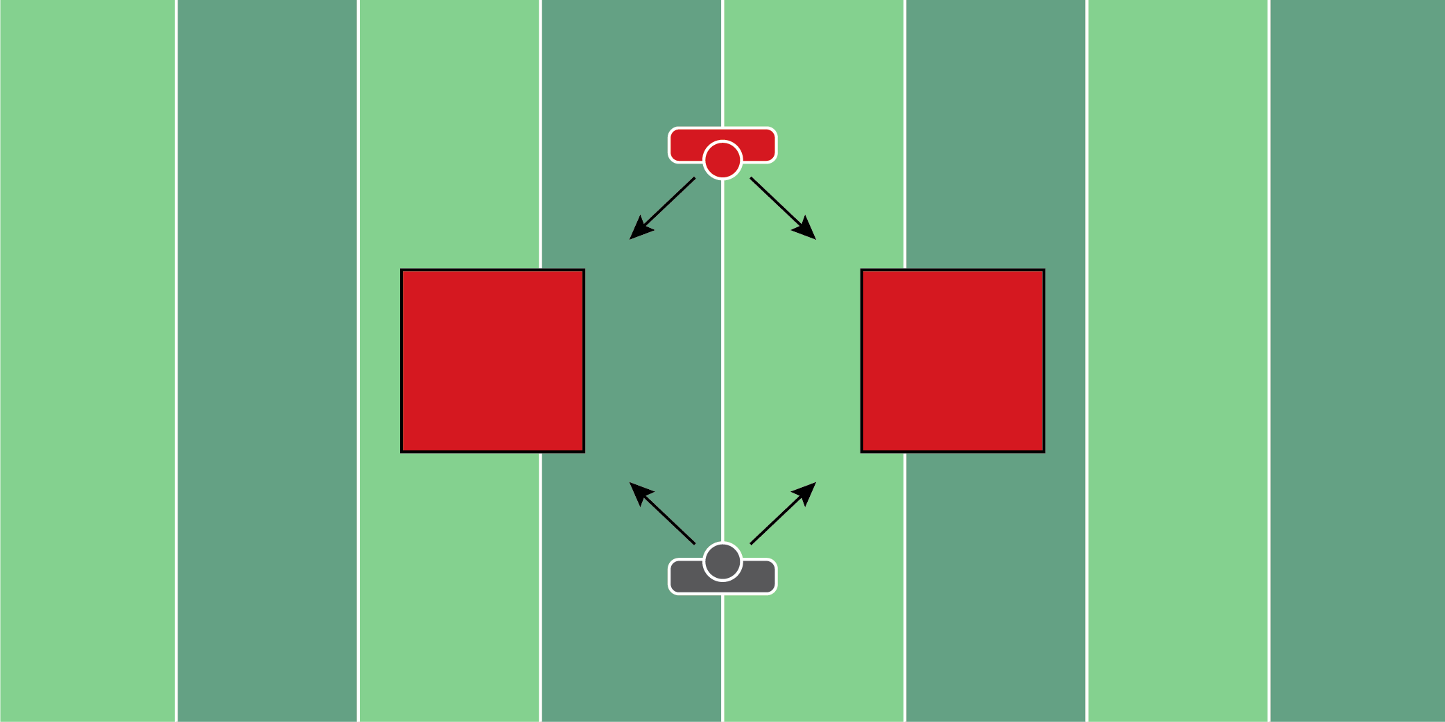
Figure 8.14

Form Tackling Drill (2)

Equipment Needed: Crashpads

Purpose: Training the defensive player to properly contact the offensive player.

Required Players: 2

Required Coaches: 0

Description: (1) The defensive and the offensive player should start 5 yards away from each other, outside of the crash pads. (2) When the coach says “go”, both players should run at an angle. The defensive player should make contact with the offensive player, driving him into the crash pad. This drill is used to help players deliver contact from the defensive end, as well as absorb contact from the offensive end.
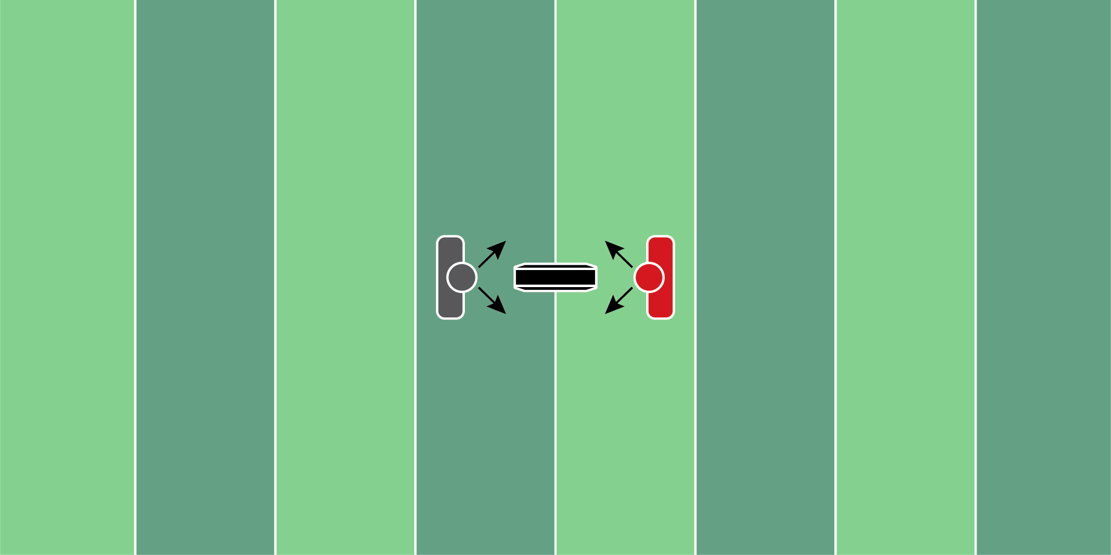
Figure 8.15

Multiple Contact Finish Drill

Equipment Needed: Step over bag & hand shield

Purpose: Training the defender to bring the arms on contact and run the feet post-contact.

Required Players: 2

Required Coaches: 0

Description: (1) The defensive and the offensive player will start on opposite sides of the step-over bag. The offensive player will hold the hand shield against their chest. (2) When the coach says “go”, the defensive player will move to the side of the step-over bag and make contact with the player holding the bag. (3) After the first contact is made, the defender will retreat back to the starting point and make contact on the other side of the step-over bag. (4) Repeat this process 2 more times and then have the defender finish by driving the offensive player back 5 yards.
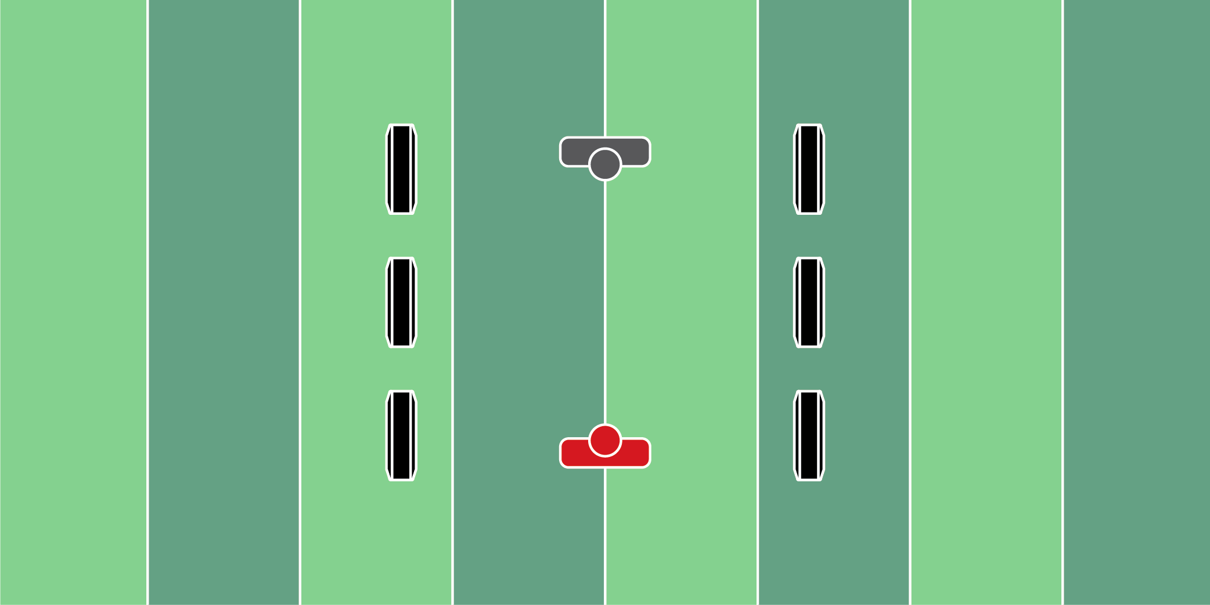
Figure 8.16

Open Field Tackling Drill

Equipment Needed: Cones

Purpose: Training the defensive player to close space and make an open-field tackle.

Required Players: 2

Required Coaches: 0

Description: (1) The defensive and the offensive players will be 10 yards apart from each other. (2) When the coach says “go”, the defensive player is trying to close the space and tackle the offensive player.
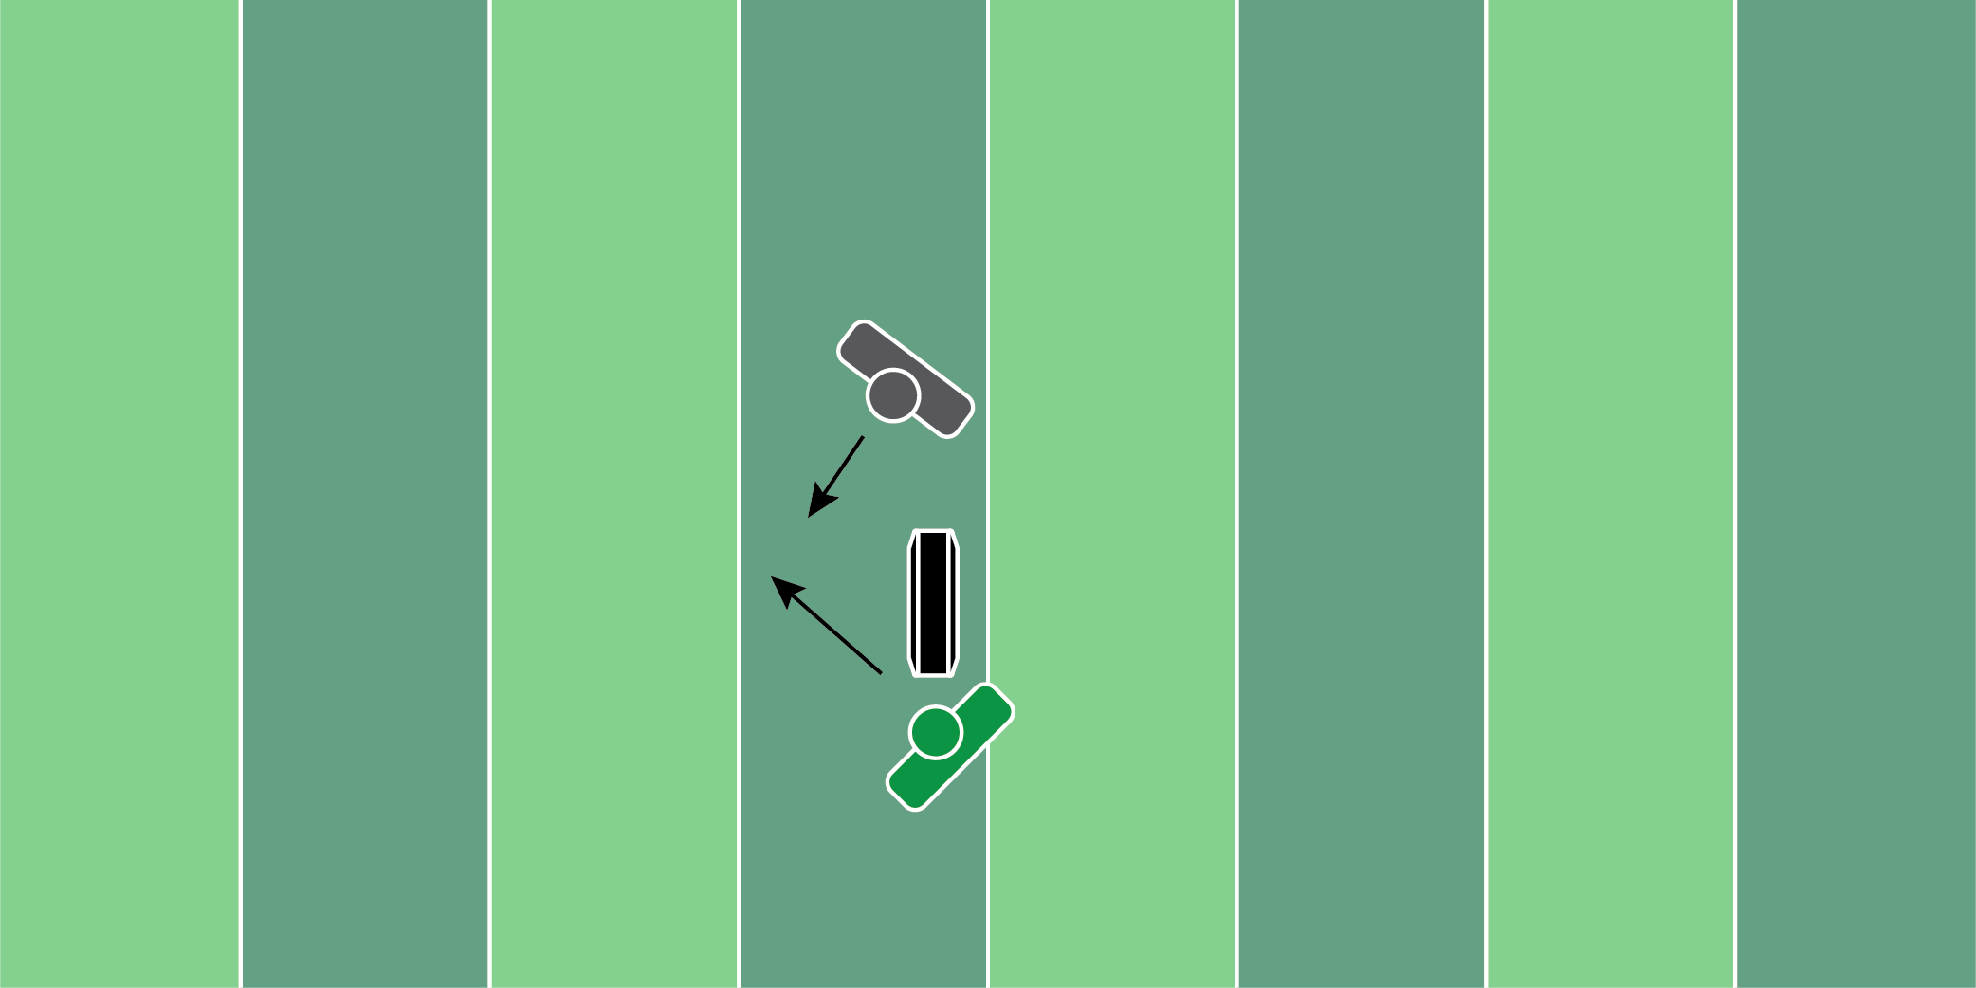
Figure 8.17

Step Over Bag Tackle Drill

Equipment Needed: Step over bags

Purpose: Training the defensive player to run the feet on contact.

Required Players: 1

Required Coaches: 1

Description: (1) The defensive player will start 2 yards away from the coach, who is on his knee with a step-over bag in his hands. (2) When the coach says “go”, he will throw the step-over bag to his left or right. (3) The defensive player must make contact with the bag, run his feet, and finish the tackle on the ground.

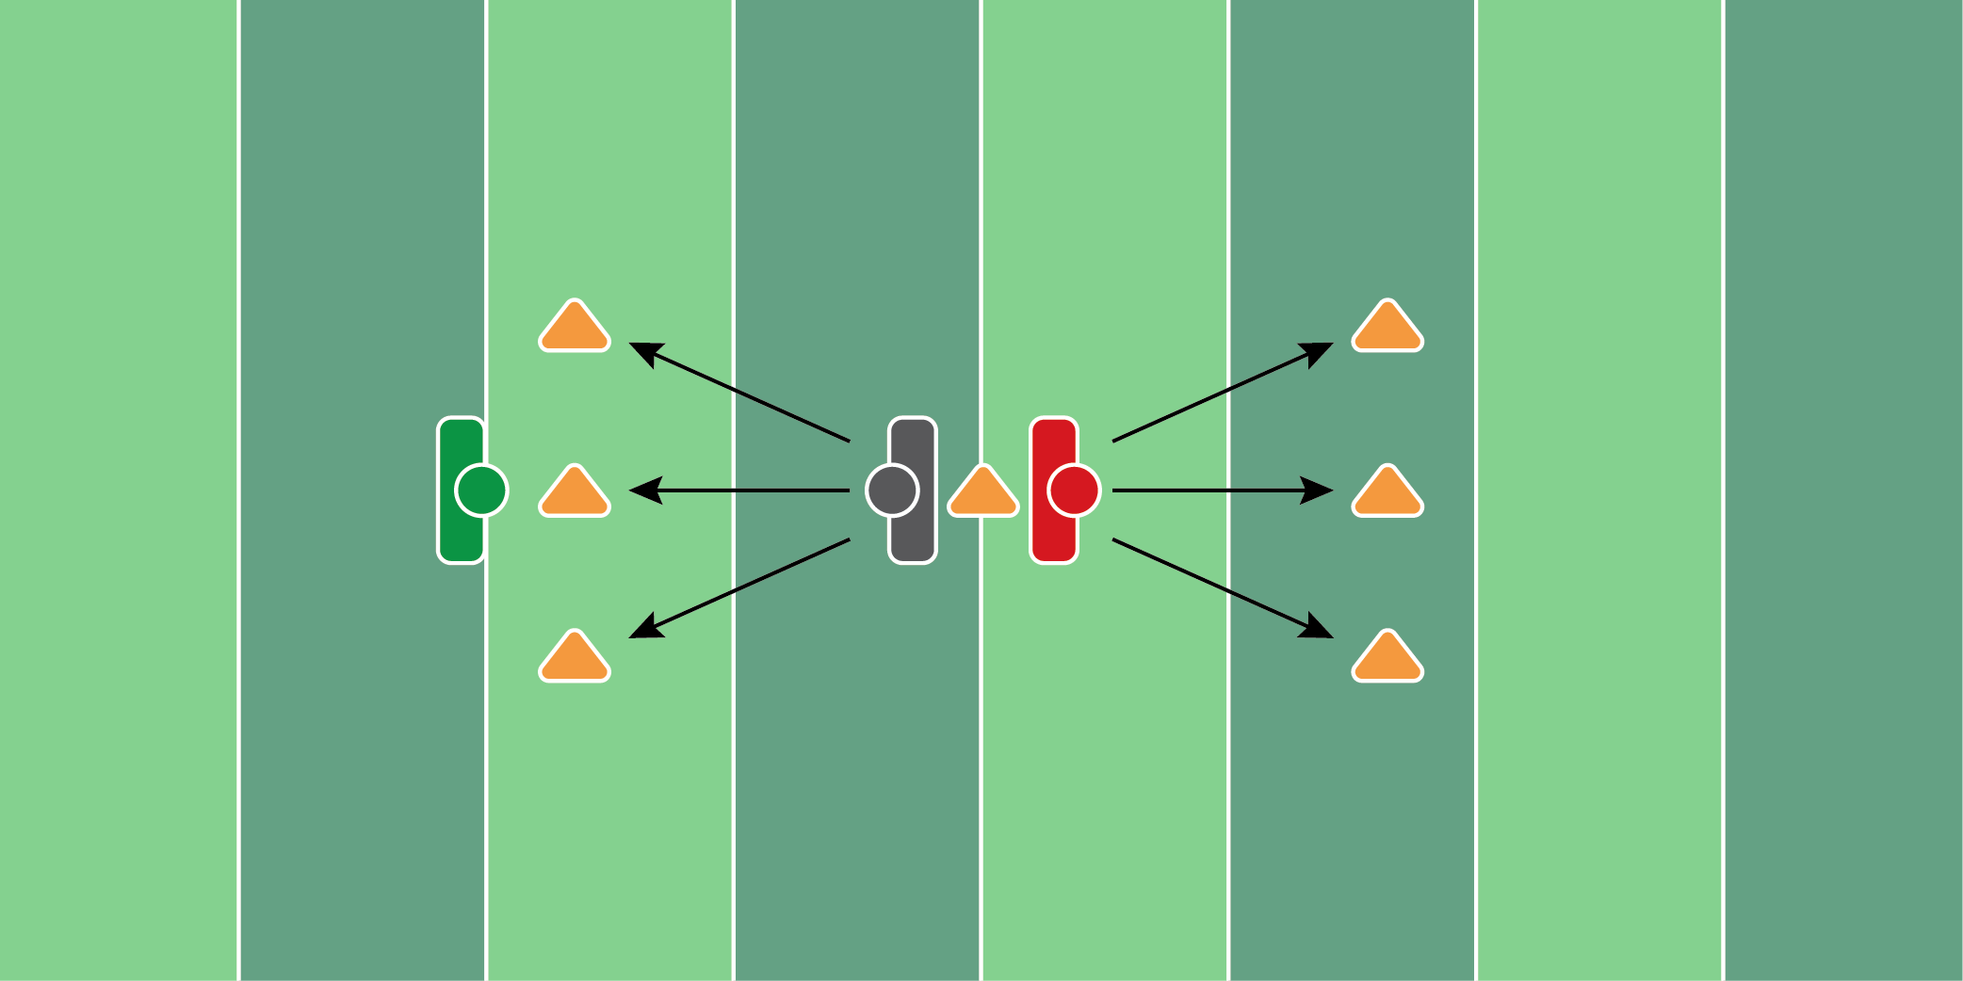
Figure 8.18

6 Cone Depth Drill

Equipment Needed: Cones

Purpose: Training the defender to tackle from different angles.

Required Players: 2

Required Coaches: 0

Description: (1) The defensive and the offensive player will start back to back. (2) When the coach says “go”, both players will pick a cone to run around. (3) Once each player runs around the cone, the defensive player will then try to make an open-field tackle on the offensive player.
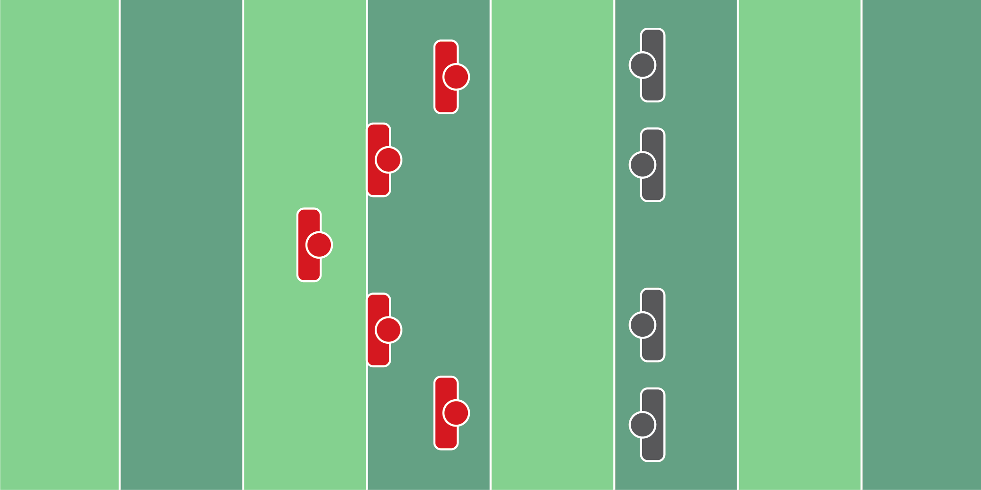
Figure 8.19

Rally & Tackle Drill

Equipment Needed: Players/Coaches

Purpose: Training defensive players to rally to the football and make an open-field tackle.

Required Players: 8

Required Coaches: 0

Description: (1) The defensive and offensive players will line up 10 yards away from each other. Each offensive player will have a football in their hands. (2) The coach will stand behind the defense, and designate which player should run. When the coach says “go”, the player that the coach selected will run and try to elude the defensive players. (3) The defensive players need to run to the football to make a tackle.

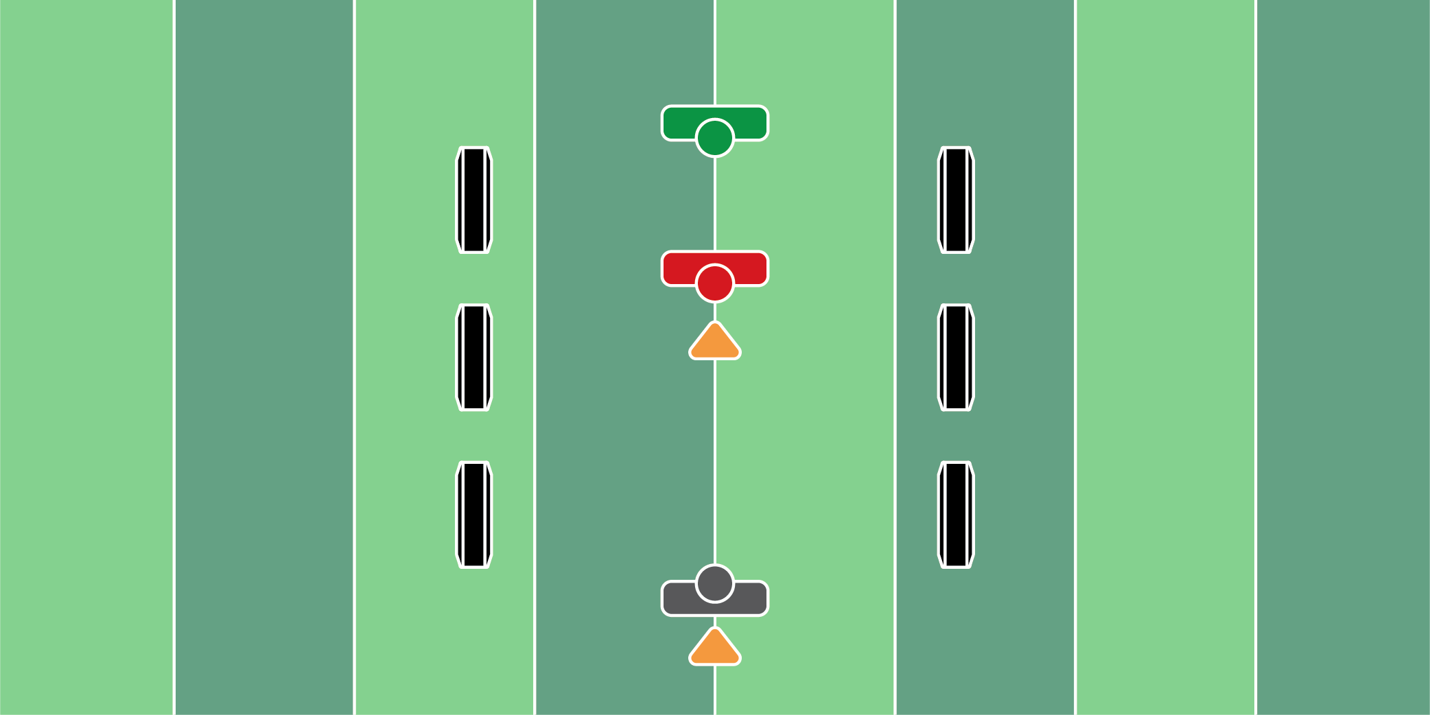
Figure 8.20

Open Field Tackling Drill

Equipment Needed: Cones & hand shield

Purpose: Training the defensive players to make a 2 vs 1 vice tackle.

Required Players: 3

Required Coaches: 2

Description: (1) The two defensive players will start 10 yards apart. The offensive player will start 20 yards away from the two defensive players. (2) When the coach says “go”, the coach will throw the ball to the offensive player, who will be hit with a hand shield from another coach. After the catch, the receiver should run up the field. (3) Meanwhile, the defensive player will do an up-down, trying to close the gap between the receiver and make a tackle.

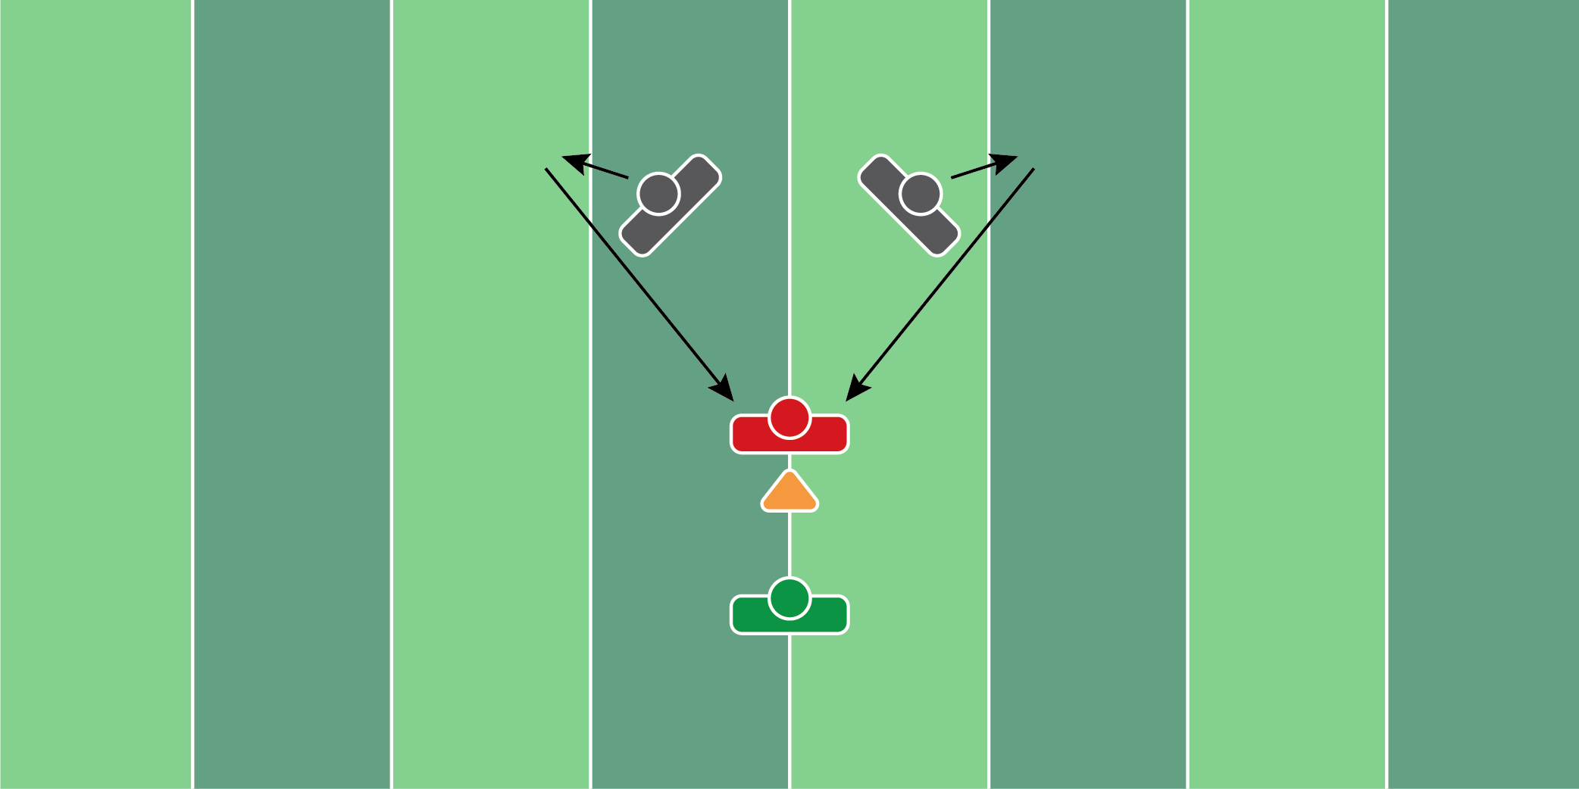
Figure 8.21

Vice Strip Drill

Equipment Needed: Players/Coaches

Purpose: Training the defensive players to close on an offensive player and strip the ball out.

Required Players: 3

Required Coaches: 1

Description: (1) The defensive and offensive players should all start facing the coach. The defensive players should be behind the offensive player. (2) When the coach says “go”, the defensive players should backpedal and drop into their hook/curl zones. (3) Once the linebackers get into their zones, the coach should throw the ball to the offensive player. (4) The defensive players should close on the offensive player and try to strip the football.

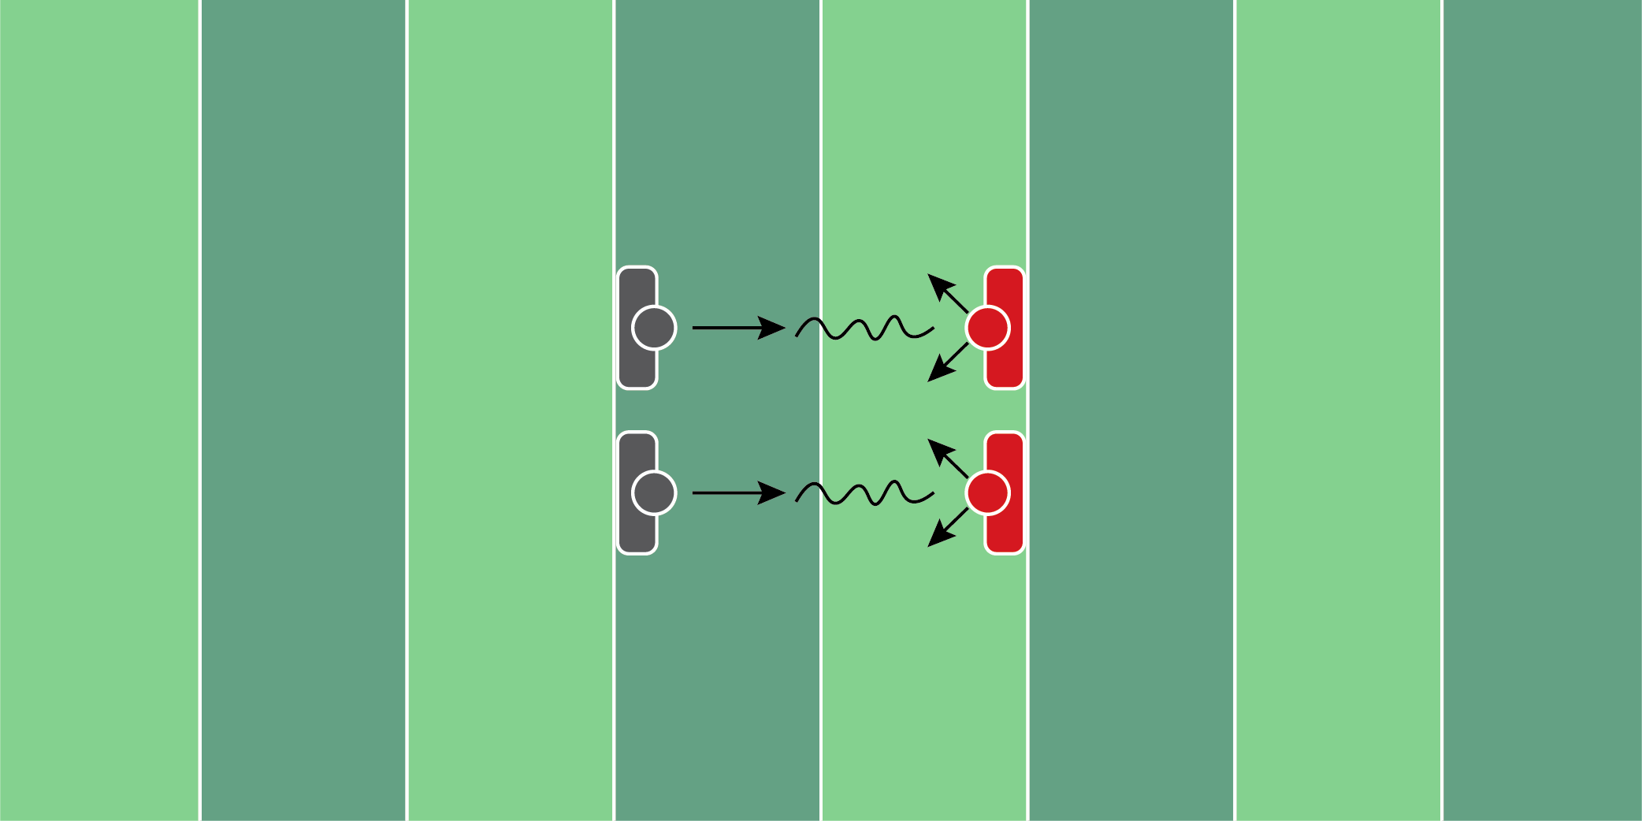
Figure 8.22

First Step Fit Drill

Equipment Needed: Players/Cones

Purpose: Training the defensive player to use near foot/near-shoulder technique when tackling.

Required Players: 2

Required Coaches: 0

Description: (1) The defensive and the offensive players will start 10 yards away from each other. (2) When the coach says “go”, the defensive player will sprint toward the offensive player. As they get 2-3 yards away from the offensive player, they will start to chop their feet and throttle down. (3) The offensive player will then take 1 step in a 45-degree direction left or right. (4) The defensive player must finish in a position to make a tackle, with his near foot and near shoulder in line to make a tackle.

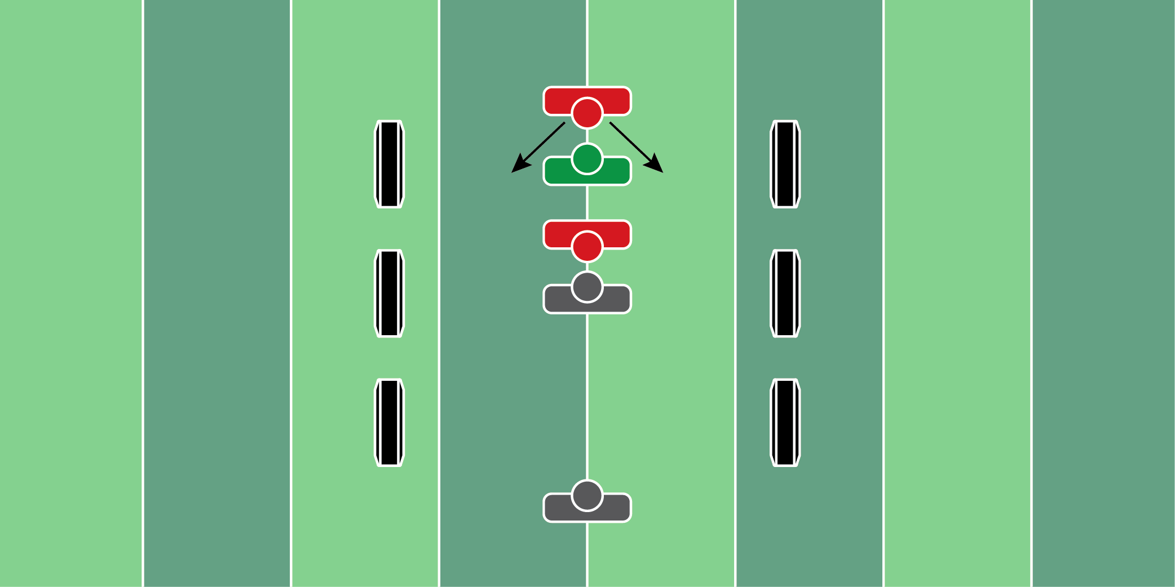
Figure 8.23

Delayed Oklahoma Drill

Equipment Needed: Cones & step over bags

Purpose: Oklahoma drill with an added delay to create an open field tackle situation.

Required Players: 5

Required Coaches: 0

Description: (1) The 2 lineman will lineup one yard away from each other. The quarterback and running back will lineup directly behind them. The defensive back/linebacker will be 15 yards away from the lineman. (2) When the coach says “go”, the quarterback will hand the football to the running back. The defensive lineman will try to shed the offensive lineman and make a tackle on the running back. (3) The defensive back will delay, do an up-down and try to make a tackle.

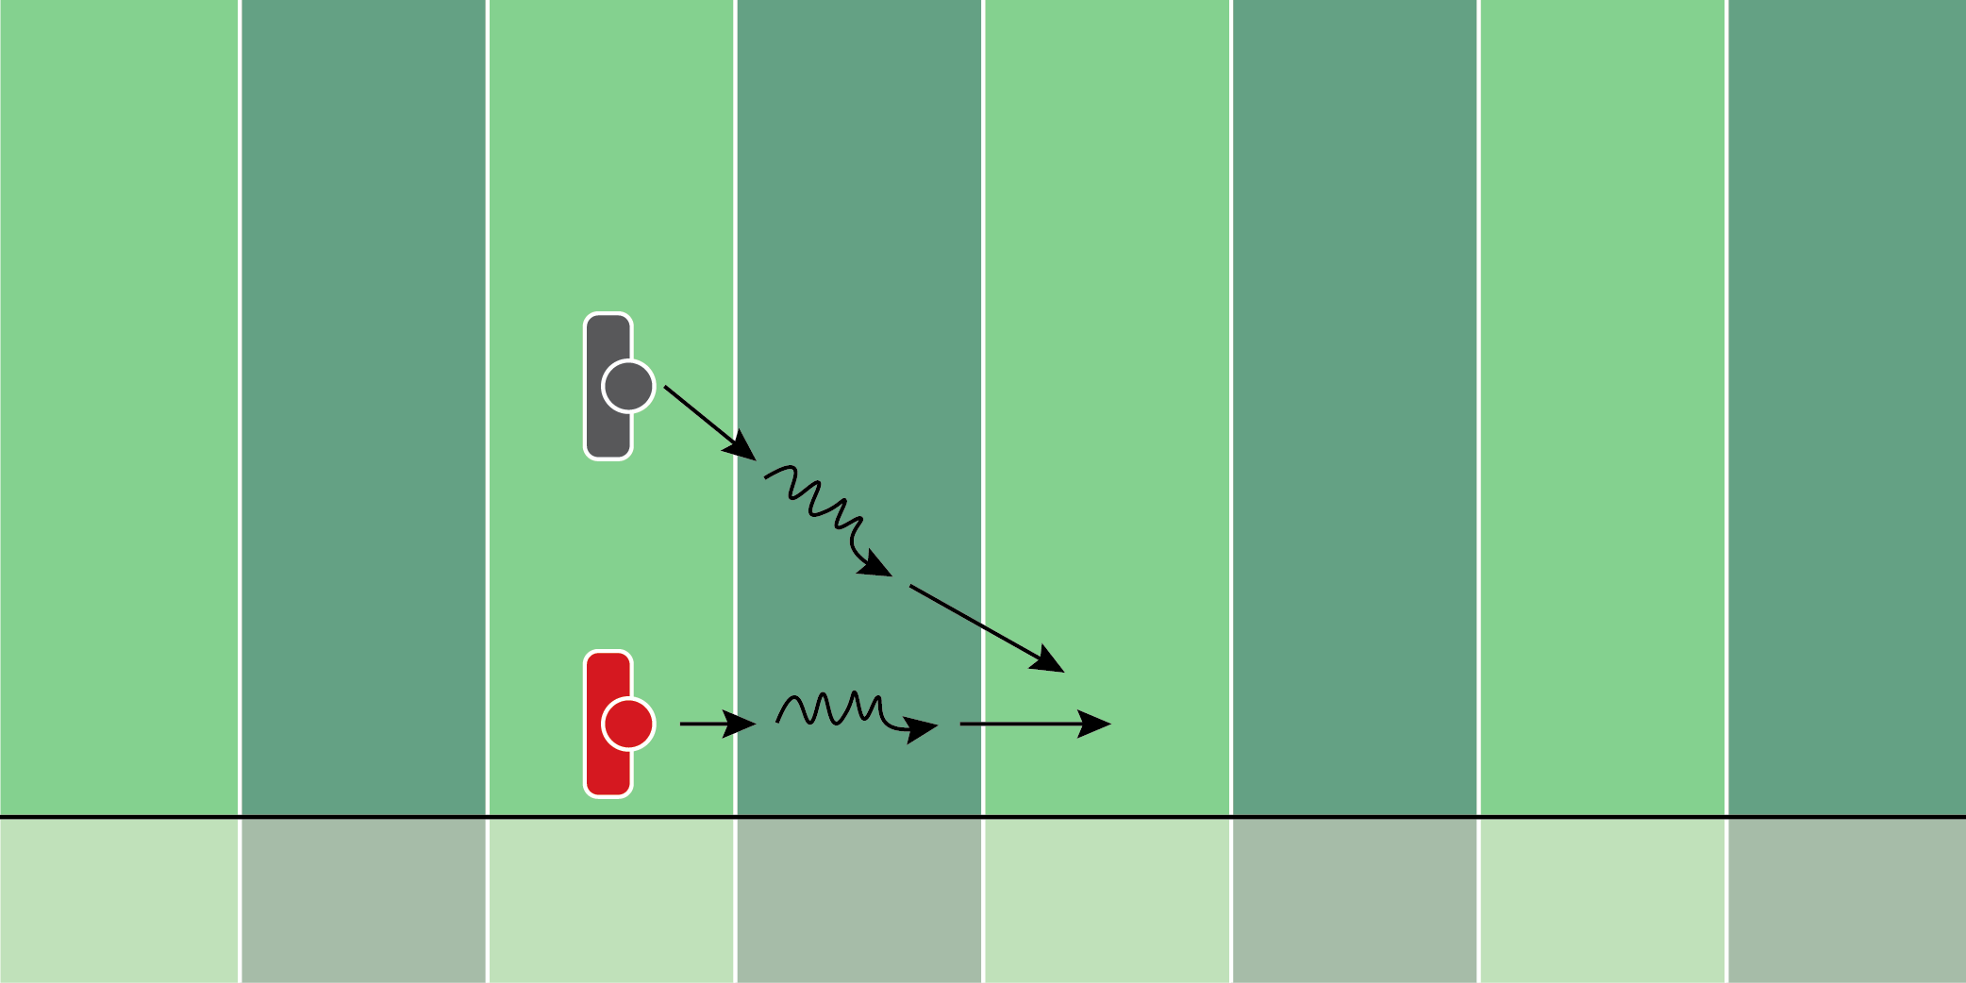
Figure 8.24

Track & Gather Drill

Equipment Needed: Cones

Purpose: Training the defensive player to stay on the back hip of the ball carrier.

Required Players: 2

Required Coaches: 0

Description: (1) The defensive and the offensive players will start 10 yards away from each other. (2) When the coach says “go”, the offensive player will jog and sprint, changing speeds every 2-3 yards in a straight line down the sideline. (3) The defensive player will close the gap between him and the offensive player, changing from sprinting to shuffling, depending on the offensive player’s speed. (4) Finish with a tackle or thud.

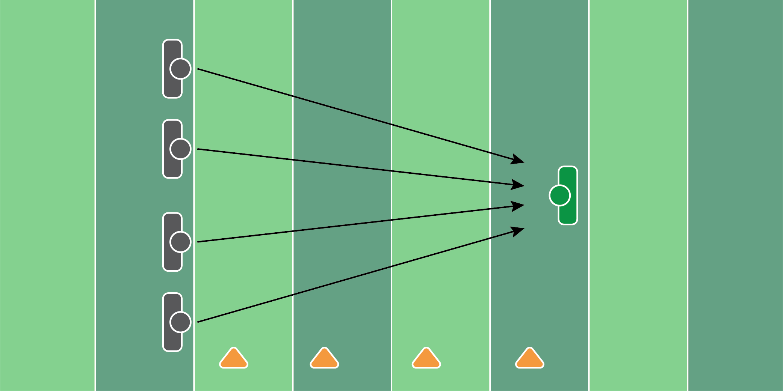
Figure 8.25

Layer & Fit Drill

Equipment Needed: Cones

Purpose: Training the defenders to take different angles to the ball carrier.

Required Players: 4

Required Coaches: 1

Description: (1) The defensive players will start 3 yards away from each other and 15 yards away from the coach. (2) When the coach says “go”, the defensive players will sprint toward the coach. (3) The coach will then point to the right or left. The players will then run to the side of the cones, and get to one of the available cones. It’s important the players don’t run behind each other when chasing down a ball carrier. This slows them down and creates poor angles to the ball carrier.

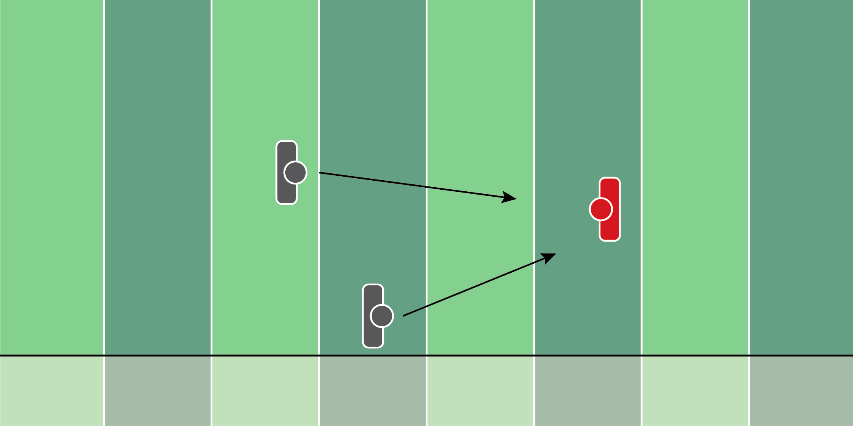
Figure 8.26

Corner & Safety Vice Drill

Equipment Needed: Players/Coaches

Purpose: Training the corner and safety to vice a receiver with the proper angle.

Required Players: 3

Required Coaches: 0

Description: (1) The cornerback and the safety should line up in their positions. The offensive player should be 5 yards behind the line of scrimmage as if they’re catching a bubble screen. (2) When the coach says “go”, the defensive players will do an up-down, and try to vice the offensive player. (3) The offensive player will start with a football in their hands, and try to make the defensive players miss.

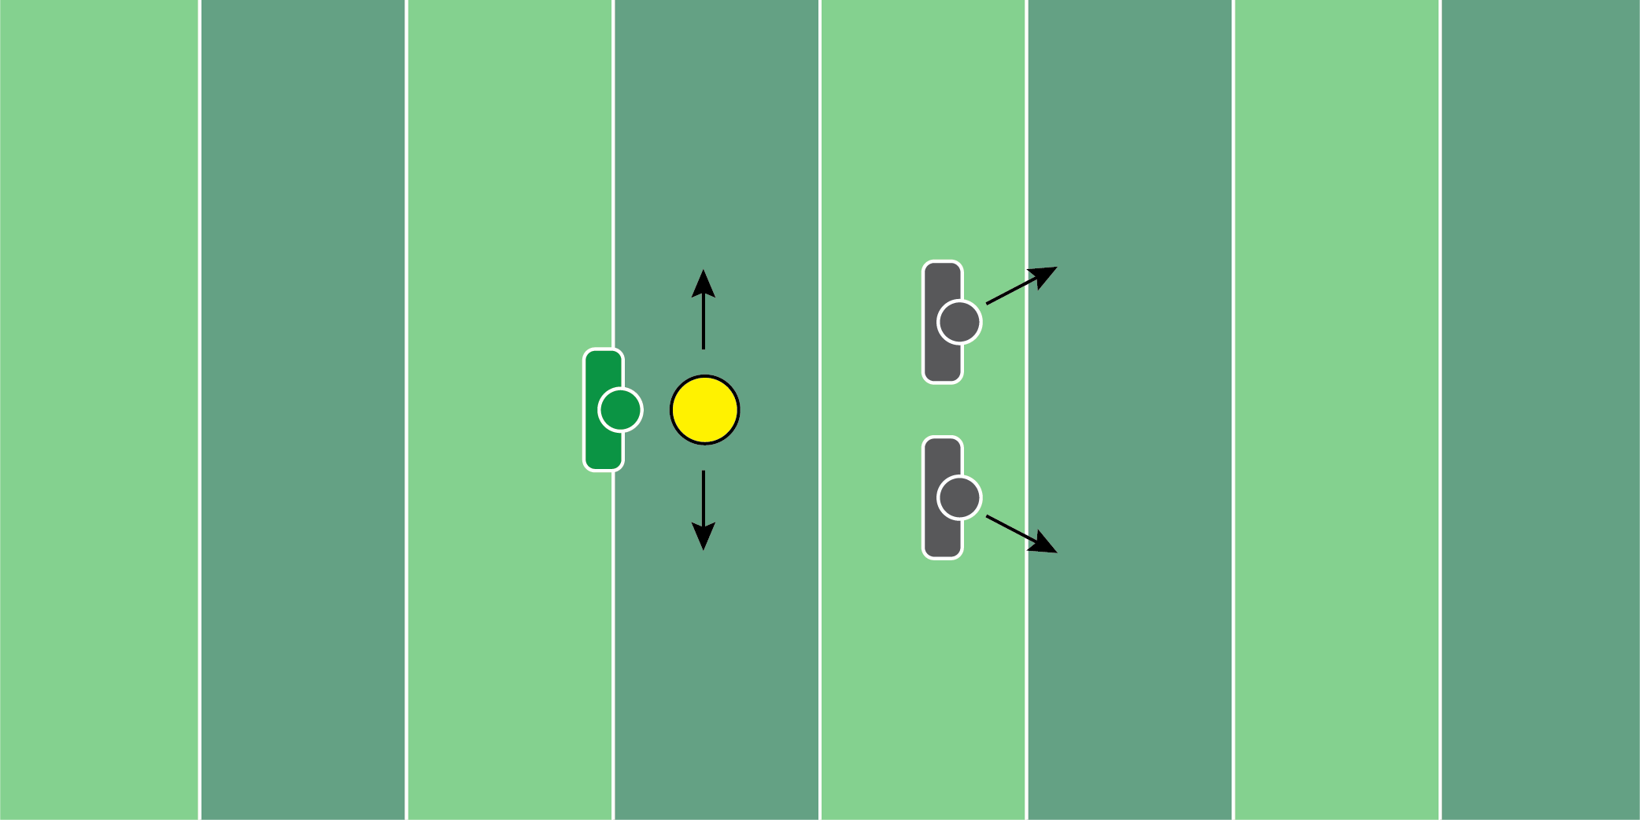
Figure 8.27

Zone Drop & Chase Drill

Equipment Needed: Tackling rings & cones

Purpose: Training the linebackers to drop into their zones, then close on the running back or receiver.

Required Players: 2

Required Coaches: 0

Description: (1) The linebackers should line up in their positions. (2) When the coach says “go”, the linebackers should drop into their zone. (3) When the coach says “break”, the coach should roll the tackling ring to the right or left. The linebackers should close and tackle the tackling ring.

SPECIAL TEAMS
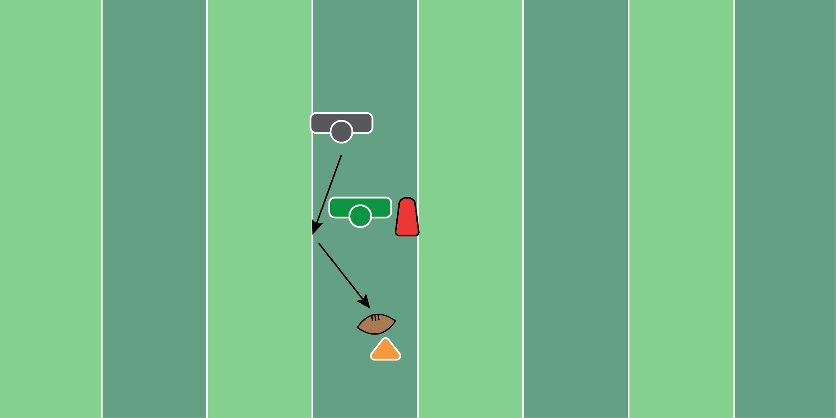
Figure 9.1

Punt Block Drill

Equipment Needed: Pop up dummy & traffic cone

Purpose: Training the special teams player to take the proper angle to block the punt.

Required Players: 1

Required Coaches: 1

Description: (1) The special teams player should start in a 3 point stance on the line of scrimmage. (2) When the ball is snapped, the player should work to the outside of the popup dummy. (3) The coach should bend in the popup dummy as if they’re blocking a person in the middle. (4) The player should dip the shoulder to get around the popup dummy and get to the football that is resting on top of the traffic cone.
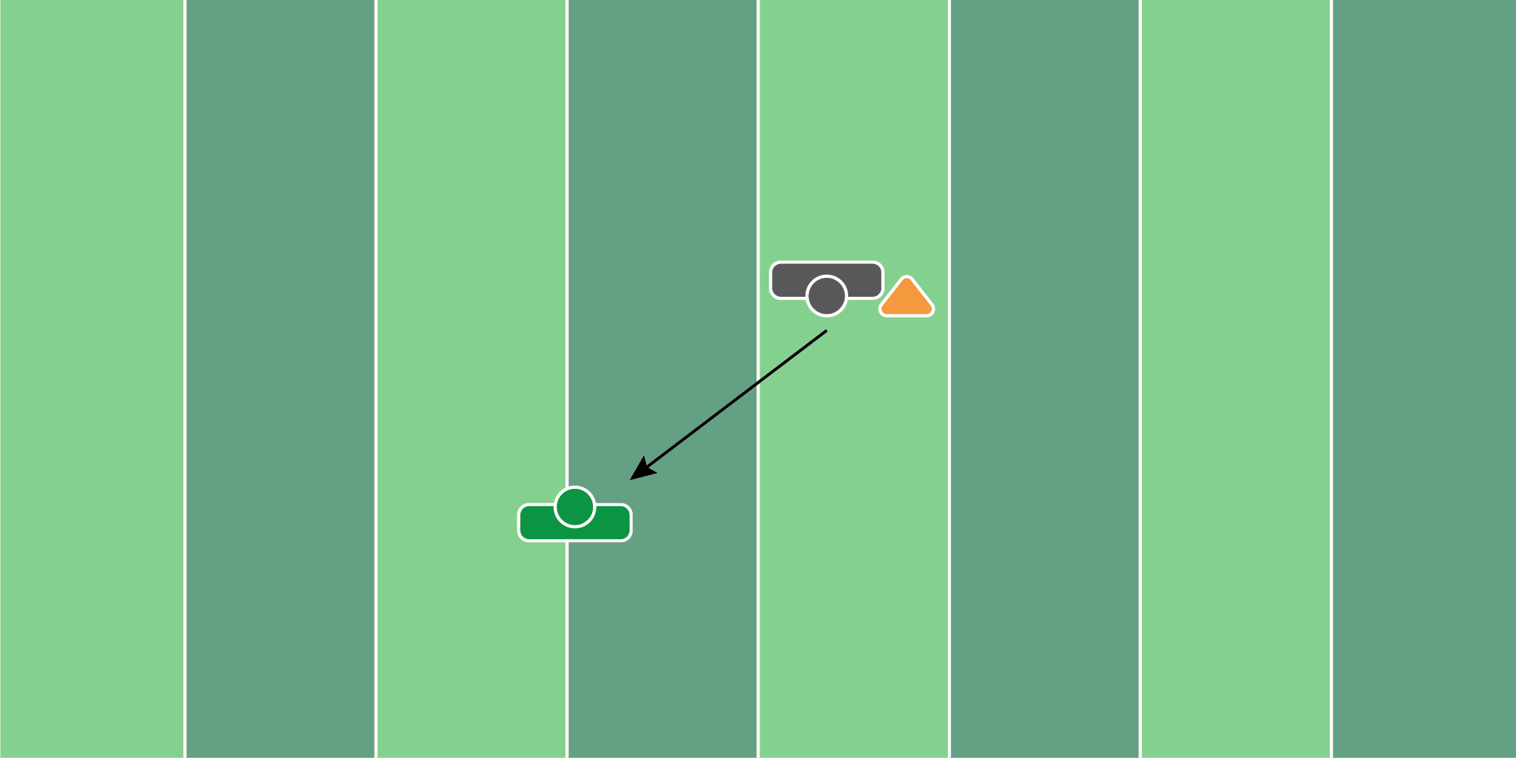
Figure 9.2

Field Goal Block Drill

Equipment Needed: Crashpad & track blocks

Purpose: Training the special teams player to get out of their stance as fast as possible.

Required Players: 1

Required Coaches: 1

Description: (1) The special teams player should line up with their feet in the track blocks. (2) When the coach says “go”, the player should come out of the track blocks, and take the proper angle to block the field goal. The player should dive on the crash pad and simulate as if they’re blocking the ball that the coach is holding.
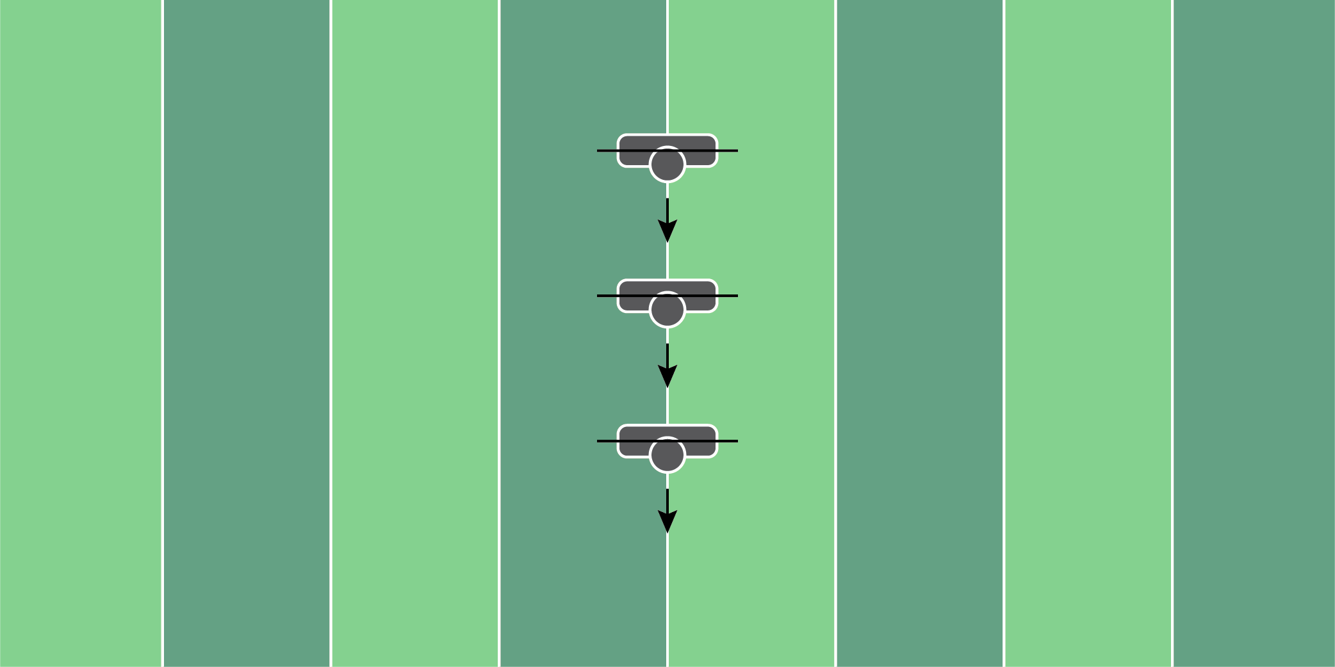
Figure 9.3

PVC Pipe Bend Drill

Equipment Needed: PVC Pipe

Purpose: Training the special teams player to bend the shoulder and hip at the same time.

Required Players: 1

Required Coaches: 0

Description: (1) The special teams player will put the PVC pipe behind their back, holding it up by both of their arms. (2) When the coach says “go”, the player will run from sideline to sideline, dipping their shoulder every 5 yards to simulate dipping around a blocker.

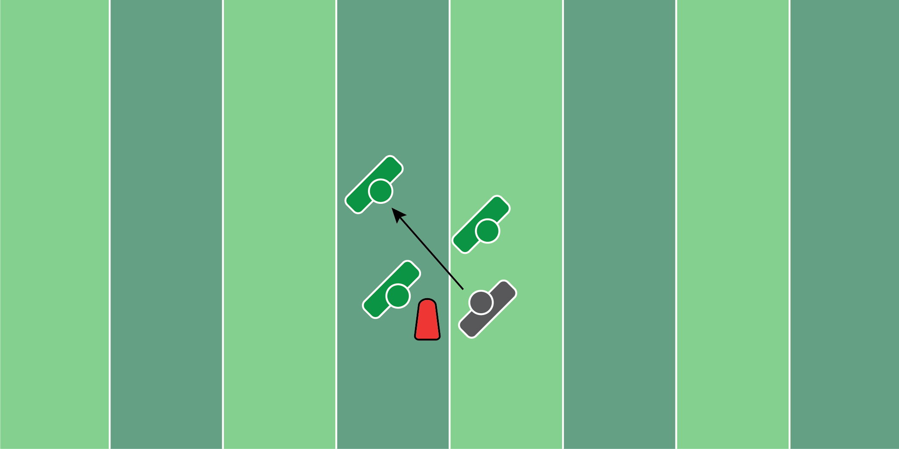
Figure 9.4

Field Goal Bend Drill

Equipment Needed: Pop up dummy & hand shields

Purpose: Training the special teams player to block field goals, by staying tight to the inside player’s outside leg.

Required Players: 1

Required Coaches: 2

Description: (1) The special teams player should start in a 3 point stance on the line of scrimmage. (2) When the ball is snapped, the coach holding the popup dummy should move to the inside. The second coach holding the hand shield should try to make contact with the special teams player, trying to throw him off balance. (3) The special teams player should dip to the inside and take the proper angle to the field goal holder, simulating a block.

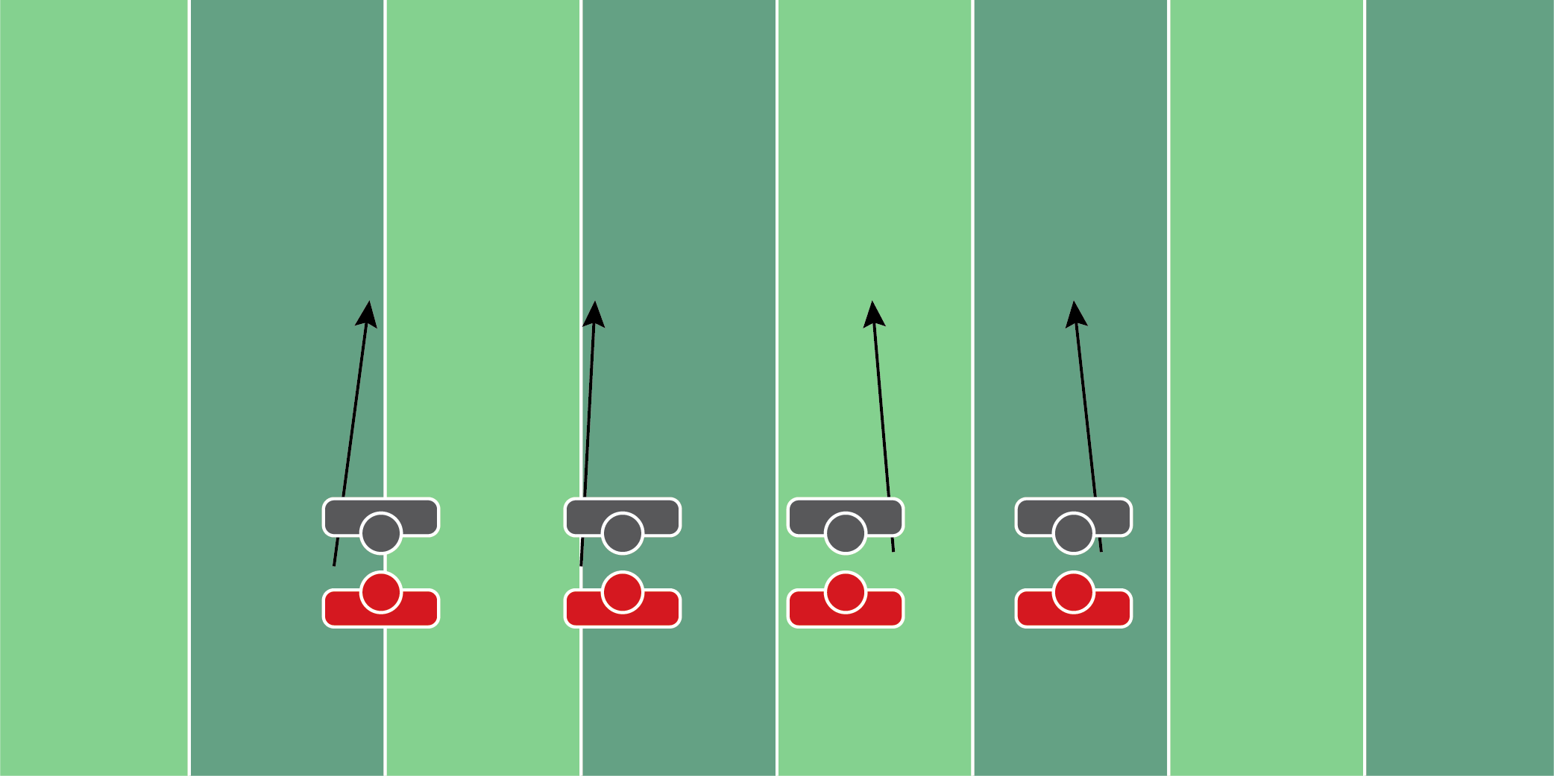
Figure 9.5

Collide & Funnel Drill

Equipment Needed: Players/Coaches

Purpose: Training special teams players’ to ride the hip of a moving defender and block him properly.

Required Players: 2

Required Coaches: 0

Description: (1) The return and punting players should start side by side. (2) When the coach says “go”, both players should run to a point 20 yards down the field. The key is to make sure the punt return player (inside player) maintains his leverage and blocks the punt team player from the front. This drill is a great way to teach proper blocks and avoid blocks back.

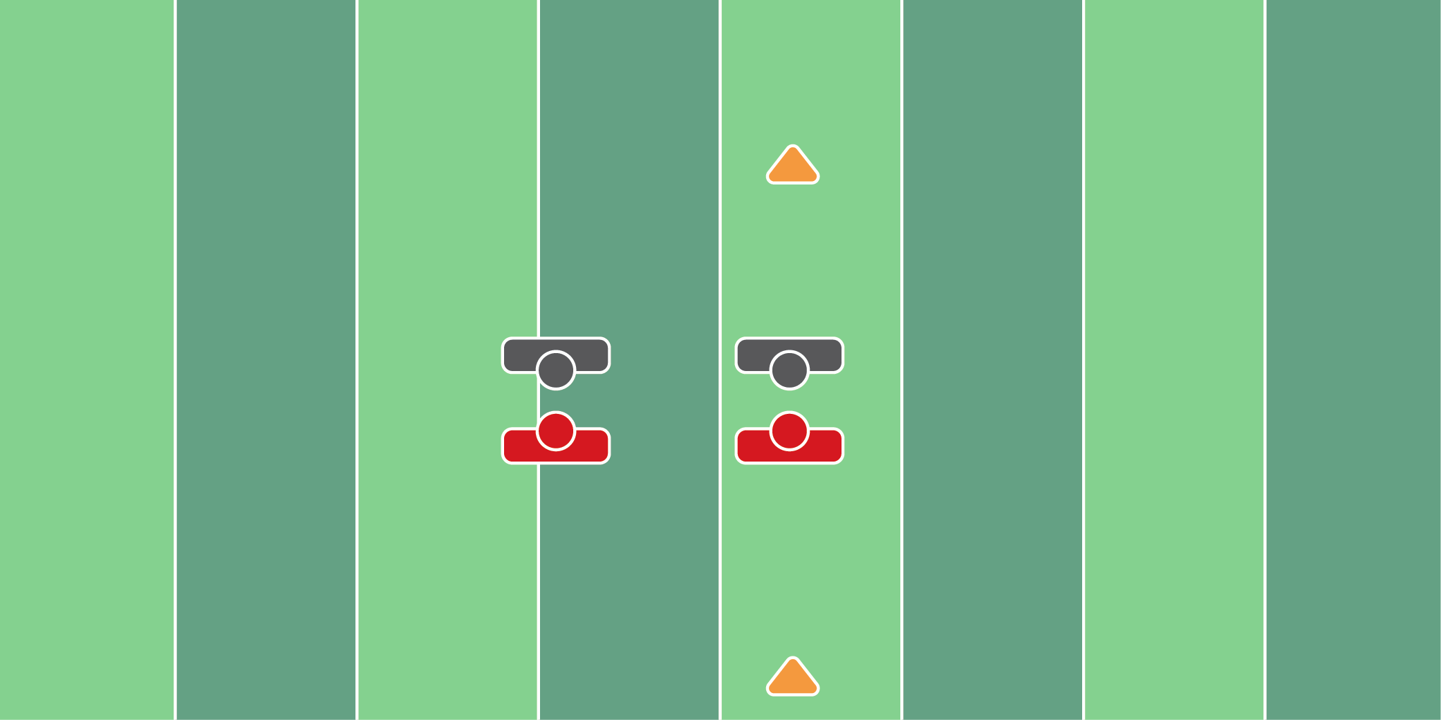
Figure 9.6

Punt Compete Drill

Equipment Needed: Cones

Purpose: Training punt return players to block with the proper angles.

Required Players: 4

Required Coaches: 0

Description: (1) There should be two punt players and two punt return players lined up opposite of each other. (2) When the ball is snapped, the inside punt return player should try to block the punt. (3) The outside punt return player is blocking and setting up a return. All players are competing during this drill.

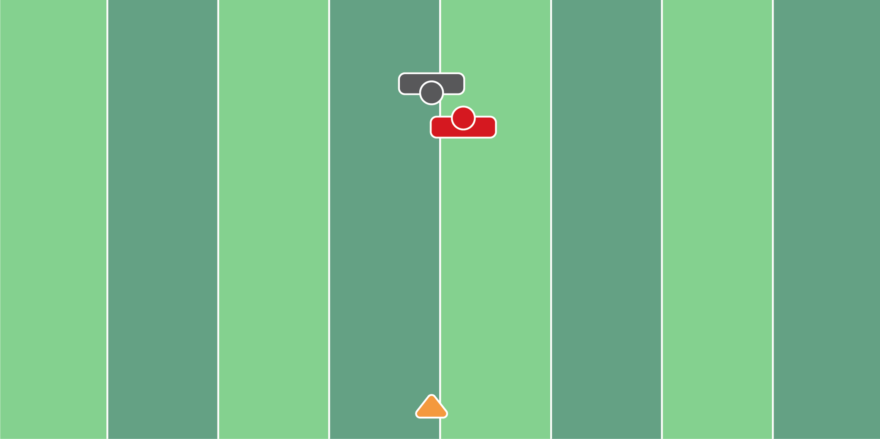
Figure 9.7

Gunner Compete Drill

Equipment Needed: Cones

Purpose: Teaching the gunners to reposition themselves for a legal block when trailing.

Required Players: 2

Required Coaches: 0

Description: (1) The returning player should start ½ yard behind the gunner. (2) When the coach says “go”, both players are trying to race for position. The returning player, who starts trailing, should try to win back position and block the gunner to the outside. (3) The gunner should try to win and stack on top of the return man, racing to the cone.

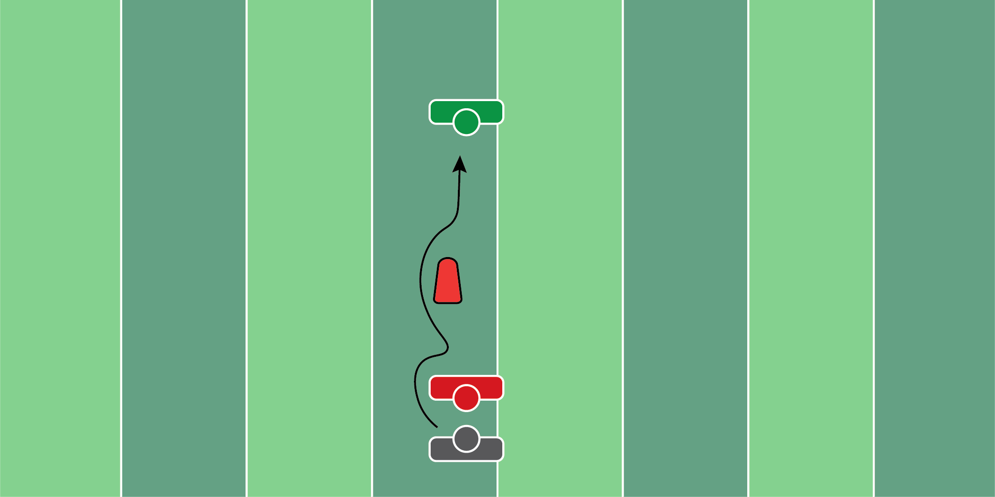
Figure 9.8

Block Release Drill

Equipment Needed: Pop up dummy & step over pads

Purpose: Teaching special teams players to block and release when the ball is kicked.

Required Players: 2

Required Coaches: 1

Description: (1) The punt player should be facing the punt return player. (2) When the coach says “go”, the punt player should block the returning player for 2-3 seconds. (3) After blocking, the player is going to release downfield, dip around the popup dummy, and finish the tackle by tackling the step-over pad. The step-over pad can be substituted with a tackling ring or live player.

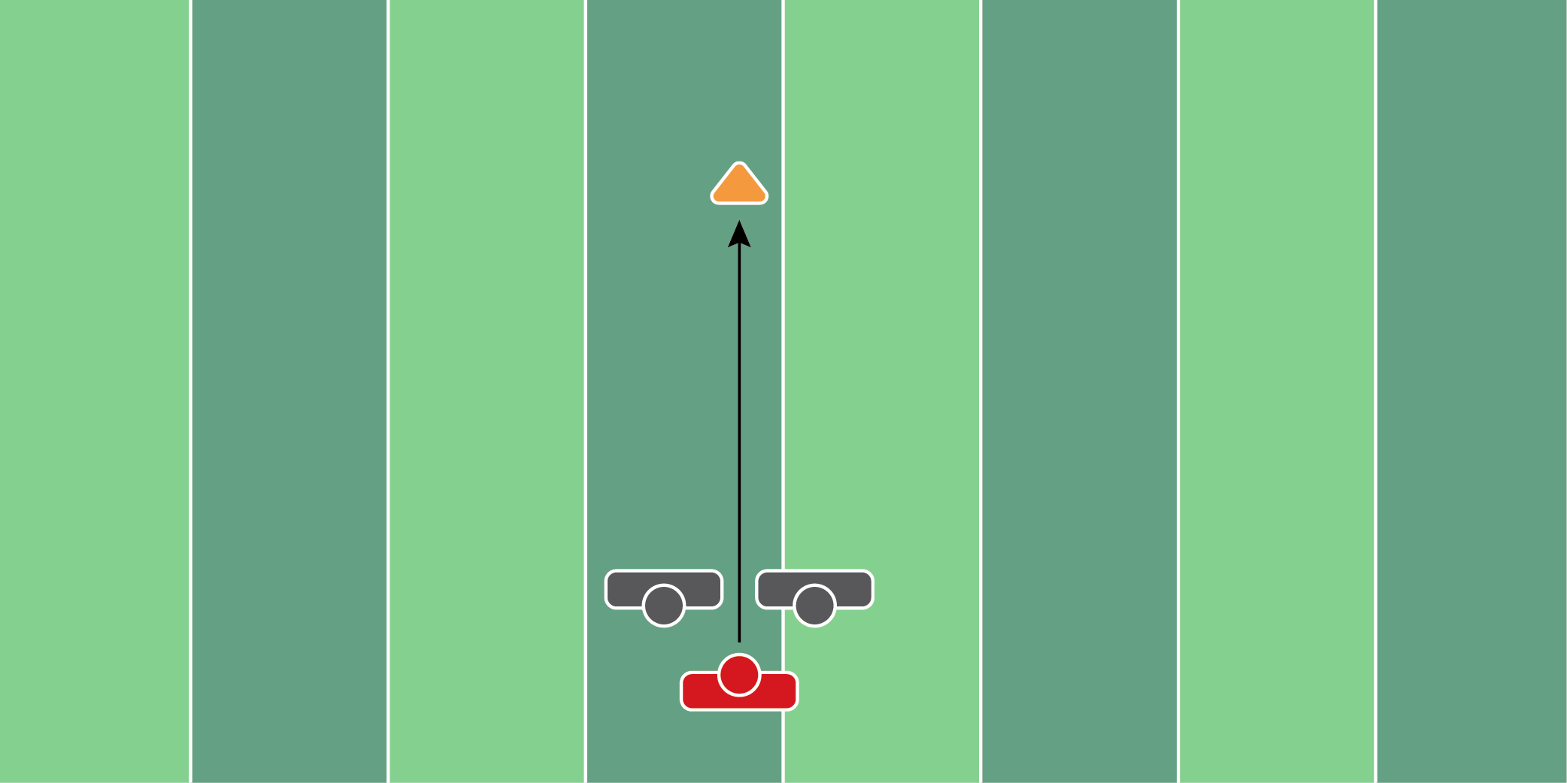
Figure 9.9

Punt Double Team Drill

Equipment Needed: Cones

Purpose: Training the gunner to get through a double team. Also teaches punt return edge players to double team a gunner.

Required Players: 3

Required Coaches: 0

Description: (1) There will be two punt return edge players and one punt gunner on the outside. (2) When the ball is snapped, the gunner should try to split or get by the double team. The return edge player should try to block the player and slow him down as much as possible. (3) The drill is over when the gunner gets to the cone that is 30-40 yards downfield.

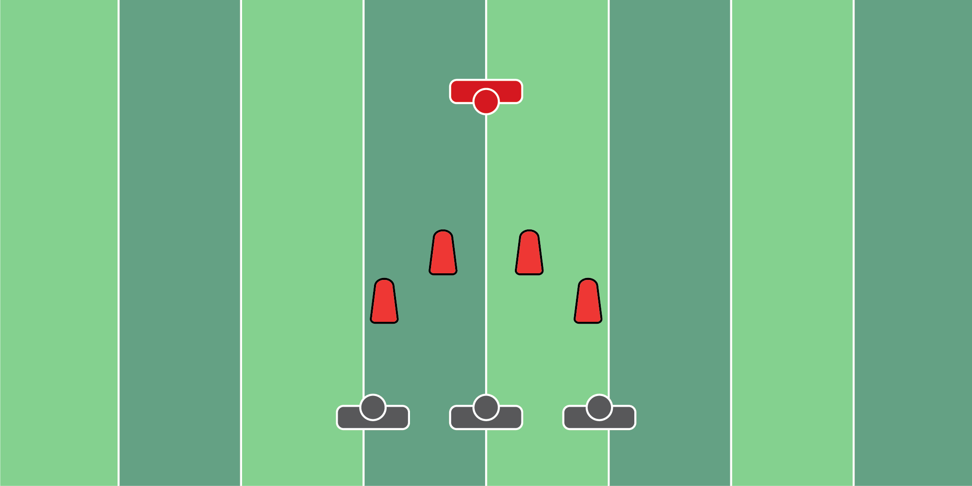
Figure 9.10

3-Man Punt Fit Drill

Equipment Needed: Pop up dummies

Purpose: Training the special teams player to avoid contact and track down the returner.

Required Players: 4

Required Coaches: 0

Description: (1) The special teams players should start behind the 4 popup dummies. (2) When the coach says “go”, the players need to run toward the returner. When running, the players should make a move and dip around popup dummies. (3) When the players clear the dummies, the returner should try to make a move away from the special teams’ players.

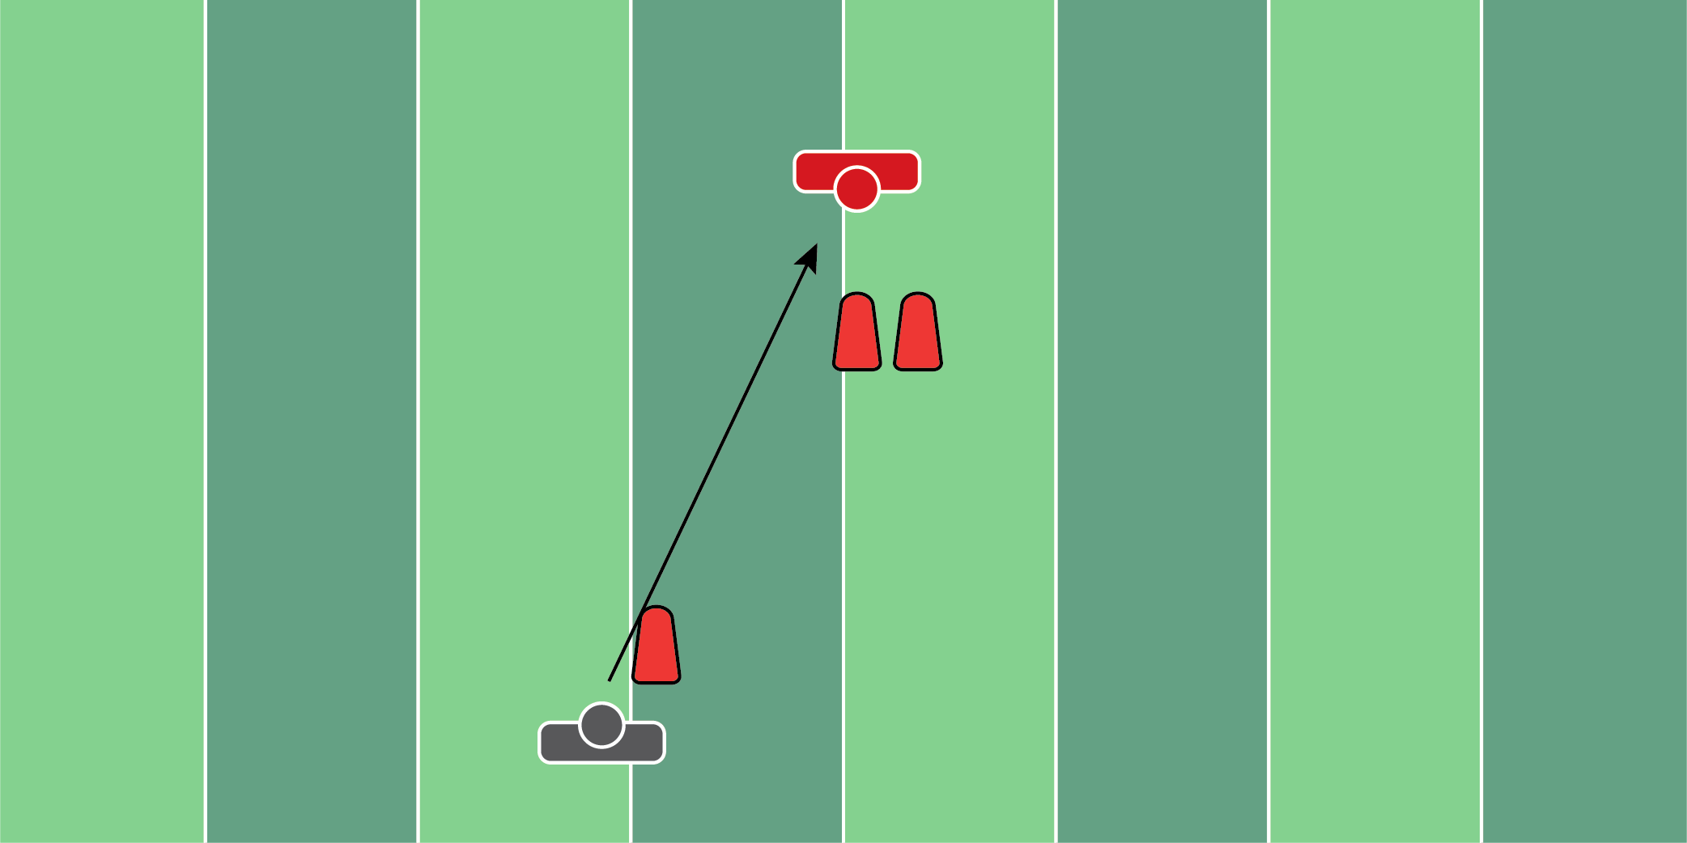
Figure 9.11

Punt Block Drill (2)

Equipment Needed: Popup dummies

Purpose: Training the special teams player dip around punt return players and take the proper angle to block the punt.

Required Players: 1

Required Coaches: 1

Description: (1) The special teams player should line up opposite of the first popup dummy. (2) When the coach says go, the player should dip past the first popup dummy. (3) After clearing the first dummy, the player should then dip past the second popup dummy and block the punt.
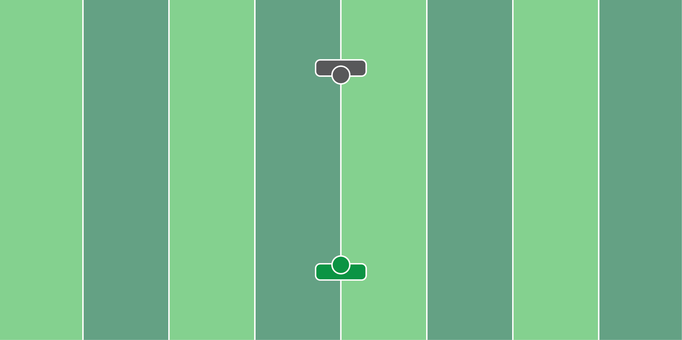
Figure 9.12

Boxing Glove Catch Drill

Equipment Needed: Boxing Gloves

Purpose: Training the special teams player to catch punts with their hands and arms together.

Required Players: 1

Required Coaches: 1

Description: (1) The special teams player should wear boxing gloves and line up in a punt return position. (2) When a coach (or player) punts the football, the player should try to catch the football with the boxing gloves on.
CONCLUSION

I hope that you’ve found some good use out of these drills. Even as the author of this book, I continue to go back to these drills and replicate them with both my offensive and defensive players.

Here are a few tips for us that have worked when structuring practices that we hope can help you:

- Keeping drills under 5 minutes. Individual drills that go for over 5 minutes tend to get stale. The players (no matter what age) will tend to lose interest.
- Don’t stop the entire drill if only one player is doing it wrong. Too often coaches will stop the drill when only one player is doing it wrong. Valuable reps are lost by stopping the drill. Pull that one player to the side and talk to him individually.
- Film Everything. There are going to be steps, hand placements, etc. that are missed during a live practice. Visual aids such as film help players see and understand their mistakes, so they don’t replicate them.
- Understand your players’ learning styles. Most players are visual learners. Some need to actually physically do the drill to understand what you’re trying to teach. It’s important to learn how each individual player learns best, that way he/she will absorb your coaching faster.

If there’s a drill you didn’t quite understand or that you need further explanation, be sure to send me a message on Twitter @chrisvIQtory and I will try to help out as best as I can!
ABOUT THE AUTHOR

Chris Haddad is a high school football coach in Massachusetts as well as the founder of vIQtory Sports. vIQtory Sports is a football education platform that helps coaches and players learn more about the game of football.

Through his 4 years of operating vIQtory, Chris has interviewed more than 100+ professional athletes and over 125+ coaches at all levels of football.

On top of coaching, Chris also has helped innovate the game of football with the use of his football inventions. The Shell Stick, made by Rae Crowther, teaches athletes to absorb contact safely to prevent injury to the head and neck area.

Chris is active on his Twitter account as well as all of the vIQtory Sports social media accounts, which can be found here:

Chris Haddad - Twitter - @chrisvIQtory

vIQtory Sports - All Platforms - @vIQtorySports

v2.

